

**TRIBHUVAN UNIVERSITY**

**INSTITUTE OF ENGINEERING**

**PULCHWOK CAMPUS**

**Subject**: C-Programming

**Experiment Number**: 1&2

**Title**: Introduction and Variables

**Date**: 2077/02/31

**Submitted By:**   **Submitted To:**

Name: Subham Shrestha Department of Electronics and Computer Engineering

Program: Bachelor in Computer Engineering

Section: C/D Checked By:

Roll: 077BCT082

**Contents of report**

**1. Background information**

1. Introduction to C programming language
2. Compiler and interpreter
3. Compilation process
4. Algorithm and flowchart
5. Pseudo code
6. Getting used to c
7. Basic syntax in C
8. Variables
9. C data type
10. Qualifiers
11. Type conversion and casting

**2. Code and output**

1. Source code
2. Output

**3. Analysis and discussion**

**4. Conclusion**

**Background Information**

**Introduction to Programming Language**

Program is an organized list of instructions that, when executed, causes computer to behave in a predetermined manner. Programming Language is standardized communication technique for describing instructions for computer. Its types are:

1 Low level language: They are closer to hardware and are hardware specific. It includes Machine language and Assembly language

2 High level language: They are closer to human language. They need to be converted to machine language by the help of compiler or interpreter for computer to understand.eg: C, C++, Java, etc.

**Introduction to C Programming Language**

C programming language is high level programming language developed n 1970s by Dennis Ritchie at bell lab. Its instructions consist of algebraic expressions, English keywords such as *if, else, for, do while*, etc. as it can be divided into small modules, it is also called structured programming language. It is flexible to use as system and application programming and has huge collection of operators and library functions.

**Compiler**

The source code written in source file is the human readable source for program that needs to be compiled into machine language so that CPU can actually execute the program as per the instructions given.

The compiler is a program that compiles/translates the source codes into final executable programs. It translates high level instruction to machine level language (i.e. 0 & 1). Every high level language comes with a compiler. For examples the compiler for C are Turbo C, Visual Studio Code and many more.

**Interpreter**

It is a program which converts each high level language program to machine code. The translation and execution occur one statement at a time in a succession, without looking at the entire program. The advantage of interpreter is that they can execute program immediately.

|  |  |
| --- | --- |
| Compiler | Interpreter |
| It converts all source code to object code and finally in executable code to produce exe file. | It converts each statement before executing and doesn’t produce exe file |
| It takes time to execute. | It executes immediately. |
| Once compiled program doesn’t need to recompile for next run so produced program are faster and efficient. | For running next time, it is required to repeat from beginning so it is slower. |
| Immediate editing and executing for a long program is costly. | It is possible to execute and edit program immediately. |

**Compilation Process**

Compilation is the process of translation from high level language (source code) to machine language (object code).

The first step is to pass the source code through a compiler, which translates the high-level language instructions into objects.

The final step in producing an executable program is to pass the object code through a linker. The linker combines modules and real values to all symbolic addresses, thereby producing machine code.

Compilation process ends producing an executable program. Compiler stores the object file and executable files in secondary storage. If there is any illegal instruction in the source code, compiler lists all the errors during compilation.

In turbo C, Alt + F9 Compilation Ctrl + F9 Run



**Debugging and testing**

It is the process of detecting and removing errors in programs that desired result is obtained.

Errors may include Syntax error, Run time error, Logical error, and Latent error.

**Algorithm and flowchart**

Algorithm is set of ordered steps/procedure necessary to solve a problem. To be algorithm, set of steps must be followed and have a clear stopping point. It can be said as verbal form of program. It should not use any programming language syntax and must use plain language.

Flowchart is a diagrammatic representation of algorithm. It illustrates the sequence of operation to be performed to get solution in logical order.

Flow line Decision

Terminal (Start/Stop) Connector

Input/output

**Pseudo code**: It is natural language construct modded to look like statements available in many programming language. It is mixture of structured English and code. Thus, it is a logic development tool that uses English like statements to present logical steps necessary to solve problem.

**Getting used to C**

**Basic syntax used in C**

1. Keywords: All keyword have fixed meaning that cannot be changed. They serve as building blocks for program statement and written in lowercase.eg *float, for*
2. Identifiers: it refers to the name of variables, functions and arrays. These are user defined name and consist of letters and digits. Underscore is also taken as identifires.eg. Num, prime, etc.
3. Constants: It refers to fixed values that do not change during the execution of program.
   1. Integer Constants : 1,8,7,-2,-7
   2. Real Constants: 1234.5678 ,6.8,-7.9
   3. Character Constants: ‘a’, ‘p’, ‘4’, ‘*’ ‘ ’,
   4. String Constants : “ Pulchowk Campus”
4. Operators

Arithmetic Operators: +, -, *, /, %

Logical Operators: &&, ||, !

Relational Operators: <, >, <=, >=, ==, !=

Assignment Operators, =, *=, +=, -=, %=, /=, &=, |=, ^=, <<=, >>=

Increment and Decrement Operators, post increment and pre increment

Conditional Operators ?:

Bitwise Operators, &,|, ^, <<, >>, ~

Special Operators, size of

Comma operator: (,)

Pointer Operator (*, &)

Member Selection Operator (. and🡪)

1. Special Symbols { }, [ ], &, ^

6. **Variables**

Variable is a data name that may be used to store a data value. It is a space in the computer memory set aside for a certain kind of data and given a name for easy reference. Variable are used so that same space in memory can hold different values. All variables are identifier but all identifiers might not be a variable.

Declaration of variables: all variables must be declared before they appear in a program in order to reserve memory space for each data item. A declaration may consist of one or more variables of same data type. A declaration begin with data types following with one or more variables and ends with semicolon.

E.g. int x=6, y=7; float a=3.5656;

**C data types**

a. Fundamental data type:

They are not composed of other data types. Its types are;

|  |  |  |
| --- | --- | --- |
| Data | Size | range |
| char (single character) | 1 byte | -128 to 127 |
| int (integer) | 2 byte | -32678 to 32767 |
| float (floating point number) | 4 byte | 3.4 e-38 to 3.4 e +38 |
| double (double precision floating point) | 8 byte | 1.7e-308 to 1.7e+308 |

b. Derived data type: functions, array and pointers

c. User defined data type: structure, union and enumeration

Qualifiers: It modifies the behavior of the variable type. There are four types of qualifiers:

1. Size Qualifiers**:** short and long, both can be applied to int but only long can be used in double
2. Sign Qualifiers**:** Signed (Positive and Negative) and Unsigned (Positive)
3. const**:** an object declared to be const cannot be modified by program. E.g. constint num=20
4. volatile**:** A variable should be declared volatile whenever its value can be changed

**Type conversion**

If the operands are of different types, the smaller type is automatically converted to higher type before the operation proceeds.

Float to int=causes truncation of the fractional part

Double to float=causes rounding of digits

Long int to int=causes dropping of the excess higher order bits

**Type casting**

Sometime it is required to convert the type of an expression forcefully. This is called type casting or explicit type conversion.

**Code and output**

**LAB - 1**

Compiler used = Turbo C

**Q.1**

Source Code:

*#include<stdio.h>*

*#include<conio.h>*

*void main()*

*{*

*printf("This is my first C program.");*

*getch();*

*}*

Output:

This is my first C program.

**Q.2** **Write a program to find value of s.**

Source Code:

*#include <stdio.h>*

*#include <conio.h>*

*void main()*

*{*

*int s,a,b,c=20;*

*printf("Enter value of a:");*

*scanf("%d",&a);*

*printf("Enter value of b :");*

*scanf("%d",&b);*

*s=a+b*c;*

*printf("Sum=%d",s);*

*getch();*

*}*

Output:

Enter the value of a and b: 4

5

Sum=104

**Q.3** **Run the given program.**

Source Code:

*#include<stdio.h>*

*#include<conio.h>*

*void main()*

*{*

*int s,a,b;*

*float p;*

*clrscr();*

*printf("Address of s is %x",&s);*

*printf("\n Address of a is %x",&a);*

*printf("\n\n Occupied number of bytes by variable s is %d",sizeof(s));*

*// size of operator.It returns the size ocupied by any variable or data.//*

*printf("\n\n\n Size of a %d",sizeof(p));*

*printf("\n\n\n\n Size of 1.5 is %d",sizeof(1.5));*

*printf("\n\n\n\n\n Size of float data type is %d",sizeof(float));*

*getch();*

*}*

Output:

Address of s is fff4

Address of a is fff2

Occupied number of bytes by variable s is 2

Size of a 4

Size of 1.5 is 8

Size of float data type is 4

**Q.4** **Write a program to calculate the area, circumference of circle of radius.**

Source Code:

*include<stdio.h>*

*#include<conio.h>*

*void main()*

*{*

*float r,C,A; clrscr();*

*printf(" Enter the radius of circle:\n");*

*scanf("%f",&r);*

*C=2*3.14*r;*

*printf("Circumference of cirle is %f\n",C);*

*A=3.14*r*r;*

*printf("Area of circle is %f\n",A);*

*getch();*

*}*

Output:

Enter the radius of circle:

7.8

Circumference of circle is 48.984001

Area of circle is 191.037613

**Q.5** **Write a program to calculate volume of sphere.**

Source Code:

*include<stdio.h>*

*#include<conio.h>*

*void main()*

*{*

*float r,V; clrscr();*

*printf("Insert the value of radius:\n");*

*scanf("%f",&r);*

*V=(4*3.14*r*r*r)/3;*

*printf("The volume of Sphere is %f\n",V);*

*getch();*

*}*

Output:

Insert the value of radius:

3.6

The volume of Sphere is 195.333099

**Q.6** **To calculate the simple interest.**

Source Code:

*#include<stdio.h>*

*#include<conio.h>*

*void main()*

*{*

*float p,r,t,SI; clrscr();*

*printf("\n Enter principle:"); scanf("%f",&p);*

*printf("\n Enter rate:"); scanf("%f",&r);*

*printf("\n Enter time:"); scanf("%f",&t);*

*//calculate simple interest//*

*SI=(p*r*t)/100;*

*printf("Simple interest is %f", SI);*

*getch();*

*}*

Output:

Enter principle:2564

Enter rate:4.5

Enter time:3

Simple interest is 345.140015

**Q.7** **To read values of x and y from user and evaluate: v=x^3+y^2-100/x.**

Source Code:

*#include<stdio.h>*

*#include<conio.h>*

*void main()*

*{*

*int x,y;*

*float v; clrscr();*

*printf("\n Insert x=");*

*scanf("%d",&x);*

*printf("\n Insert y=");*

*scanf("%d",&y);*

*//evaluation of expression//*

*v=(x*x*x + y*y)-(100/x);*

*printf("The value of v is%f\n",v);*

*getch();*

*}*

Output:

Insert x=4

Insert y=6

The value of v is 75.000000

**Q.8** **To read four integers and display its mean**.

Source Code:

*#include<stdio.h>*

*#include<conio.h>*

*void main()*

*{*

*float a,b,c,d,M;*

*clrscr();*

*printf("\nInsert the integers value:");*

*scanf("%f%f%f%f",&a,&b,&c,&d);*

*//calculation of mean//*

*printf(" Mean value of 4 integer is%2.2f",M=(a+b+c+d)/4,M);*

*getch();*

*}*

Output:

Insert the integers value:2

3

4

5

Mean value of 4 integer is3.50

**Q.9** To find volume of cuboid

Source Code:

*#include<stdio.h>*

*#include<conio.h>*

*void main()*

*{*

*float l,b,h,V; clrscr();*

*printf("Insert length:\n");*

*scanf("%f",&l);*

*printf("Insert breadth:\n");*

*scanf("%f",&b);*

*printf("Insert height:\n");*

*scanf("%f",&h);*

*//calculation of volume of cuboid//*

*printf("Volume of Cubiod is %f\n",V=l*b*h,V);*

*getch();*

*}*

Output:

Insert length:

5.2

Insert breadth:

6.5

Insert height:

2

Volume of cuboid is 67.59999

**Q.10** **To read the price of pens and copies and calculate price after discount of 10%.**

Source Code:

*#include<stdio.h>*

*#include<conio.h>*

*void main()*

*{*

*int q1,q2;*

*float p,c,d,t,T; clrscr();*

*printf("\nEnter the unit price and quantity of pens:");*

*scanf("%f%d",&p,&q1);*

*printf("\nEnter the unit price and quantity of copies:");*

*scanf("%f%d",&c,&q2);*

*t=p*q1 + c*q2;*

*printf("\nTotal amount is %f",t);*

*//deduction of discount//*

*printf("\nDiscount rate:");*

*scanf("%f",d);*

*T=(t-(d*t/100));*

*printf("\nAfter discount, grand total is %f",T);*

*getch();*

*}*

Output:

Enter the unit price and quantity of pens:50

2

Enter the unit price and quantity of copies:100

5

Total amount is 600.00000

Discount rate :10

After discount, grand total is 540.00

**Q.11** **To calculate total time in seconds spend for studying in 30 days.**

Source Code:

#*include<stdio.h>*

*#include<conio.h>*

*void main()*

*{*

*unsigned int h,m,s,t;*

*printf("\nEnter hour, minutes and second of a day:");*

*scanf("%u%u%u",&h,&m,&s);*

*printf("\nTotal second in month is%u",((h*3600)+(m*60)+s));*

*//calculation of total second in 30 days//*

*t=(h*3600)+(m*60)+s;*

*printf("\nTotal seconds in a month is%li",t*30);*

*getch();*

*}*

Output:

Enter hour, minutes and second of a day:6

50

56

Total second in month is2456

Total seconds in a month is739680

**Q.12** **To read name and age and display them**.

Source Code:

*#include<stdio.h>*

*#include<conio.h>*

*int main()*

*{*

*char str[40];*

*unsigned int age;*

*printf("\n Enter the name and age:");*

*scanf(" %s%u",&str,&age);*

*printf("\nthe name is %s",str);*

*printf("\n the age is %u",age);*

*return 0;*

*}*

Output:

Enter the name and age:Subham

19

the name is Subham

the age is 19

**Q.13** **To read a character and display it.**

Source Code:

*#include<stdio.h>*

*#include<conio.h>*

*void main()*

*{*

*char a;*

*clrscr();*

*printf(" Insert character \n");*

*a=getchar();*

*printf("Entered character \n");*

*putchar(a);*

*getch();*

*}*

Output:

Insert character

C

Entered character

C

**LAB -2**

**Q.1** **To convert seconds to minutes and again to seconds**.

Source Code:

*#include<stdio.h>*

*void main()*

*{*

*int seconds,min;*

*printf("\nEnter number of seconds:");*

*scanf("%d",&seconds);*

*min=seconds/60;*

*printf("\nMinutes=%d",min);*

*printf("\nSeconds=%d",seconds);*

*}*

Output:

Enter number of seconds:24560

Minutes=409

Seconds=24560

**Q.2** **To illustrate prefix increment operator**.

Source Code:

*#include<stdio.h>*

*void main()*

*{*

*int x=5,v;*

*v=(++x) * (++x) +(++x);*

*printf("v=%d,x=%d\n",v,x);*

*}*

Output:

V=57,x=8

**Q.3** **To read three values and display the largest one.**

Source Code:

*#include<stdio.h>*

*#include<conio.h>*

*void main()*

*{*

*int a,b,c,l;*

*clrscr();*

*printf("Enter three different integers:");*

*scanf("%d%d%d",&a,&b,&c);*

*if(a>b&&a>c)*

*l=a;*

*else if(b>a&&b>c)*

*l=b;*

*else*

*l=c;*

*printf("Largest :%d",l);*

*getch();*

*}*

Output:

Enter three different integers:

3 4 5

Largest :5

**Q.4** **To find sum .**

Source Code:

*#include<stdio.h>*

*#include<conio.h>*

*void main()*

*{*

*int x,y,z;*

*clrscr();*

*x=20000,y=30000;*

*z=x+y;*

*printf("sum=%d",z);*

*getch();*

*}*

Output:

Sum=50000

**Q.5** **To display different data types variables.**

Source Code:

*#include<stdio.h>*

*#include<conio.h>*

*void main()*

*{*

*float a;*

*char b;*

*long int c;*

*unsigned int e;*

*clrscr();*

*printf("Enter value of a and b:");*

*scanf("%f %c",&a,&b);*

*printf("Enter the value of c and e:");*

*scanf("%ld%u",&c,&e);*

*printf("value of a:%f\nvalue of b:%c\nvalue of c:%ld\nvalue of e:%u",a,b,c,e);*

*getch();*

*}*

Output:

Enter value of a and b:3.54

F

Enter the value of c and e:

687687

66

value of a:3.540000

value of b:F

value of c:687687

value of e:66

**Q.6** **To convert Celsius to Fahrenheit.**

Source Code:

*#include<stdio.h>*

*#include<conio.h>*

*void main()*

*{*

*float F,C;*

*clrscr();*

*printf("Enter the value in Celsius:");*

*scanf("%f",&C);*

*//coversion of celsius to fahrenheit//*

*F=1.8*C+32;*

*printf("The measure in Fahrenheit is%f",F);*

*getch();*

*}*

Output:

Enter the value in Celsius : 100

The measure in Fahrenheit is212.00000

**Q.7** **To find equivalent resistance in series and parallel.**

Source Code:

*include<stdio.h>*

*#include<conio.h>*

*void main()*

*{*

*float r1,r2,s,p;*

*clrscr();*

*printf(" enter the resistance: ");*

*scanf("%f%f",&r1,&r2);*

*//for series and parallel connetion//*

*s=r1+r2;*

*p=(r1*r2)/(r1+r2);*

*printf("If in series, value is %.2f\n",s);*

*printf("if in parallel, value is %.2f\n",p);*

*getch();*

*}*

Output:

enter the resistance : 2

3

If in series, value is 5.00

if in parallel, value is 1.20

**Q.8** **To find midpoint of ends of line.**

Source Code:

*#include<stdio.h>*

*#include<conio.h>*

*void main()*

*{*

*float x1,x2,y1,y2,midx,midy;*

*clrscr();*

*printf("enter the value of point1:");*

*scanf("%f%f",&x1,&y1);*

*printf("\nenter the value of point2:");*

*scanf("%f%f",&x2,&y2);*

*//calculation of midpoint//*

*midx=(x1+x2)/2;*

*midy=(y1+y2)/2;*

*printf("Midpoint of line are %.2f %.2f",midx,midy);*

*getch();*

*}*

Output:

enter the value of point1:4

6

enter the value of point2:7

3

Midpoint of line are 5.50 4.50

**Q.9** **To read the number of girls and boys and find ratio of girls to boys.**

Source Code:

*#include<stdio.h>*

*#include<conio.h>*

*void main()*

*{*

*float g,b;*

*float r;*

*printf("Enter the number of girls:");*

*scanf("%f",&g);*

*printf("\n enter the number of boys:");*

*scanf("%f",&b);*

*r=g/b;*

*printf("Ratio of girls to boys is %.2f",r);*

*getch();*

*}*

Output:

Enter the number of girls:30

Enter the number of boys:40

Ratio of girls to boys is 0.75

**Q.10** **Evaluate the given expression**

**a.**

Source Code:

*#include<stdio.h>*

*#include<conio.h>*

*#include<math.h>*

*void main()*

*{*

*float x,y,S;*

*printf("Enter the value of x and y: ");*

*scanf("%f%f",&x,&y);*

*S=pow(x,5)+0.2*x*y+pow(y,7);*

*printf("the value of expression is %.4f",S);*

*getch();*

*}*

Output:

Enter the value of x and y: 3

4.5

the value of expression is 37612.6445

**b.**

Source Code:

*#include<stdio.h>*

*#include<conio.h>*

*#include<math.h>*

*void main()*

*{*

*float a,b,c,p,q,x,y,S;*

*printf("Enter the value of a,b and c: ");*

*scanf("%f%f%f",&a,&b,&c);*

*printf("Enter the value of p and q: ");*

*scanf("%f%f",&p,&q);*

*printf("Enter the value of x and y: ");*

*scanf("%f%f",&x,&y);*

*S=pow(a+b,(2*x+y)/(p-q))+ c-100;*

*printf("the value of expression is %.4f",S);*

*getch();*

*}*

Output:

Enter the value of a, b and c: 1

2

3

Enter the value of p and q: 5

3

Enter the value of x and y: 7

8

the value of expression is 177050.0000

**c.**

Source Code:

*#include<stdio.h>*

*#include<conio.h>*

*void main()*

*{*

*float A,B,r;*

*printf("Enter A:");*

*scanf("%f",&A);*

*printf("\n enter B:");*

*scanf("%f",&B);*

*r=A/B;*

*printf("Ratio of is %.2f",r);*

*getch();*

*}*

Output:

Enter A:22

enter B:33

Ratio of is 0.67

**d.**

Source Code:

*#include<stdio.h>*

*#include<conio.h>*

*#include<math.h>*

*void main()*

*{*

*float u,v,p,q,x,y,r;*

*printf("Enter the value of u and v: ");*

*scanf("%f%f",&u,&v);*

*printf("Enter the value of p and q: ");*

*scanf("%f%f",&p,&q);*

*printf("Enter the value of x and y: ");*

*scanf("%f%f",&x,&y);*

*r=pow((u/x)+(v/y),5)/pow(((p*p)/(3*pow(u,2.5)))-(q/(2*v)),3.5);*

*printf("the value of expression is %f",r);*

*getch();*

*}*

Output:

Enter the value of u and v: 2

3

Enter the value of p and q: 4

5

Enter the value of x and y: 7

8

the value of expression is 290.038727

**Q.11** **To swap value of variable using third variable.**

Source Code:

*#include<stdio.h>*

*#include<conio.h>*

*void main()*

*{*

*int a,b,t;*

*clrscr ();*

*printf("insert a=");*

*scanf("%d",&a);*

*printf("Insert b=");*

*scanf("%d",&b);*

*//after swapping//*

*t=a; a=b ;b=t;*

*printf("After swapping, a=%d\n", a);*

*printf("After swapping=%d\n", b);*

*getch();*

*}*

Output:

Insert a=10

Insert b=20

After swapping, a=20

After swapping=10

**Analysis and Discussion**

During lab1, we studied about basic of C programming and on basis of that we practically indulged in its application by programming in TURBO C. The main focus of this exercise was to make us enable to understand and write the very basic programs in the language of C programming. We programmed simple programs involving basic arithmetic and other related basic math problem like finding area, circumference of circle, volume. We practiced the application of *printf, scanf, getchar; put char* functions in various cases through live demonstration and peer discussion.

During lab2, we went a bit deeper into C programming. We understood the data types and its application in various problem cases. We applied the various arithmetic operator used in C programming language. In addition to that we programmed problem related to increment function (++x), evaluation of algebraic expression, finding ratio of two variable, and lastly swapping of two variable using third variable.

**Conclusion**

Therefore, C programming language is a high level language which is flexible and widely popular. Through the lab discussion we came to know more about the application of C language in various problem cases, basic programming syntax used and structure of program in C. we became familiar with the variables, data types, operators used in C during this lab course.

**Thank you**



**TRIBHUVAN UNIVERSITY**

**INSTITUTE OF ENGINEERING**

**PULCHWOK CAMPUS**

**Subject**: C-Programming

**Experiment Number**: 3&4

**Title**: Input/output and branching

**Date**: 2077/03/04

**Submitted By:**   **Submitted To:**

Name: Subham Shrestha Department of Electronics and Computer Engineering

Program: Bachelor in Computer Engineering

Section: C/D Checked By:

Roll: 077BCT082

**Contents of report**

**1. Background information**

1. Input and output operation
2. Format specification
3. Formatted input
4. Formatted output
5. Decision making and Branching
6. If statement
7. Else if statement
8. Nested if
9. Switch statement

**2. Code and output**

1. Algorithm and flowchart
2. Source code
3. output

**3. Analysis and discussion**

**4. Conclusion**

**Background information**

**Input and output operation:**

**Input a character – The getchar function**

The function getchar returns a single characater from a given inputdevice .The getchar takes the given form:

*Character variable=getchar ();*

**Output a character – the putchar function**

Function putchar is for writing characters one at a time on the display. This function is complementary to the getchar function.It takes the form as shown below:

*putchar ( character variable);*

**String Input and Output**:

Much like the input and output of a character, it is similar to input and output of a string.

*gets* = this function accepts string variable as parameter.

*puts* = this function display string stored in the string variable

**Format specification:**

The general form is:

*% -w.p conversion character*

% = format specifier

‘-‘ = flag for left justification

w = width specifier

‘.’ = period separating width from precision

p = precision specifier

conversion character = according to data type like c,s,d,f

**Formatted input- scanf function:**

Formatted input refers to an input data that has been arranged in particular format. It can be  performed using *scanf*function. The general format of scanf is

*scanf (“control string”,arg1,arg2,……argn);*

The control string specifies the field format in which the data is to be entered.

Control string contain field specification, which direct the  interpretation of input data. It may include: format) specifications, conversion character %, type specifier,and an optional field width.

**Inputting Integer Numbers:**The field specification for reading an integer number is:

*%wd*

It means that scanf function reads integer of width ‘w’.

**Inputting Real Numbers:** Here, the field width of real number is not to be specified. scanf  reads real numbers using the simple specification %f .

*scanf(“%f %f %f”, &x, &y, &z);*

**Inputting Character /Strings:**Scanf can input strings containing more than one character. Given as:

*%ws or %wc*

**Formatted output – printf function:**

The general form of printf statement is :

*printf(“control string”, arg1,arg2,…. argn);*

The control string indicates how many arguments follow and what their types are. The arguments should match in number, order and type with  the format specifications.  Commonly used printf format codes:

%c printing a single character

%d printing a decimal integer

%e printing a floating point value in exponent form

%f printing a floating point value without exponent

%g printing a floating point value either e-type of f-type

%o printing an octal integer, without leading zero

%s print an unsigned decimal integer

%x print a hexadecimal integer, without leading Ox

%hd print a short integer

%ld print a long integer

**Decision making and Branching**:

C language possesses such decision-making capabilities by supporting the following statements:

1. **if** statement

2. **switch** statement

3. **conditional operator** statement

4. **goto** statements

**if statement:**

It takes the following form:

*if (test expression)*

It allows the computer to evaluate the expression first and then, depending on whether the value  of the expression is **‘**true’or ‘false’, it transfers the  control to a particular statement.

Flowchart of if statement:

Entry

Test expression

False

True

**The if..else statement:**

Syntax :

*if**(test expression)*

*{*

*True-block statement(s)*

*}*

*else*

*{*

*False-block statement(s)*

*}*

*statement-x*

if the test expression is *true*, then the true-block statement(s), immediately following the if  statements are executed: otherwise, the false-block statement(s) are executed. In both the cases, the control is transferred  subsequently to the statement-x.

  Entry

Test

  True False

Expression  

True-block   False-block  statement

statement

Statement x

Exit

**Nesting of if…else statement**

Synatx:

*if (test condition-1)*

*{ if(test condition-2)*

*{*

*statement-1;*

*}*

*else*

*{*

*statement-2;*

*}*

*}*

*else*

*{*

*statement-2;*

*}*

*statement-x;*

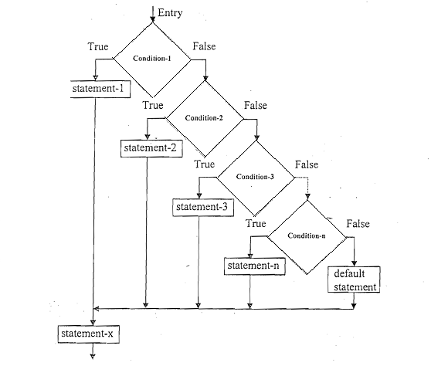**The else if ladder**:

Syntax:

*if (condition 1)*

*statement-1;*

*else if (condition 2)*

*statement -2;*

*else if (condition 3)*

*statement -3;*

*else if ( condition n)*

*statement-n;*

*else*

*default-statement;*

*statement-x;*

flowchart of else if ladder:

**The switch statement:**

 Syntax :

*switch (expression)*

*{ case value-1:  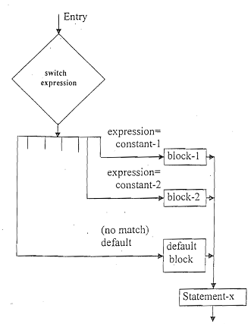*

*block-1;*

*break;*

*case value-2:*

*block-2;*

*break;*

*………*

*default: default-block*

*break;*

*} statement-x;*

Flowchart of switch statement:

**The ? : operator:**

Conditional operatoris a combination of ? and :, an takes three operands. Syntax:

*Conditional expression? expression1: expression2*

The conditional expression is evaluated first. If the result is nonzero, expression1 is evaluated  and is returned as the value of the conditional expression. Otherwise, expression2 is evaluated  and its value is returned.

**The goto statement**

It is the statement to branch unconditionally from one point to another in the program. The goto requires a label to identify the place where the branch is to be made. A label is any valid  variable name, and must be followed by a colon. The label is placed immediately before the  statement where the control is to be transferred.

**Code and output**

**LAB – 3**

Compiler used = GDB compiler and debugger

**Q.1 Write aprogram to read a character using gethar() and display using putchar().**

Source Code:

*#include<stdio.h>*

*#include<conio.h>*

*void main()*

*{*

*char op;*

*printf("\n Insert character ");*

*op=getchar();*

*putchar(op);*

*getch();*

*}*

Output:

Enter the character a

a

**Q.2 Write a program to read a character using scanf() and printf().**

Source Code:

*#include<stdio.h>*

*#include<conio.h>*

*void main()*

*{*

*char c, str[30];*

*printf("Enter a character");*

*scanf(" %c",&c);*

*printf("\n the entered character is %c",c);*

*printf("\nenter the string");*

*scanf("%s",str);*

*printf("\n the entered sting is %s",str);*

*getch();*

*}*

Output:

Enter a character T

the entered character is T

enter the string Kathamndu

the entered sting is Kathamndu

**Q.3 Write a program to read a string using gets() and puts().**

Source Code:

*#include<stdio.h>*

*#include<conio.h>*

*void main()*

*{*

*char str[30];*

*printf("\n enter the string");*

*gets(str);*

*puts(str);*

*getch();*

*}*

Output:

enter the string Daily Routine

Daily Routine

**Q.4 To print integer using format specifications.**

Source Code:

*#include<stdio.h>*

*#include<conio.h>*

*void main()*

*{*

*int a=12345;*

*printf("\nCase1 %d",a);*

*printf("\nCase2 %i",a);*

*printf("\nCase3 %15d",a);*

*printf("\nCase4 %-15d",a);*

*printf("\nCase5 %015d",a);*

*printf("\nCase6 %-+15d",a);*

*printf("\nCase7 %3d",a);*

*getch();*

*}*

Output:

Case1 12345

Case2 12345

Case3 12345

Case4 12345

Case5 000000000012345

Case6 +12345

Case7 12345

**Q.5 To print real numbers using format specifications.**

Source Code:

*#include<stdio.h>*

*#include<conio.h>*

*void main()*

*{*

*float n=123.9835;*

*printf("\nCase1 %f",n);*

*printf("\nCase2 %e",n);*

*printf("\nCase3 %g",n);*

*printf("\nCase4 %15.4f",n);*

*printf("\nCase5 %-15.3f",n);*

*printf("\nCase6 %015.4f",n);*

*printf("\nCase7 %.8f",n);*

*printf("\nCase8 %2.2f",n);*

*getch();*

*}*

Output:

Case1 123.983498

Case2 1.239835e+02

Case3 123.983

Case4 123.9835

Case5 123.983

Case6 0000000123.9835

Case7 123.98349762

Case8 123.98

**Q.6 To print character using format specifications.**

Source Code

*#include<stdio.h>*

*#include<conio.h>*

*void main()*

*{*

*char ch='a';*

*printf("\n case 1=%c",ch);*

*printf("\n case 2=%10c",ch);*

*printf("\n case 3=%-10c",ch);*

*getch();*

*}*

Output:

case 1=a

case 2= a

case 3=a

**Q.7 To print string using format specifications.**

Source Code:

*#include<stdio.h>*

*#include<conio.h>*

*void main()*

*{*

*char str[20]="I love Nepal.";*

*printf("\nCase1 %s",str);*

*printf("\nCase2 %18s",str);*

*printf("\nCase3 %-18s",str);*

*printf("\nCase4 %18.8s",str);*

*printf("\nCase5 %-18.9s",str);*

*printf("\nCase6 %5s",str);*

*printf("\nCase7 %.10s",str);*

*getch();*

*}*

Output:

Case1 I love Nepal.

Case2 I love Nepal.

Case3 I love Nepal.

Case4 I love N

Case5 I love Ne

Case6 I love Nepal.

Case7 I love Nep

**Q.8 To illustrates the concept of printing mixed data.**

Source Code:

*#include <stdio.h>*

*#include <conio.h>*

*int main()*

*{*

*int n = 12345;*

*float m = 123.9876;*

*char ch = 'a';*

*char str[20] ="I love Baglung.";*

*printf("n=%7d\nm=%12.5f\nch=%-2c\nstr=%16s\n", n, m, ch, str);*

*return 0;*

*}*

Output:

n= 12345

m= 123.98760

ch=a

str= I love Baglung.

**Q.9 To illustrates different format specifications for reading integers  numbers**

Source Code:

*#include <stdio.h>*

*#include <conio.h>*

*int main()*

*{*

*int a, b;*

*printf("Enter the number: ");*

*scanf("%d", &a);*

*printf("The read and stored value of a is %d\n\n", a);*

*printf("Enter another integers number: ");*

*scanf("%3d", &b);*

*printf("The read and stored value of b is %d\n", b);*

*return 0;*

*}*

Output:

Enter the number: 8

The read and stored value of a is 8

Enter another integers number: 9

The read and stored value of b is 9

**Q.10 To illustrates the concept of reading string using %wc format  specification**

Source Code:

*#include <stdio.h>*

*#include <conio.h>*

*void main()*

*{*

*char str[50];*

*printf("Enter the string: ");*

*scanf("%10c", &str);*

*printf("Read string : %s", str);*

*getch();*

*}*

Output:

Enter the string: concept reading

Read string : concept re

**Q.11 To show the concept of defining search set to read string.**

Source Code:

*#include <stdio.h>*

*#include <conio.h>*

*int main()*

*{*

*char str[70];*

*printf("Enter the string: ");*

*scanf("%[a-z0-9]",str);*

*printf("Read string: %s",str);*

*return 0;*

*}*

Output:

Enter the string: hty567$wwx

Read string: hty567

**Q.12 To show the concept of defining search set to read string.**

Source Code:

*#include <stdio.h>*

*#include <conio.h>*

*void main()*

*{*

*char str[70];*

*printf("Enter the string: ");*

*scanf("%[^M]",str);*

*printf("Read string: %s",str);*

*getch();*

*}*

Output:

Enter the string: ruytuwM

Read string: ruytuw

**LAB -4**

**Q.1 If a person’s age is greater than 65,he gets seniority allowance. Write a program to read age and display appropriate message.**

Algorithm and flowchart:

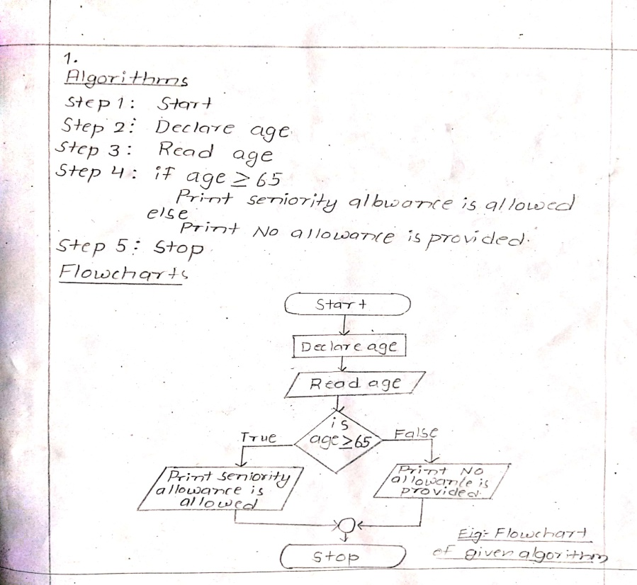

Source Code:

*#include<stdio.h>*

*#include<conio.h>*

*void main()*

*{*

*unsigned int age;*

*printf("\nEnter the age ");*

*scanf("%u",&age);*

*if(age>=65)*

*printf("\nseniority allowance is allowed");*

*else*

*printf("\nNo allowance is allowed");*

*getch();*

*}*

Output:

Enter the age 45

No allowance is allowed

Enter the age 78

seniority allowance is allowed

**Q.2 To read integer and check whether it is positive,zero or negative and display it.**

Algorithm and flowchart:

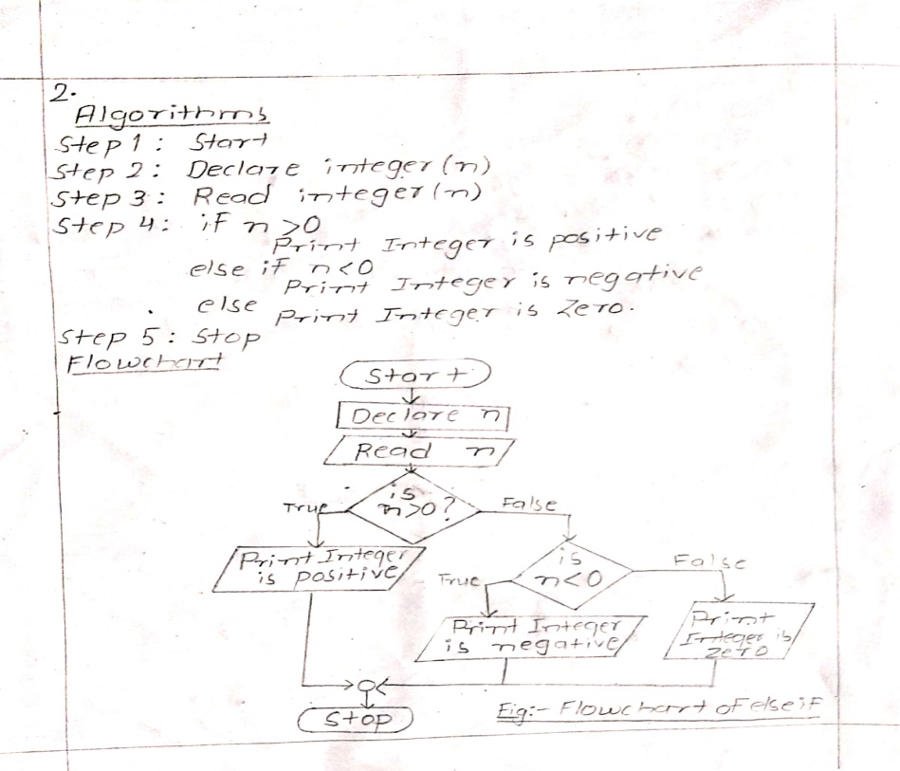

Source Code:

*#include<stdio.h>*

*#include<conio.h>*

*void main()*

*{*

*int n;*

*printf("\n Insert integer ");*

*scanf("%d",&n);*

*if(n>0)*

*printf("\nInteger is positive");*

*else if(n<0)*

*printf("\nInteger is negative");*

*else*

*printf("\n Integer is Zero");*

*getch();*

*}*

Output:

Insert integer -4

Integer is negative

**Q.3 To read sides of triangle and calculate the area of triangle.**

Algorithm and flowchart:

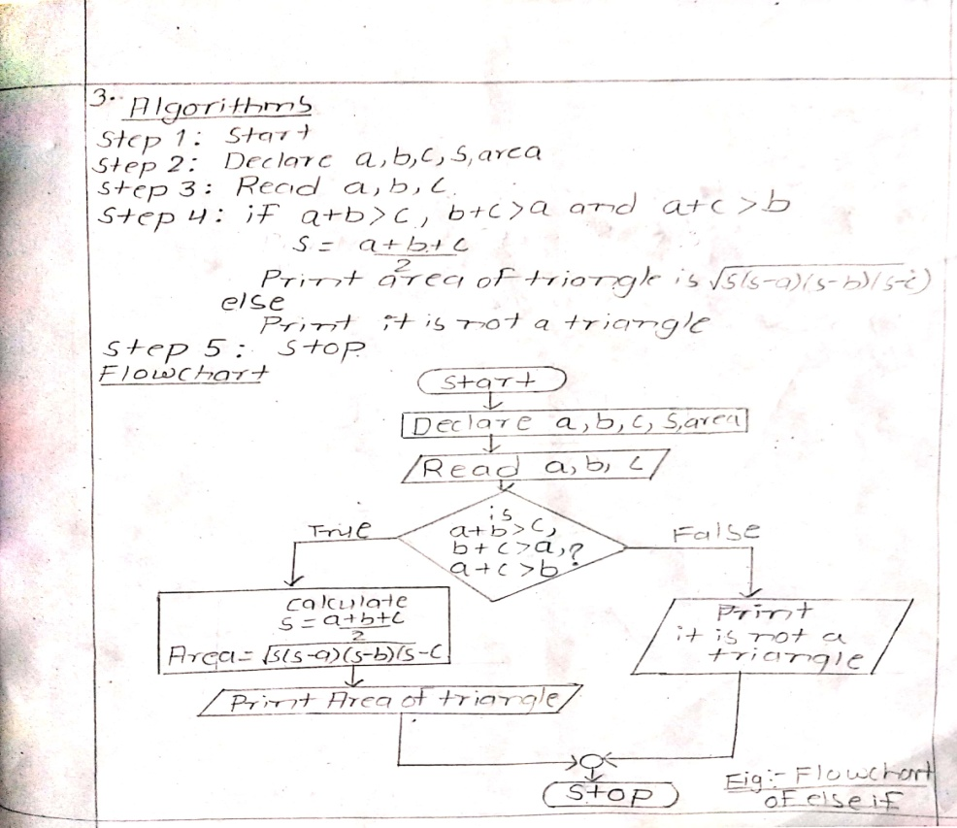

Source Code:

*#include<stdio.h>*

*#include<conio.h>*

*#include<math.h>*

*void main()*

*{*

*float a,b,c,s,ar;*

*printf("\n Enter the sides :");*

*scanf("%f%f%f",&a,&b,&c);*

*if(a+b>c && b+c>a && a+c>b)*

*{*

*s=(a+b+c)/2;*

*printf("Area of triangle is %f",ar=(sqrt(s*(s-a)*(s-b)*(s-c))),ar);*

*}*

*else*

*printf("\n It is not a triangle");*

*getch();*

*}*

Output:

Enter the sides :3

4

5

Area of triangle is 6.000000

**Q.4 To read a character and check if it is uppercase or lowercase.**

Algorithm and flowchart

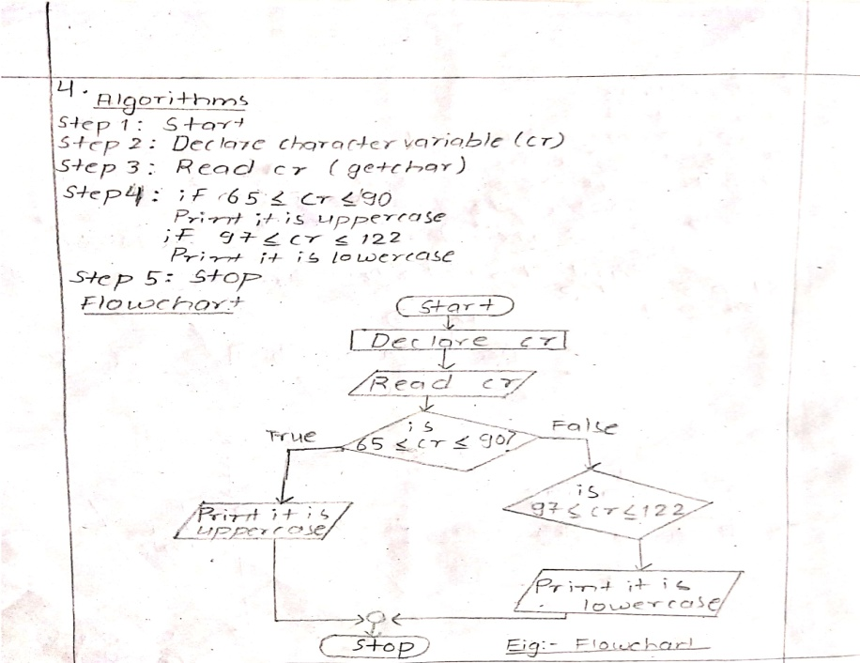

Source Code:

*#include<stdio.h>*

*#include<conio.h>*

*void main()*

*{*

*char cr;*

*printf("\n Enter a character");*

*cr=getchar();*

*if(cr>=65&& cr<=90)*

*printf("\n It is uppercase");*

*if(cr>=97 && cr<=122);*

*printf("\n it is lowercase");*

*getch();*

*}*

Output:

Enter a character Q

It is uppercase

**Q.5 To read a character and covert it to uppercase if lowercase and vice versa.**

Algorithm and flowchart

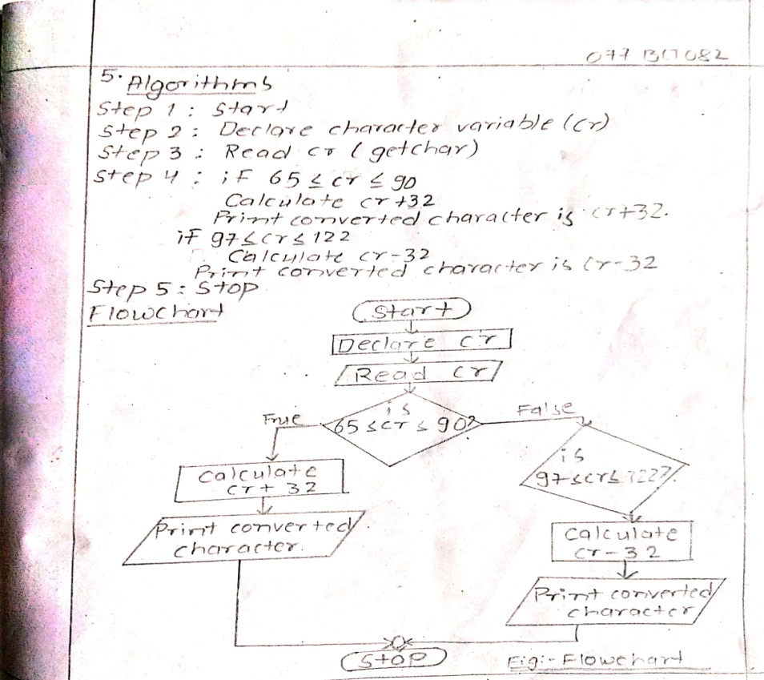

Source Code:

*#include<stdio.h>*

*#include<conio.h>*

*void main()*

*{*

*char cr;*

*printf("\n Enter a character ");*

*cr=getchar();*

*if(cr>=65&& cr<=90)*

*printf("\n converted character is %c",cr+32);*

*if(cr>=97 && cr<=122)*

*printf("\n converted character is %c",cr-32);*

*getch();*

***}***

Output:

Enter a character t

converted character is T

**Q.6 Write a program to read unsigned integer and check if it is odd or even. If it is even, check if it greater than 100 or not and display it. If it is odd, check if it is divisible by 10 and 7 or not and display it.**

Algorithm and flowchart

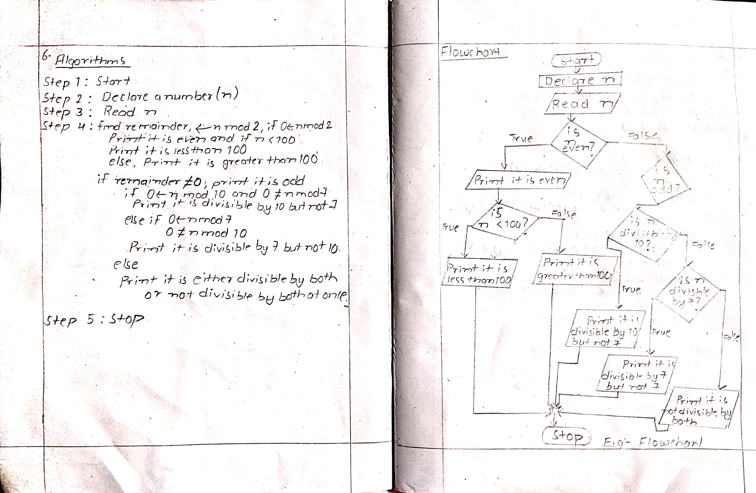

Source Code:

*#include<stdio.h>*

*#include<conio.h>*

*void main()*

*{*

*unsigned int n;*

*printf("\nInsert number :");*

*scanf("%u",&n);*

*if(n%2==0)*

*{*

*printf("\n It is even");*

*if(n<100)*

*printf("\nIt is less than 100");*

*else*

*printf("\nIt is greater than 100");*

*}*

*if(n%2!=0)*

*{*

*printf("It is odd");*

*if(n%10==0 && n%7!=0)*

*printf("\nIt id divisible by 10 but not 7");*

*else if(n%7==0 && n%10!=0)*

*printf("\nIt is divisible by 7 but not 10");*

*else*

*printf("\nIt is either divisible by both or not divisble by both at once");*

*}*

*getch();*

*}*

Output:

Insert number :88

It is even

It is less than 100

**Q.7 To find all roots of quadratic equation ax^2+bx+c.**

Algorithm and flowchart

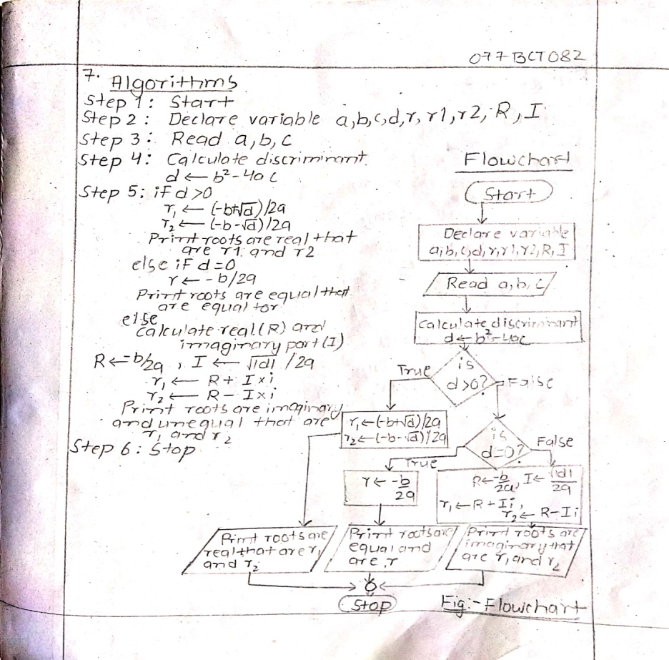

Source Code:

*#include <stdio.h>*

*#include<conio.h>*

*#include <math.h>*

*void main() {*

*double a, b, c, d, r1, r2, R,I;*

*printf("Enter coefficients a, b and c: ");*

*scanf("%lf %lf %lf", &a, &b, &c);*

*d = b * b - 4 * a * c;*

*// condition for real and different roots//*

*if (d > 0) {*

*r1 = (-b + sqrt(d)) / (2 * a);*

*r2 = (-b - sqrt(d)) / (2 * a);*

*printf("r1 = %.2lf and r2 = %.2lf", r1, r2);*

*}*

*// condition for real and equal roots//*

*else if (d == 0) {*

*r1 = r2 = -b / (2 * a);*

*printf("r1 = r2 = %.2lf;", r1);*

*}*

*// if roots are not real//*

*else {*

*R = -b / (2 * a);*

*I = sqrt(-d) / (2 * a);*

*printf("r1 = %.2lf+%.2lfi and r2 = %.2f-%.2fi",R,I,R,I);*

*}*

*getch();*

*}*

Output:

Enter coefficients a, b and c: 2 3.3 6

r1 = -0.82+1.52i and r2 = -0.82-1.52i

**Q.8 To evaluate the given expression.**

Algorithm and flowchart

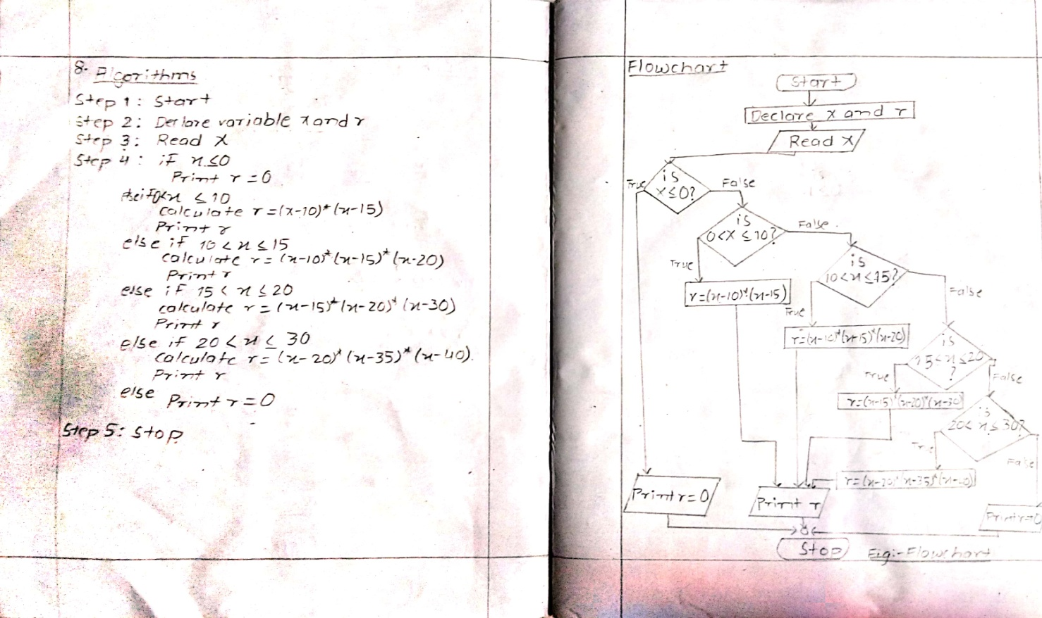

Source Code:

*#include<stdio.h>*

*#include<conio.h>*

*void main()*

*{*

*int x,r;*

*printf("Enter the value of x ");*

*scanf("%d",&x);*

*if(x<=0)*

*printf("r=0");*

*else if(x>0&&x<=10)*

*printf("r=%d",r=(x-10)*(x-15),r);*

*else if(x>10&&x<=15)*

*printf("r=%d",r=(x-10)*(x-15)*(x-20),r);*

*else if(x>15&&x<=20)*

*printf("r=%d",r=(x-15)*(x-20)*(x-30),r);*

*else if(x>20&&x<=30)*

*printf("r=%d",r=(x-20)*(x-35)*(x-40),r);*

*else*

*printf("r=0");*

*getch();*

*}*

Output:

Enter the value of x 26

r=756

**Q.9** **To read an integer from 1-7 and display corresponding day of week.**

Algorithm and flowchart

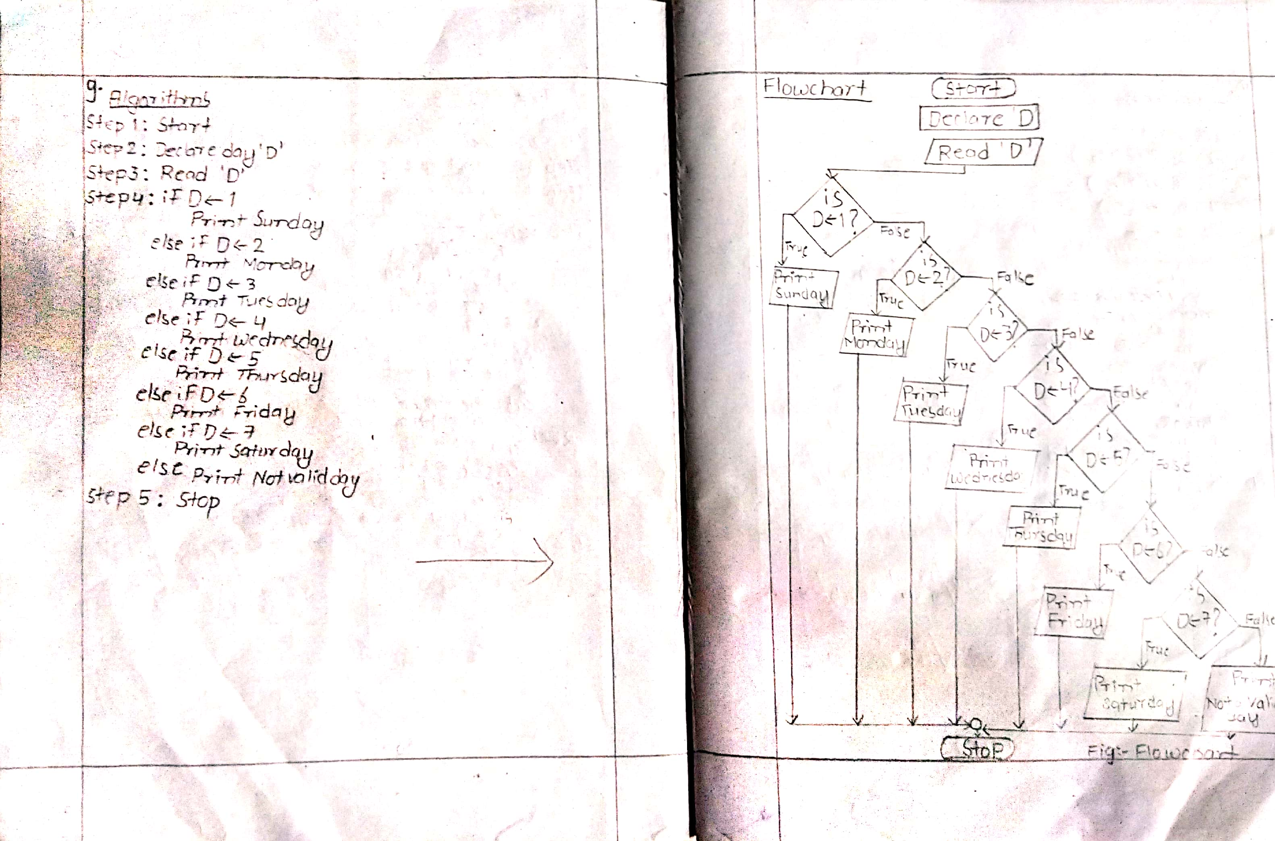

Source Code:

*#include <stdio.h>*

*#include<conio.h>*

*void main()*

*{*

*int D;*

*printf("Enter day number : ");*

*scanf("%d", &D);*

*if(D == 1)*

*printf("Sunday");*

*else if(D == 2)*

*printf("Monday");*

*else if(D == 3)*

*printf("Tuesday");*

*else if(D== 4)*

*printf("Wednesday");*

*else if(D == 5)*

*printf("Thursday");*

*else if(D == 6)*

*printf("Friday");*

*else if(D == 7)*

*printf("Saturday");*

*else*

*printf("Not a Valid day nnumber");*

*getch();*

*}*

Output:

Enter day number : 7

Saturday

**Q.10 To asks arithmetic operator and two operands and perform the operation (simple calculator).**

Algorithm and flowchart

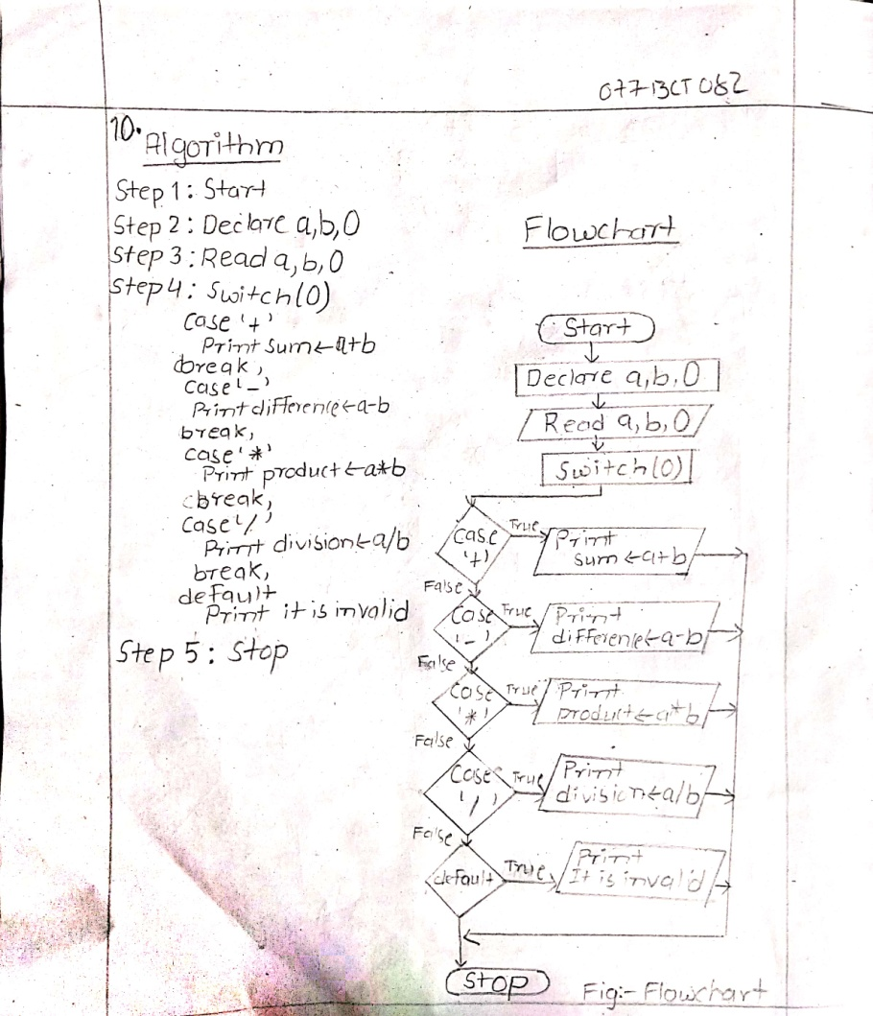

Source Code:

*#include <stdio.h>*

*#include<conio.h>*

*void main()*

*{*

*char O;*

*float a, b;*

*printf("Enter any two numbers\n");*

*scanf("%f %f", &a, &b);*

*printf("Enter Operator\n");*

*scanf(" %c", &O);*

*switch(O)*

*{*

*case '+':*

*printf("sum is a +b=%f",a+b);*

*break;*

*case '-':*

*printf("difference is a-b=%f",a-b);*

*break;*

*case '*':*

*printf("product is a *b=%f",a*b);*

*break;*

*case '/':*

*printf("division is a /b=%f",a/b);*

*break;*

*default:*

*printf("entera a valid operator");*

*break;*

*}*

*getch();*

*}*

Output:

Enter any two numbers

3 4

Enter Operator

/

division is a /b=0.750000

**Q.11**

**List of operators in C on increasing preccedence:**

|  |  |  |
| --- | --- | --- |
| Operator | description | Associativity |
| ( ) | Function call | Left to right |
| [ ] | Array element |
| + | Unary plus | Right to left |
| - | Unary minus |
| ++ | Increment |
| -- | Decrement |
| ! | Logical negation |
| ~ | Onescompliment |
| * | Pointer reference |
| & | Address |
| Sizeof | Size of object |
| (type) | Type cast |
| * | Multiplication | Left to right |
| / | Division |
| % | Modulus |
| + | Addition |
| - | Subtraction |
| << | Left shift | Left to right |
| >> | Right shift |
| < | Less than |
| <= | Less than or equal to |
| > | Greater than |
| >= | Greater than or equal to |
| == | Equality |
| != | Inequality |
| & | Bitwise AND | Left to right |
| ^ | Bitwise OR |
| | | Bitwise XOR |
| && | Logical AND |
| | | | Logical OR |
| ? : | Conditinal expression | Right to left |
| = | Assignment operator | Right to left |
| *= /= %= |
| += -= &= |
| ^= |= |
| <<= >>== |
| , | Comma operator | Left to right |

**Differences between else if and switch ladder:**

|  |  |
| --- | --- |
| Else if | Switch |
| The evaluation and selection of code is based on truth value of expression. | The evaluation and selection is based on the value of the expression. |
| Each if has its own logiacal expression to be evaluated. | Each case is referring back to original value of the expression. |
| The expression may evaluate to a value of any type, either int or char. | The expression must evaluate to an int. |
| It doesn’t require break statement. | It needs involvement of break statement to avoid execution of block. |
| It takes decisionon basis of true or false. | It takes decision on basis of equality. |

**Analysis and discussion**

In the course of our lab practical 3, we learned about input and output of a character and string using *getchar/gets* and *putchar/puts* function and also using the scanf and printf function. We further studied about format specification( Qn 4 to 7) of integers, real number, characters and strings through practical demonstration in the lab.

Similarly, during lab 4 we learned about operators and its precedence and associativity( Qn 11), decision making and branching in C that helps to understand the logic building in such statement. We understood how *if else statement*, *nested if, else if ladder* and *switch statement* works through algorithm, flowchart and its program. We learned how to apply such branching statement in different problems according to the need of the problem.

**Conclusion**

Therefore in a nutshell, through this lab we became acquainted with Formatted input/output and decision making/branhing statement. Thus we are able to solve any upcoming problem related to it.

**Thank you**



**TRIBHUVAN UNIVERSITY**

**INSTITUTE OF ENGINEERING**

**PULCHWOK CAMPUS**

**Subject**: C-Programming

**Experiment Number**: 5

**Title**: Looping

**Date**: 2077/03/07

**Submitted By:**   **Submitted To:**

Name: Subham Shrestha Department of Electronics and Computer Engineering

Program: Bachelor in Computer Engineering

Section: C/D Checked By:

Roll: 077BCT082

**Contents of report**

**1. Background information**

a.Repititive structure

1. while statement
2. do while statement
3. for statement

b. Jump statement

* 1. statement
  2. goto continuous statement
  3. break statement

**2. Code and output**

1. Algorithm and flowchart
2. Source code
3. output

**3. Analysis and discussion**

**4. Conclusion**

**Background information**

**Repetitive structure (Looping/ iteration):**

Looping (or iteration**)** is the process of executing a sequence of statements until some condition  for termination of loop is satisfied. It is classified as:

1. Entry-Controlled loop(pre-test loop)**:** In this loop, the control conditions are tested before  the start of the loop execution. If the conditions are not satisfied, then the body of the  loop will not be executed.

2. Exit-Controlled loop(post-test loop): In this loop, the test is performed at the end of the body  of the loop and therefore the body is executed unconditionally for the first time.

 For performing loop operation, C language has the following loop types:

1. While statement.

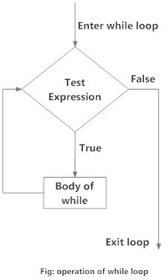2. The do statement.

3. The for statement.

**The while statement:**

Syntax:

*while (test condition)*

*{*

*body of the loop*

*}*

The *while*is an entry-controlled loop statement. The test-conditionis evaluated first then the body of the loop is executed until the condition become false.

**The do while statement:**

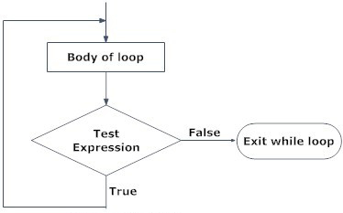Syntax:

*do*

*{*

*body of loop*

*}*

*while (test-condition);*

The *d*o statement is exit controlled loop where, first the body of looping is executed and then at the end of the loop, the test condition in the whilestatement is evaluated.

Fig:operation of do while loop

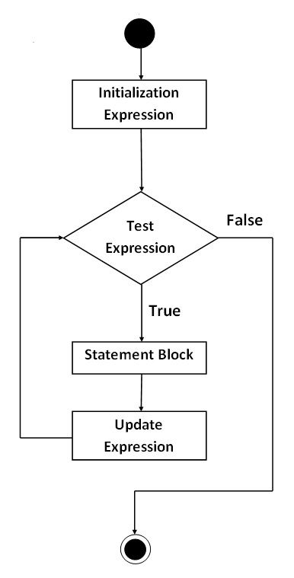**The for statement:**

For loop is the entry-controlled loop. Syntax:

*for ( initialization; test-condition; increment)*

*{*

*body of the loop*

*}*

The for statement is used to execute a code for fixed number of repititions. Here, initialization is to set up loop control variable. Test expressions determines when loop exists. Update expression defines how loop variable changes in each repetition.

**Jump Statement**:

The jump statement unconditionally transfers program control one point to another point in a  program. They are:

1. The goto statement

2. The break Statement:  The break statement enables a program to skip over part of the codes. It terminates the smallest enclosing while, do-while, for or switch statement and skips the rest of the loop and jumps over to the statement following  the loop.

3. The continue Statement:

The continue is another jump statement like the break statement.. It skips the rest of the loop statements and causes the next iteration of the  loop.

For the *for*loop, continuecauses the next iteration by updating the variable and then causing the  test-expression’s evaluation. For the *while* and *do-while*loops, the program control passes to the  conditional tests.

**Code and output:**

**LAB -5**

Compiler used= TURBO C and GDB compiler & debugger

**Q.1.a To print the ASCII value.**

Algorithm and flowchart: 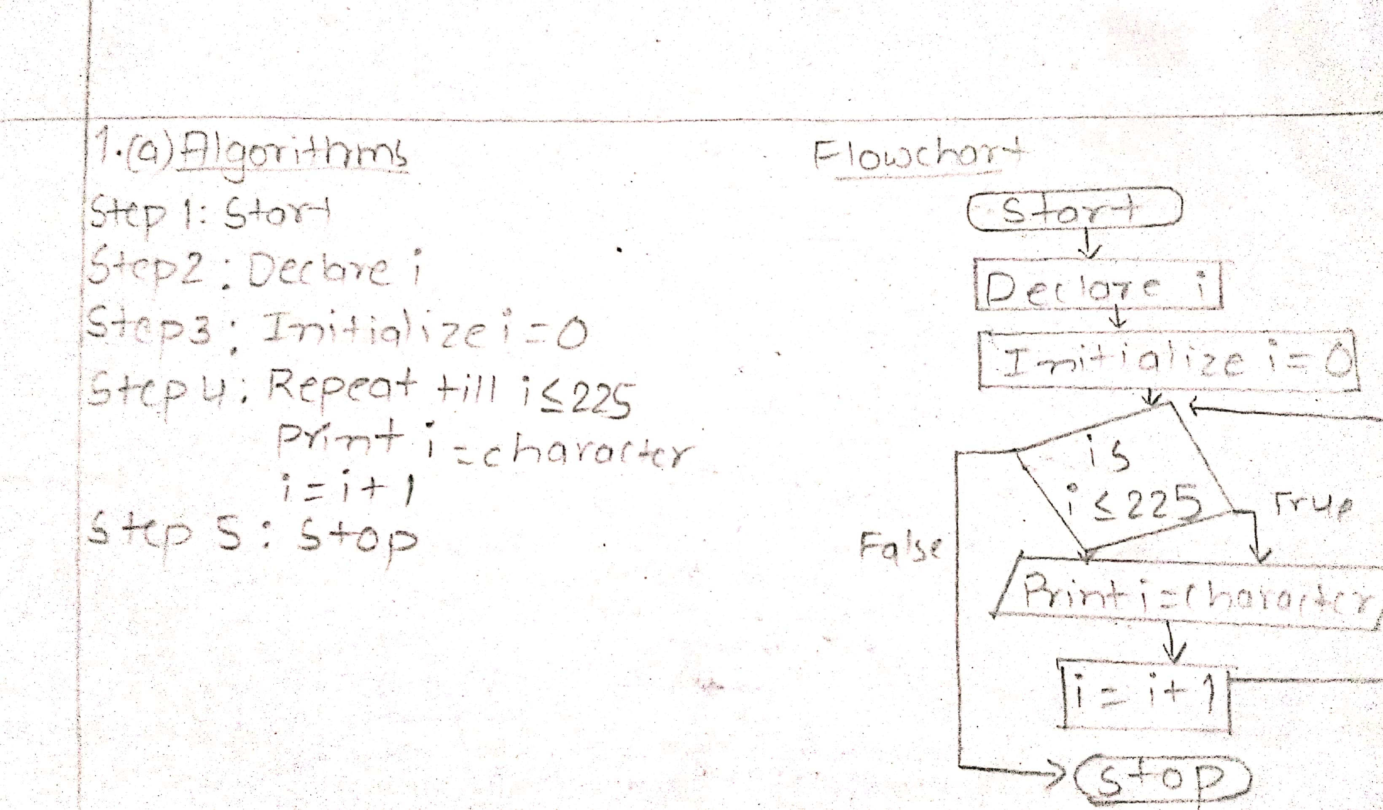

Source code:

*#include<stdio.h>*

*#include<conio.h>*

*int main()*

*{*

*int i;*

*for(i=0;i<=225;i++)*

*printf("%d=%c\t",i,i);*

*getch();*

*return 0;*

*}*

Output:

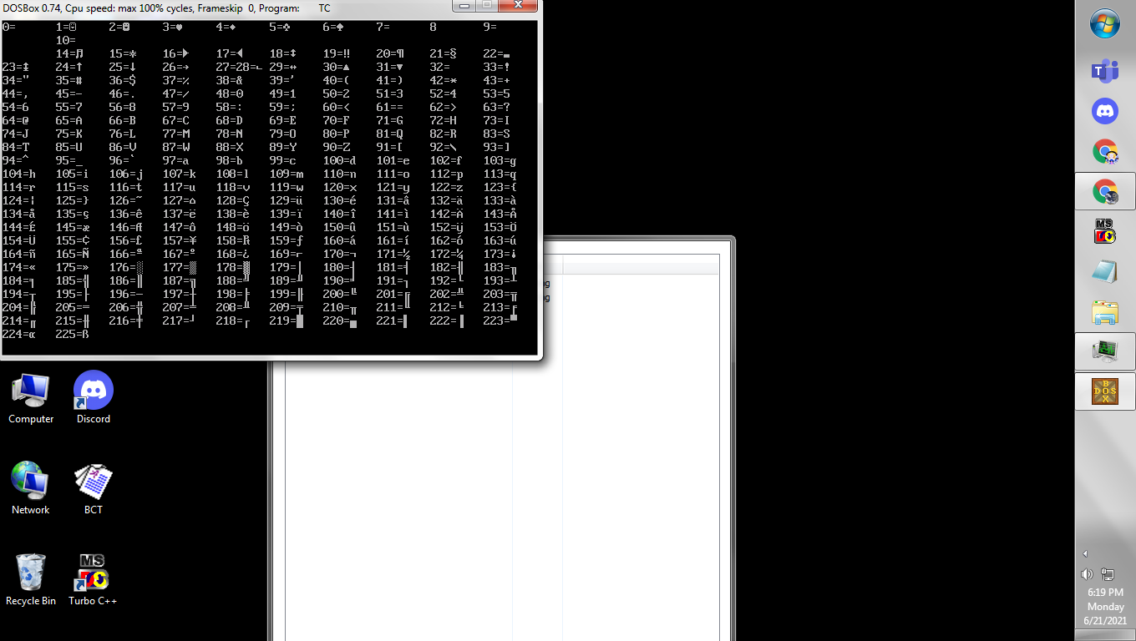

**Q.1.b To resign valuable of same variable in a program.**

Algorithm and flowchart: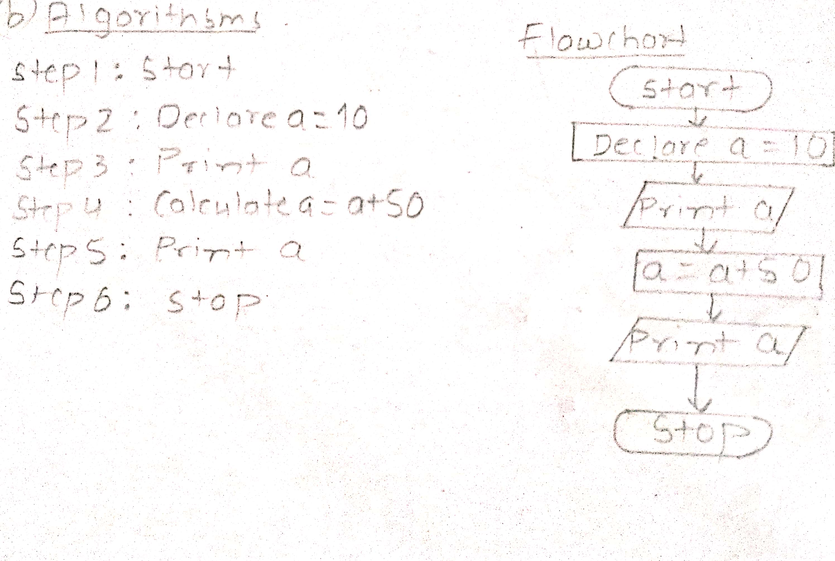

Source code:

*#include<stdio.h>*

*#include<conio.h>*

*int main()*

*{*

*int a=10;*

*printf("%d\n",a);*

*a=a+50;*

*printf("%d",a);*

*return 0;*

*}*

Output:

10

60

**Q.2 To read unsigned integer and display from 1 to n and n to 1.**

Algorithm and flowchart: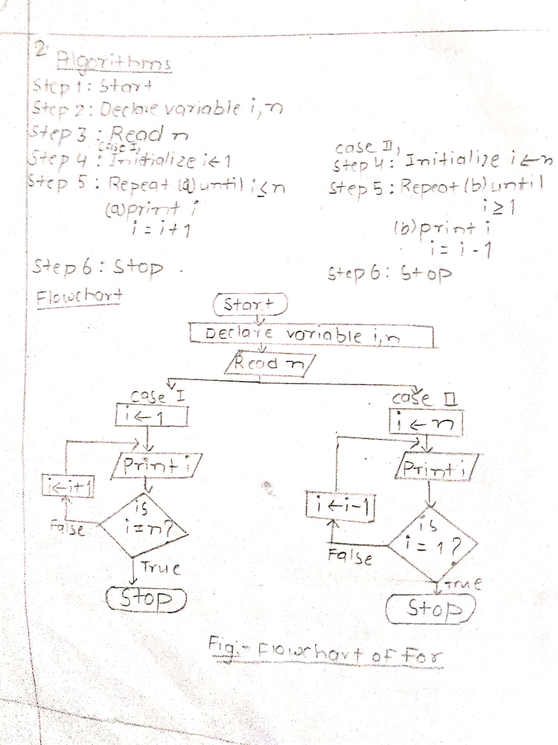

Source code:

*#include<stdio.h>*

*#include<conio.h>*

*int main()*

*{*

*unsigned int i,n;*

*printf(" enter any unsigned integer");*

*scanf("%u",&n);*

*for(i=1;i<=n;i++)*

*printf("%d\n",i);*

*printf("the reversed list is\n");*

*for(i=n;i>=1;i--)*

*printf("%d\n",i);*

*getch();*

*}*

Output:

enter any unsigned integer 9

1

2

3

4

5

6

7

8

9

the reversed list is

9

8

7

6

5

4

3

2

1

**Q.3 To display sum of even numbers from 1 to n.**

Algorithm and flowchart:

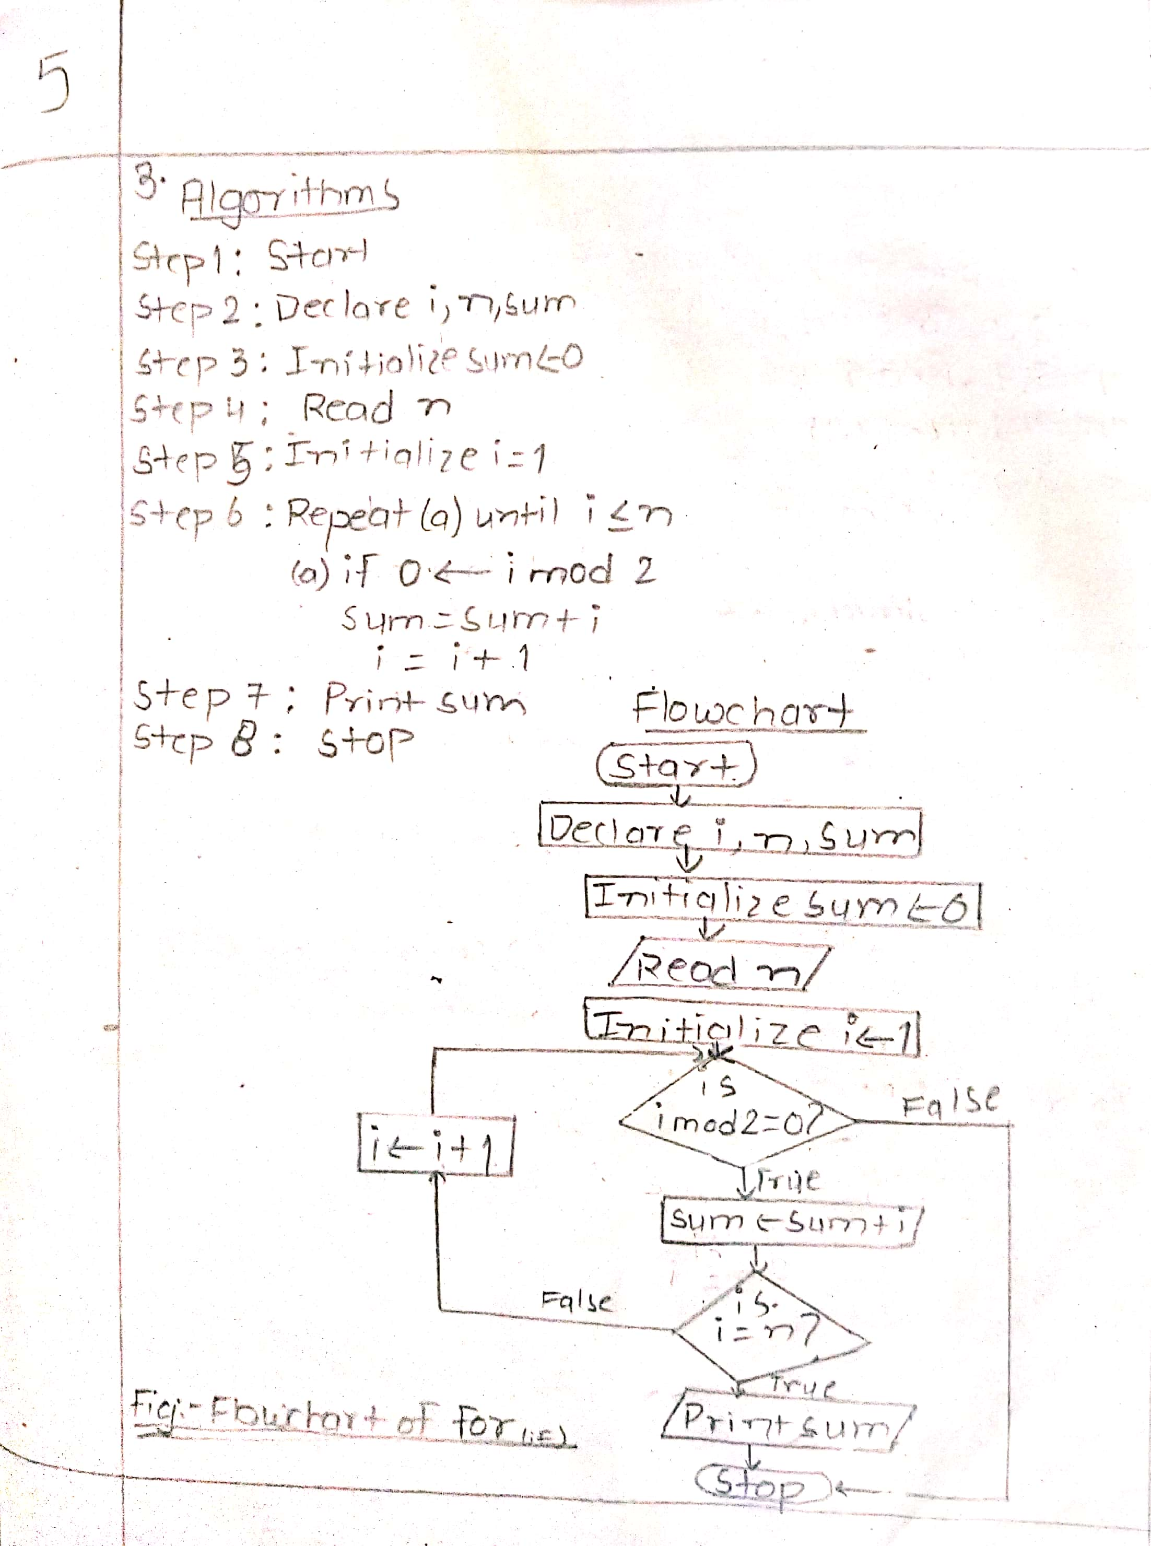

Source code:

*#include<stdio.h>*

*#include<conio.h>*

*void main()*

*{*

*int i,n,sum=0;*

*printf(" enter any integer");*

*scanf("%d",&n);*

*for(i=1;i<=n;i++)*

*{*

*if(i%2==0)*

*sum+=i;*

*}*

*printf("sum of even number is %d\n",sum);*

*getch();*

*}*

Output:

enter any integer 8

sum of even number is 20

**Q.4 To read integer and find product from 1 to n if n is even else find the sum from 0 to n.**

Algorithm and flowchart: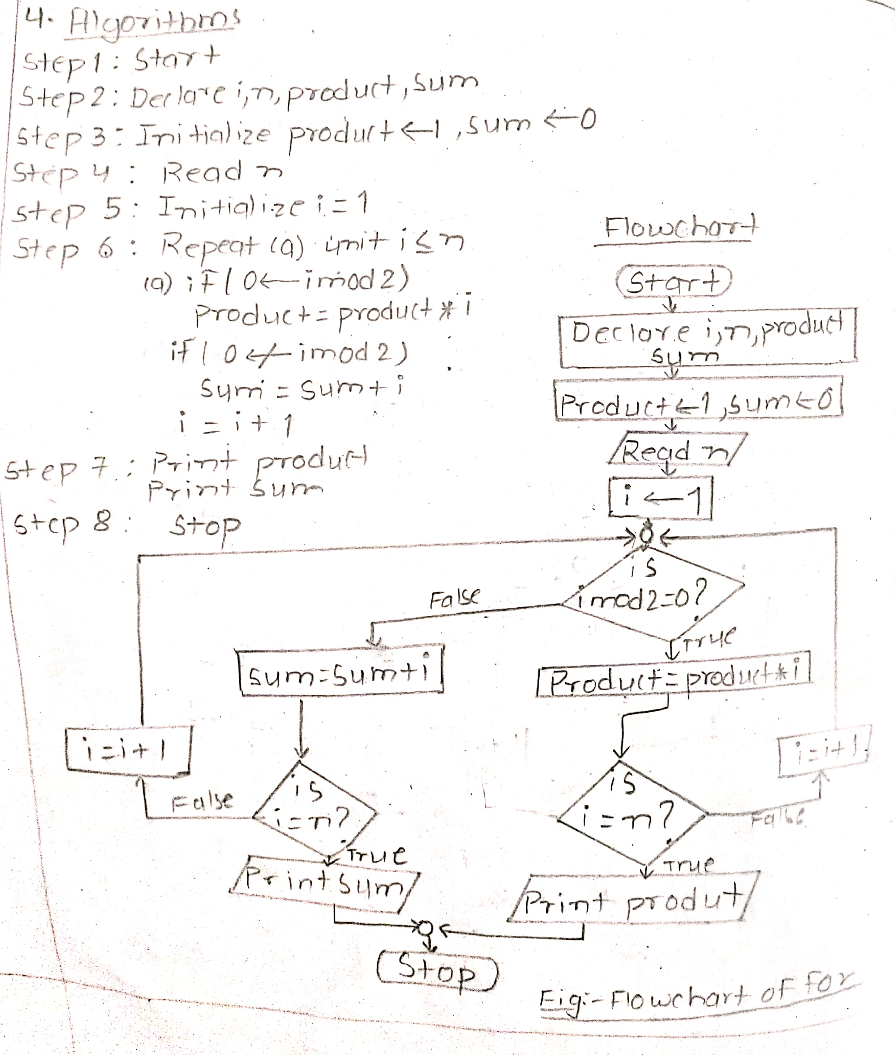

Source code:

*#include<stdio.h>*

*#include<conio.h>*

*void main()*

*{*

*int i,n, product=1,sum=0;*

*printf("Enter the integer ");*

*scanf("%d",&n);*

*if(n%2==0)*

*{*

*for(i=1;i<=n;i++)*

*product*=i;*

*printf("The product form 1 to %d is %d \n",n,product);*

*}*

*if(n%2!=0)*

*{*

*for(i=1;i<=n;i++)*

*sum+=i;*

*printf("The sum from 0 to %d is %d \n",n,sum);*

*}*

*getch();*

*}*

Output:

Enter the integer 6

The product form 1 to 6 is 720

Enter the integer 7

The sum from 0 to 7 is 28

**Q.5 To read an integer and compute its factorial and display.**

Algorithm and flowchart:

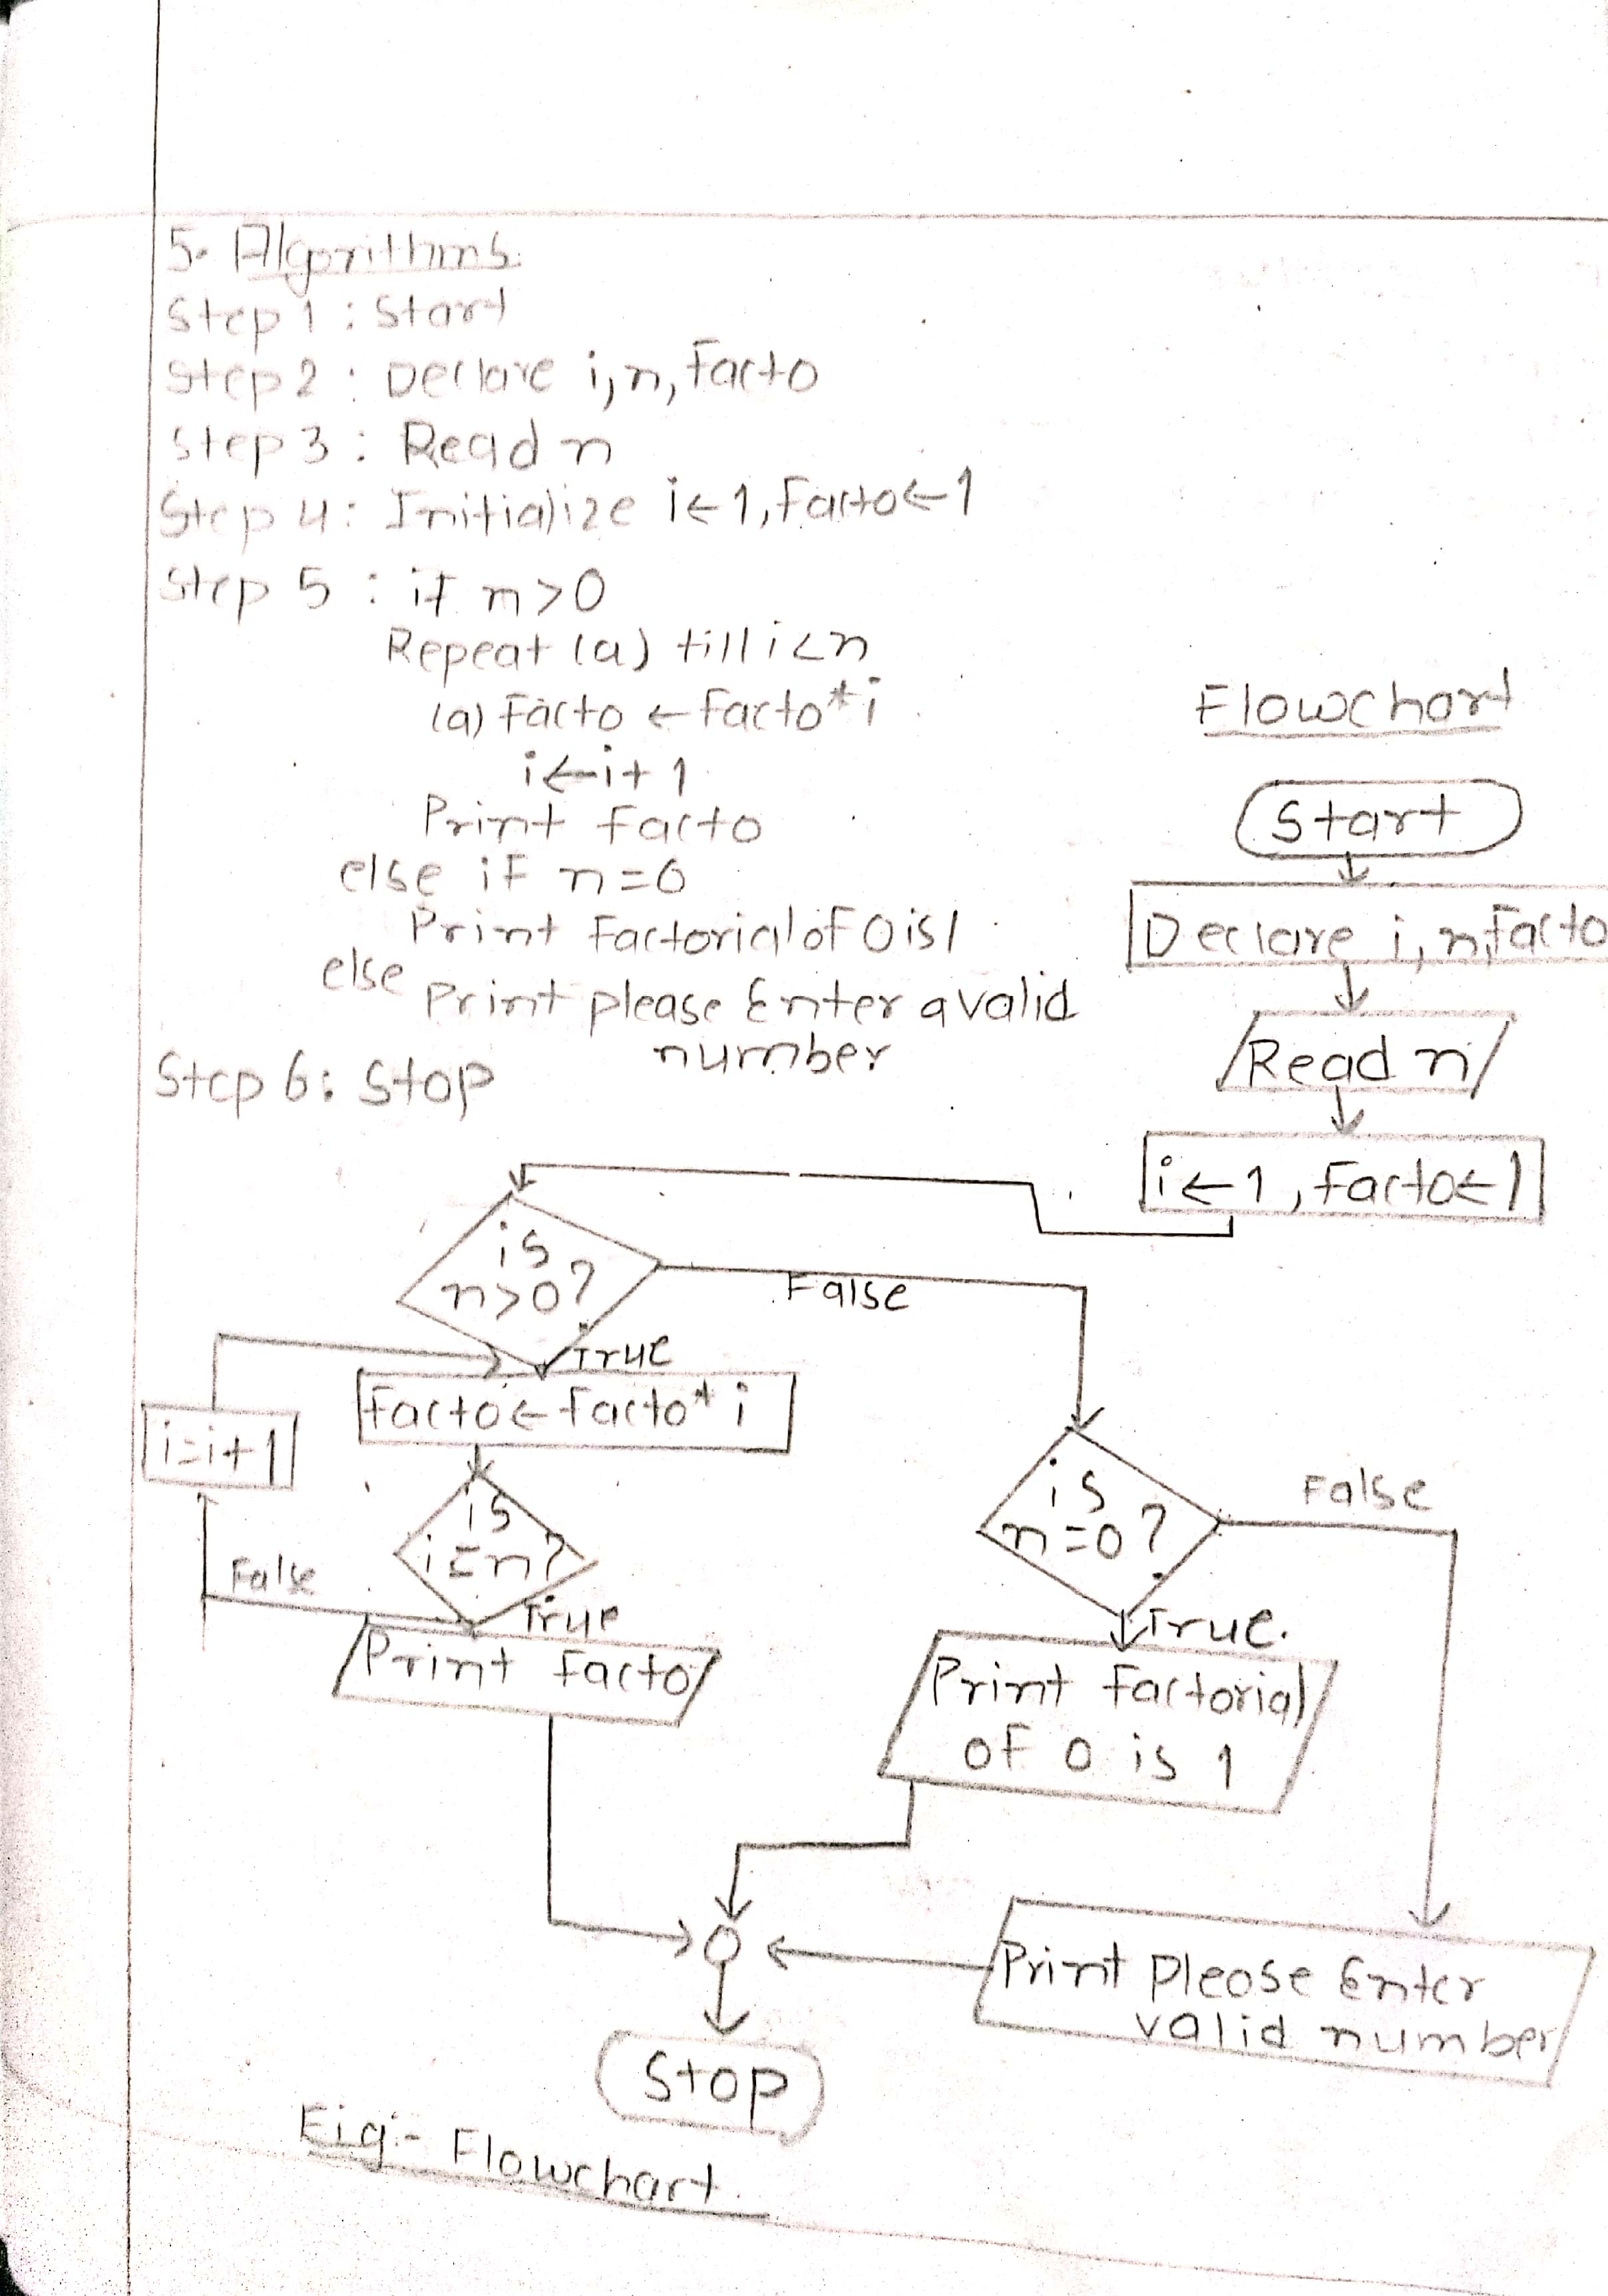

Source code:

*#include<stdio.h>*

*#include<conio.h>*

*void main()*

*{*

*int i,n,facto=1;*

*printf(" enter integer to compute its factorial ");*

*scanf("%d",&n);*

*if(n>0)*

*{*

*for(i=1;i<=n;i++)*

*facto=facto*i;*

*printf("the factorial of given integer is %d\n",facto);*

*}*

*else if(n==0)*

*printf("the factorial of 0 is 1");*

*else*

*printf("please Enter a valid number");*

*getch();*

*}*

Output:

enter integer to compute its factorial 6

the factorial of given integer is 720

enter integer to compute its factorial -24

please Enter a valid number

**Q.6 To calculate x^n/n!.**

Algorithm and flowchart:

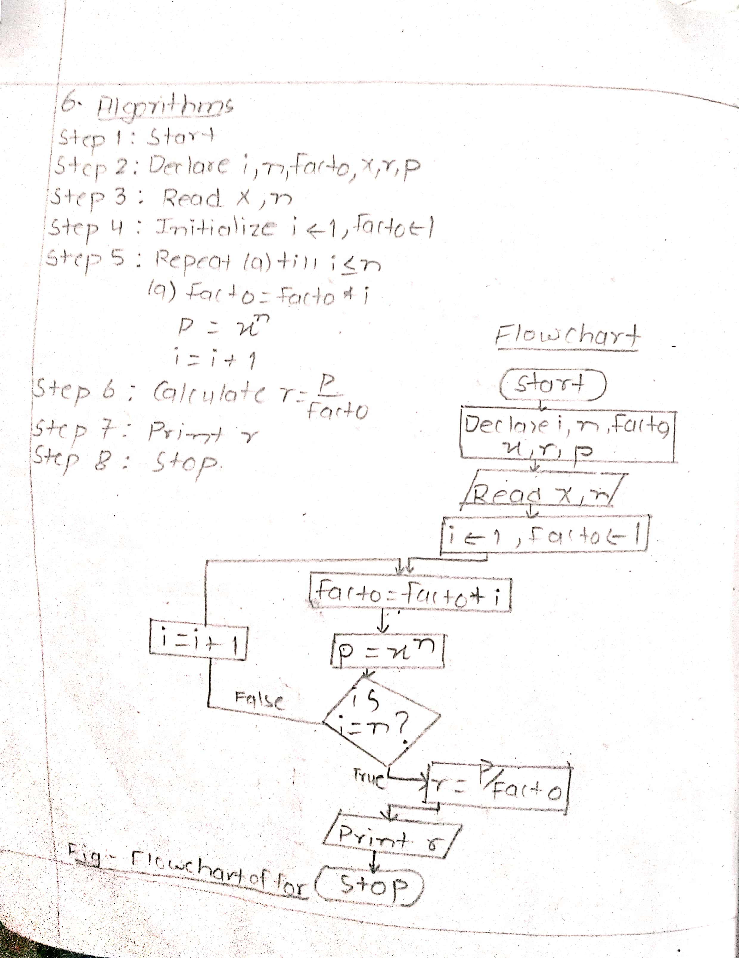

Source code:

*#include<stdio.h>*

*#include<conio.h>*

*#include<math.h>*

*void main()*

*{*

*int i,n,facto=1;*

*float x,r,p;*

*printf("enter the value of x and n ");*

*scanf("%f%d",&x,&n);*

*for(i=1;i<=n;i++)*

*{*

*facto*=i;*

*p=pow(x,n);*

*}*

*r=p/facto;*

*printf("the value is %f",r);*

*getch();*

*}*

Output:

enter the value of x and n 4 8

the value is 1.625397

**Q.7 To display Fibonacci sequence.**

Algorithm and flowchart:

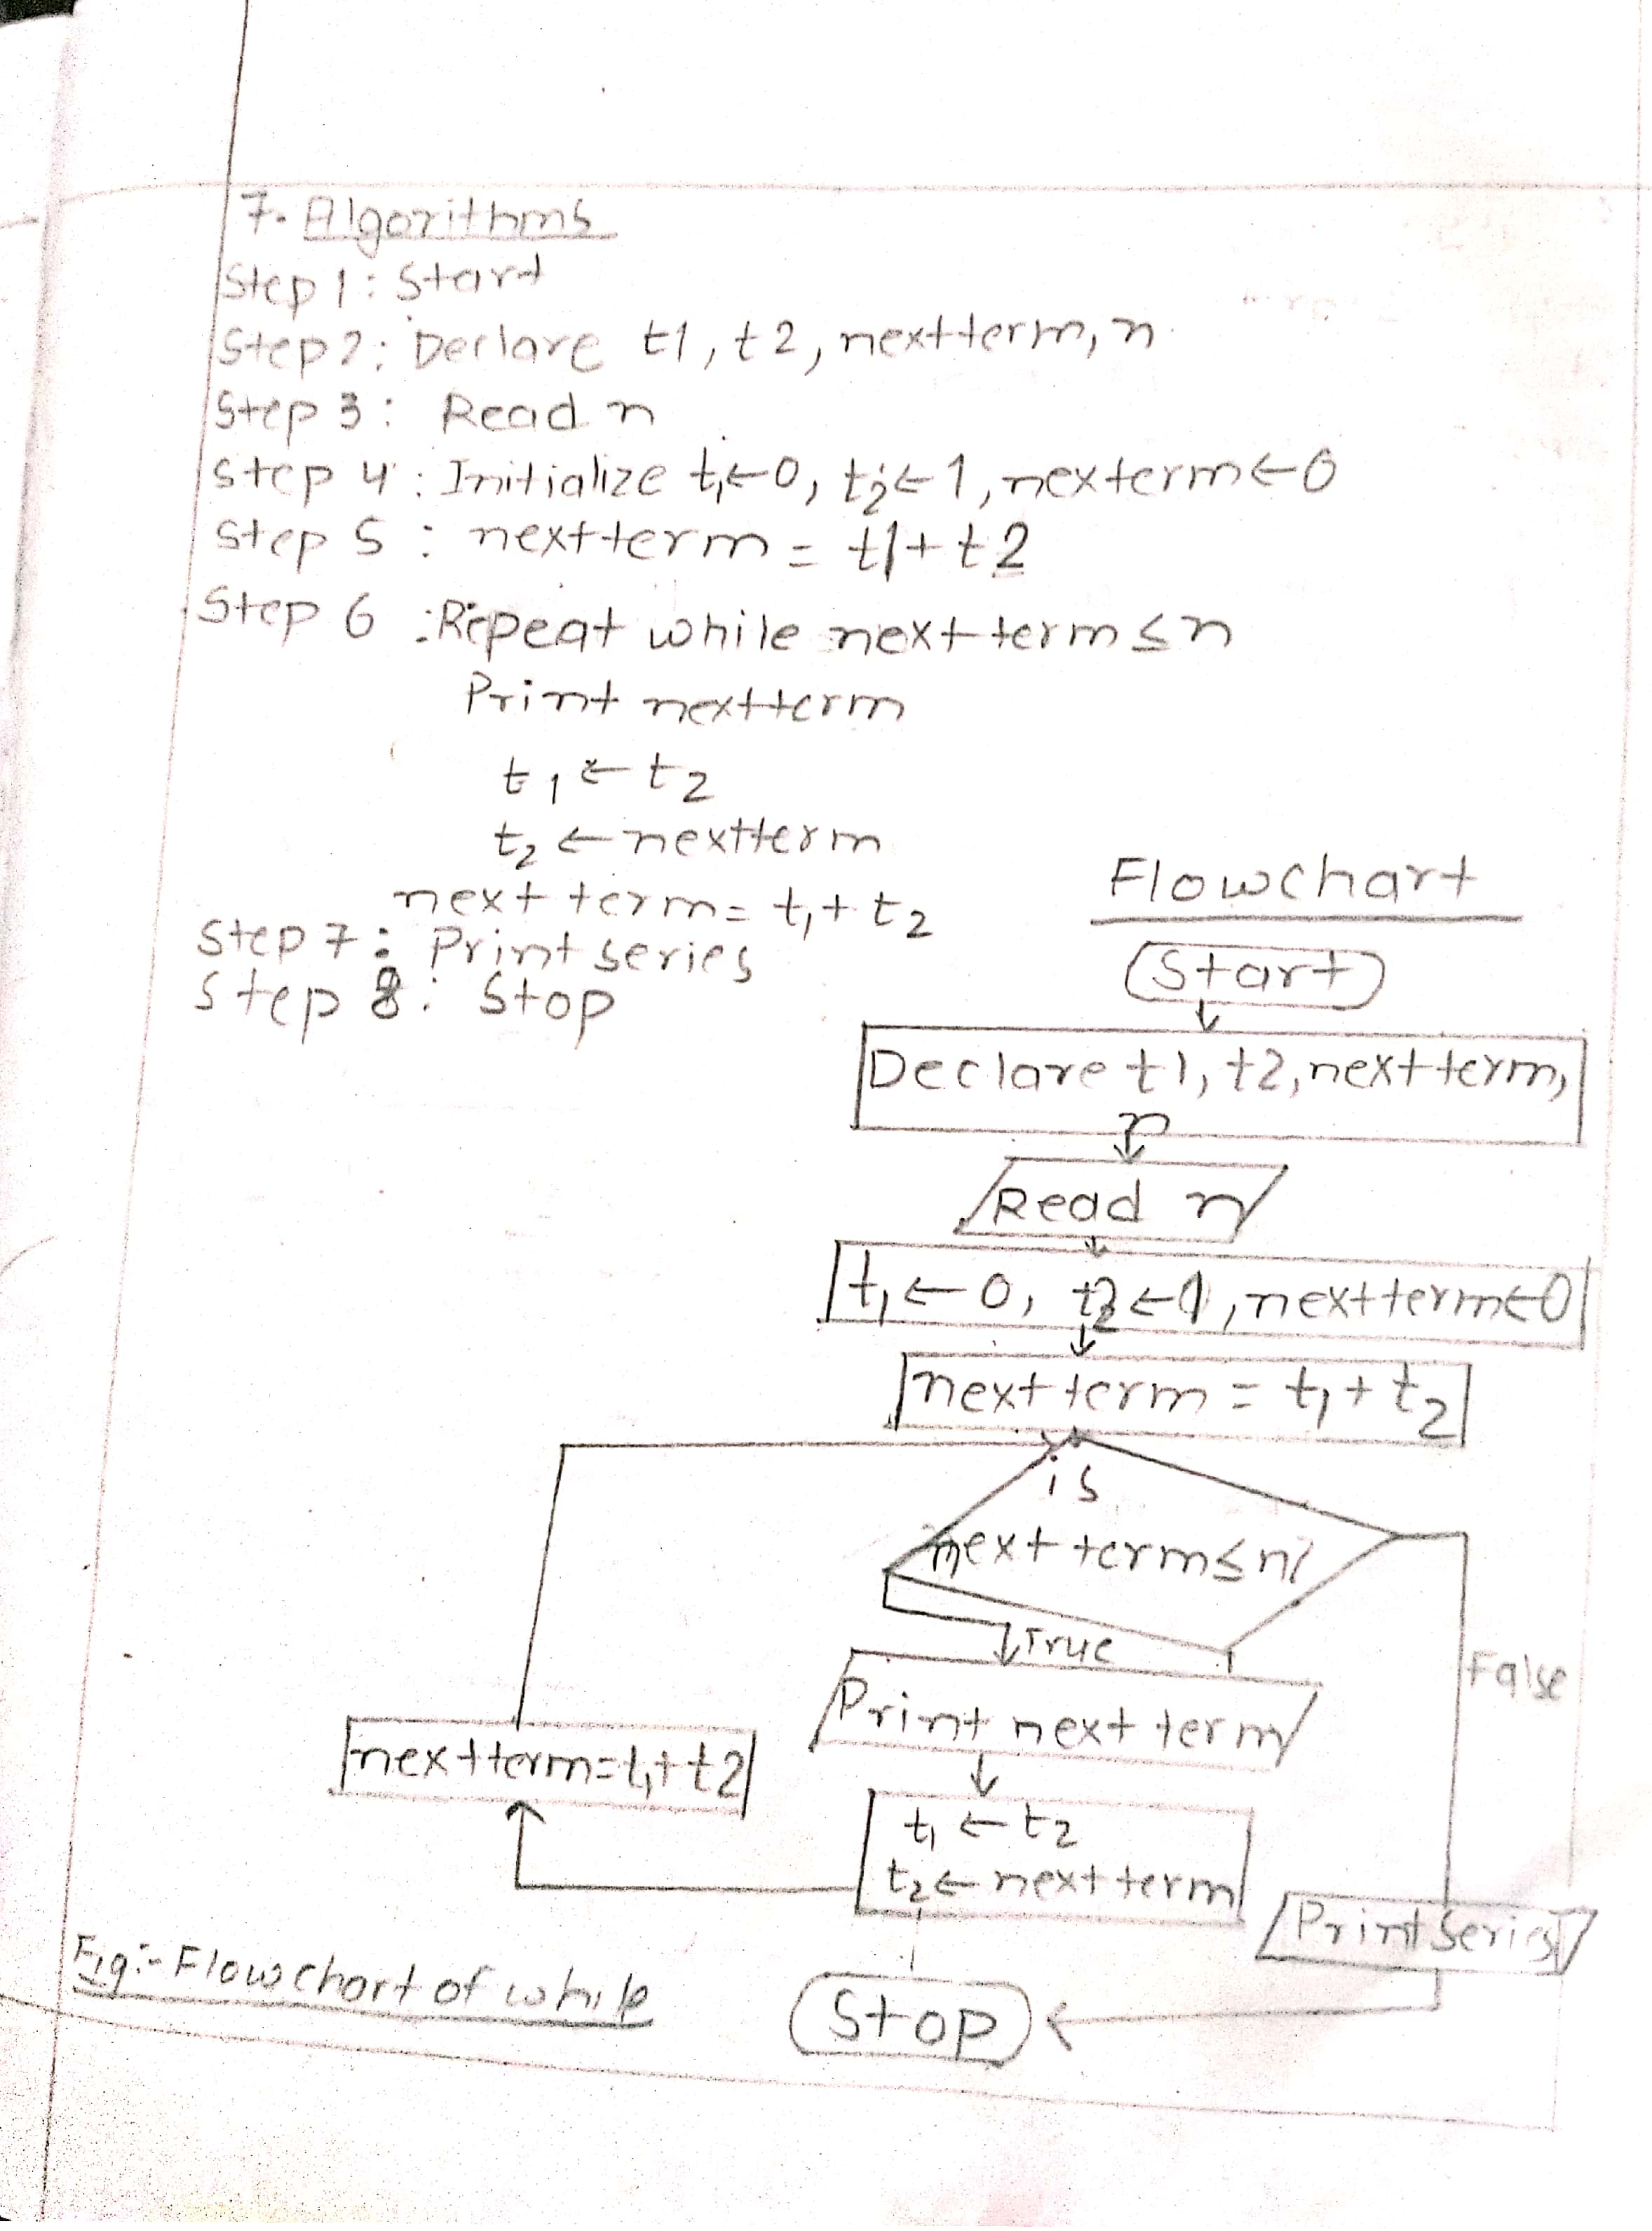

Source code:

#*include<stdio.h>*

*#include<conio.h>*

*void main()*

*{*

*int i,t1=0,t2=1,tn,n;*

*printf("Enter the number of terms in fibonacci series ");*

*scanf("%d",&n);*

*printf("%d \t %d \t",t1,t2);*

*for(i=1;i<=n-2;i++) {*

*tn=t1+t2;*

*printf("%d\t",tn);*

*t1=t2;*

*t2=tn;*

*}*

*getch();*

*}*

Output:

Enter the number of terms in fibonacci series 8

0 1 1 2 3 5 8 13

**Q.8 To read positive integer and find sum of digits in it.**

Algorithm and flowchart: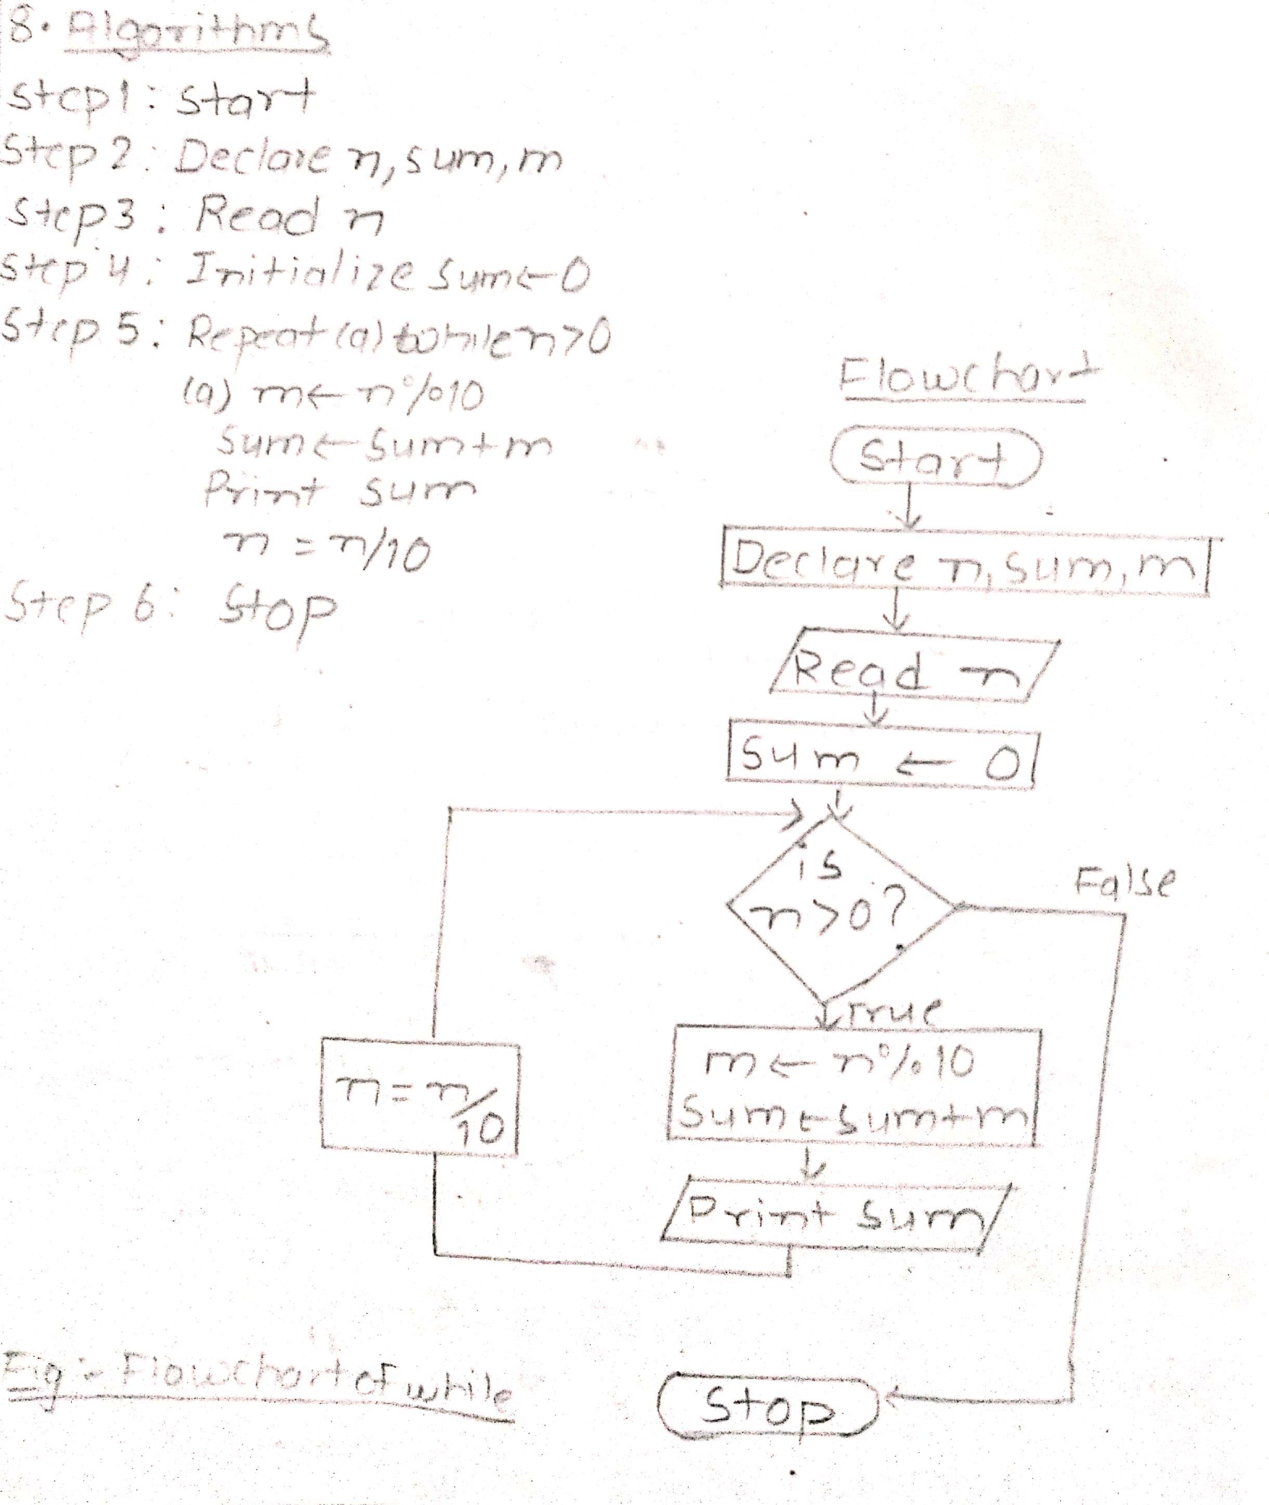

Source code:

*#include<stdio.h>*

*#include<conio.h>*

*int main()*

*{*

*int n,sum=0,m;*

*printf("Enter a number:");*

*scanf("%d",&n);*

*while(n>0)*

*{*

*m=n%10;*

*sum=sum+m;*

*n=n/10;*

*}*

*printf("Sum is=%d",sum);*

*return 0;*

*}*

Output:

Enter a number:769

Sum is=22

**Q.9.a To check whether integer is palndrome number or not.**

Algorithm and flowchart:

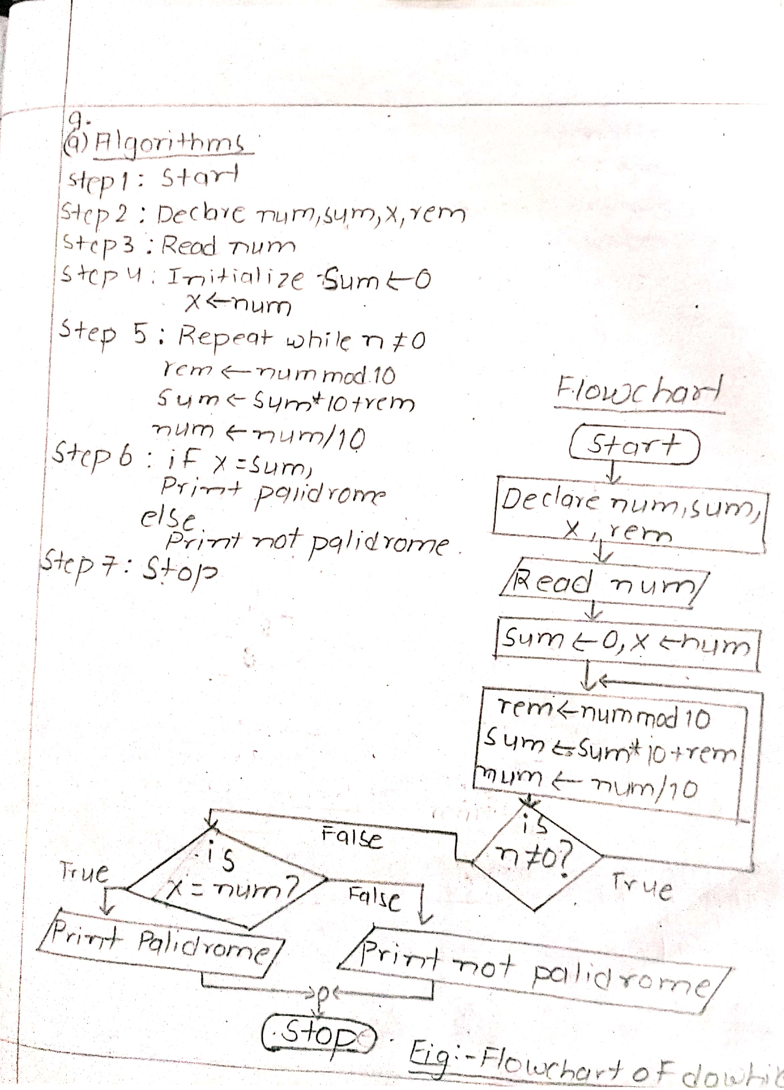

Source code:

*#include<stdio.h>*

*#include<conio.h>*

*void main()*

*{*

*int num,sum=0,x,rem;*

*printf("\n enter any integer number");*

*scanf("%d",&num);*

*x=num;*

*do*

*{*

*rem=num%10;*

*sum= sum*10+rem;*

*num=num/10;*

*}*

*while(num!=0);*

*if(x==sum)*

*printf("palidrome");*

*else*

*printf("not palidrome");*

*getch();*

*}*

Output:

enter any integer number656

palidrome

enter any integer number563

not palidrome

**Q.9.b To check whether integer is Amstrong or not.**

Algorithm and flowchart:

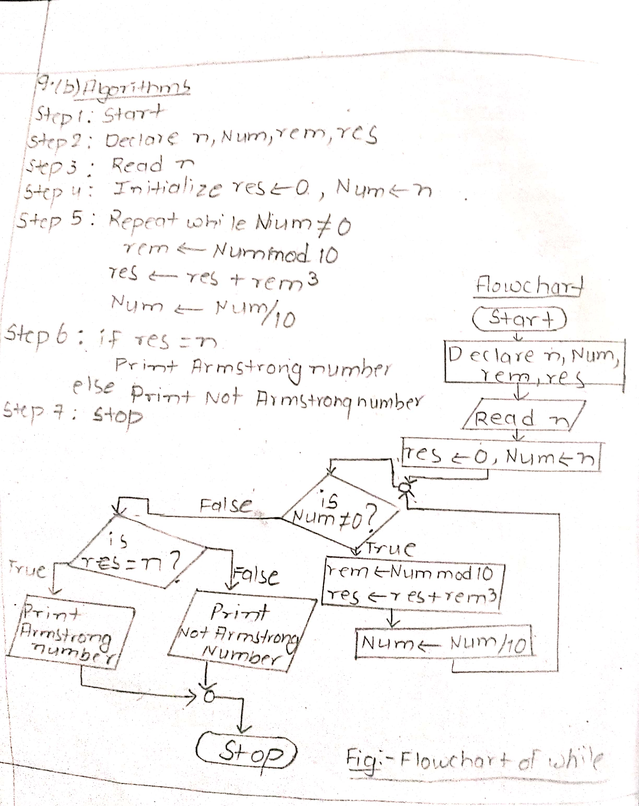

Source code:

*#include <stdio.h>*

*#include<conio.h>*

*int main() {*

*int n, Num, rem, res = 0;*

*printf("Enter a three-digit integer: ");*

*scanf("%d", &n);*

*Num = n;*

*while (Num != 0) {*

*rem = Num % 10;*

*res += rem * rem * rem;*

*Num /= 10;*

*}*

*if (res == n)*

*printf("%d is an Armstrong number.", n);*

*else*

*printf("%d is not an Armstrong number.", n);*

*return 0;*

*}*

Output:

Enter a three-digit integer: 281

281 is not an Armstrong number.

Enter a three-digit integer: 371

371 is an Armstrong number.

**Q.9.c To check whether integer is Prime or not.**

Algorithm and flowchart:

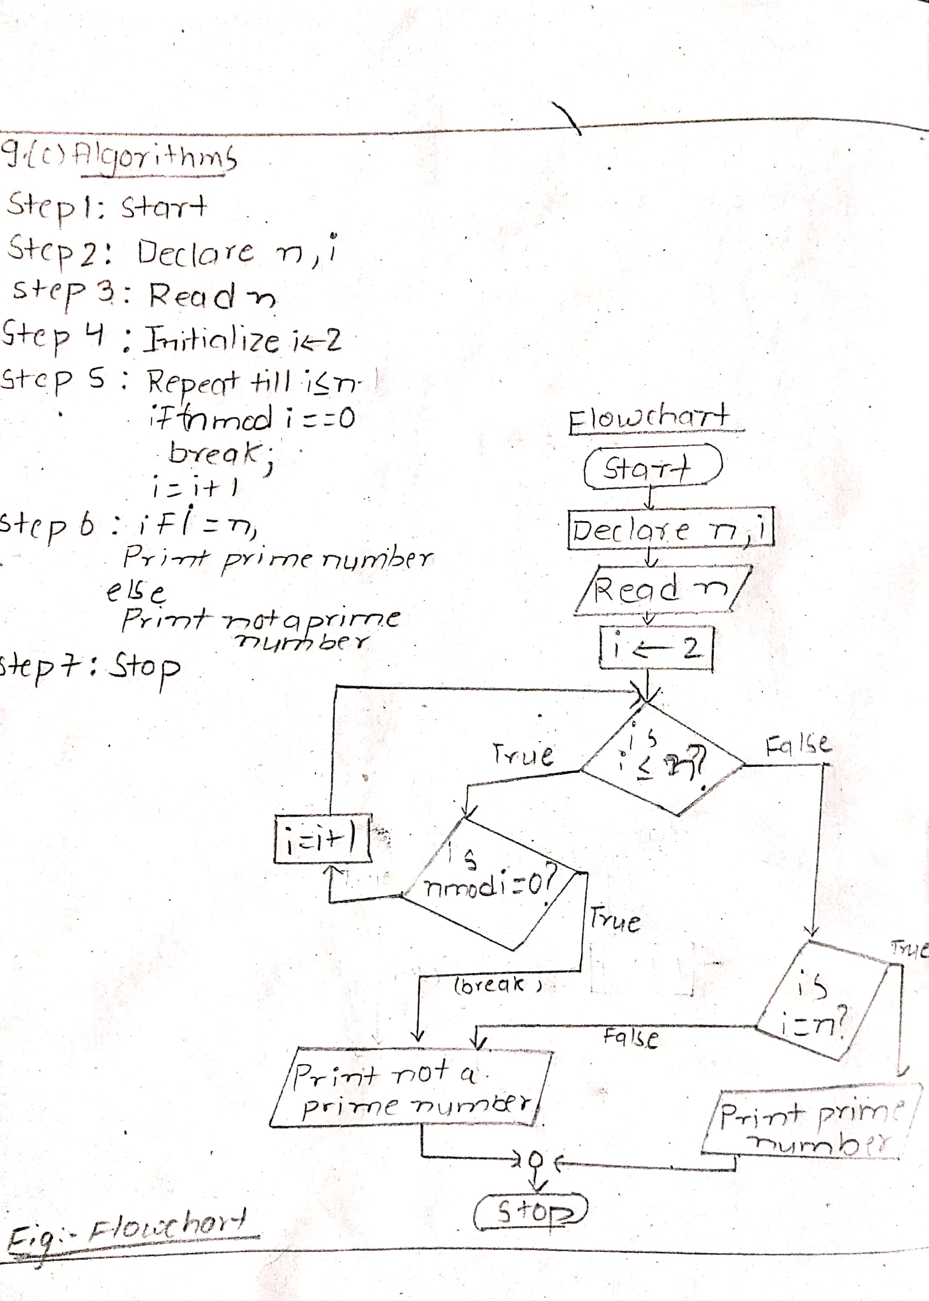

Source code:

*#include <stdio.h>*

*#include<conio.h>*

*int main()*

*{*

*int n,i;*

*printf("Enter the number ");*

*scanf("%d",&n);*

*for(i=2;i<=n;i++)*

*{ if(n%i==0)*

*break;*

*}*

*if(i==n)*

*printf("prime number",n);*

*else*

*printf(" Not a prime number",n);*

*return 0;*

*}*

Output:

Enter the number 4

Not a prime number

Enter the number 7

prime number

**Q.9.d To check whether integer is Twin prime or not.**

Algorithm and flowchart: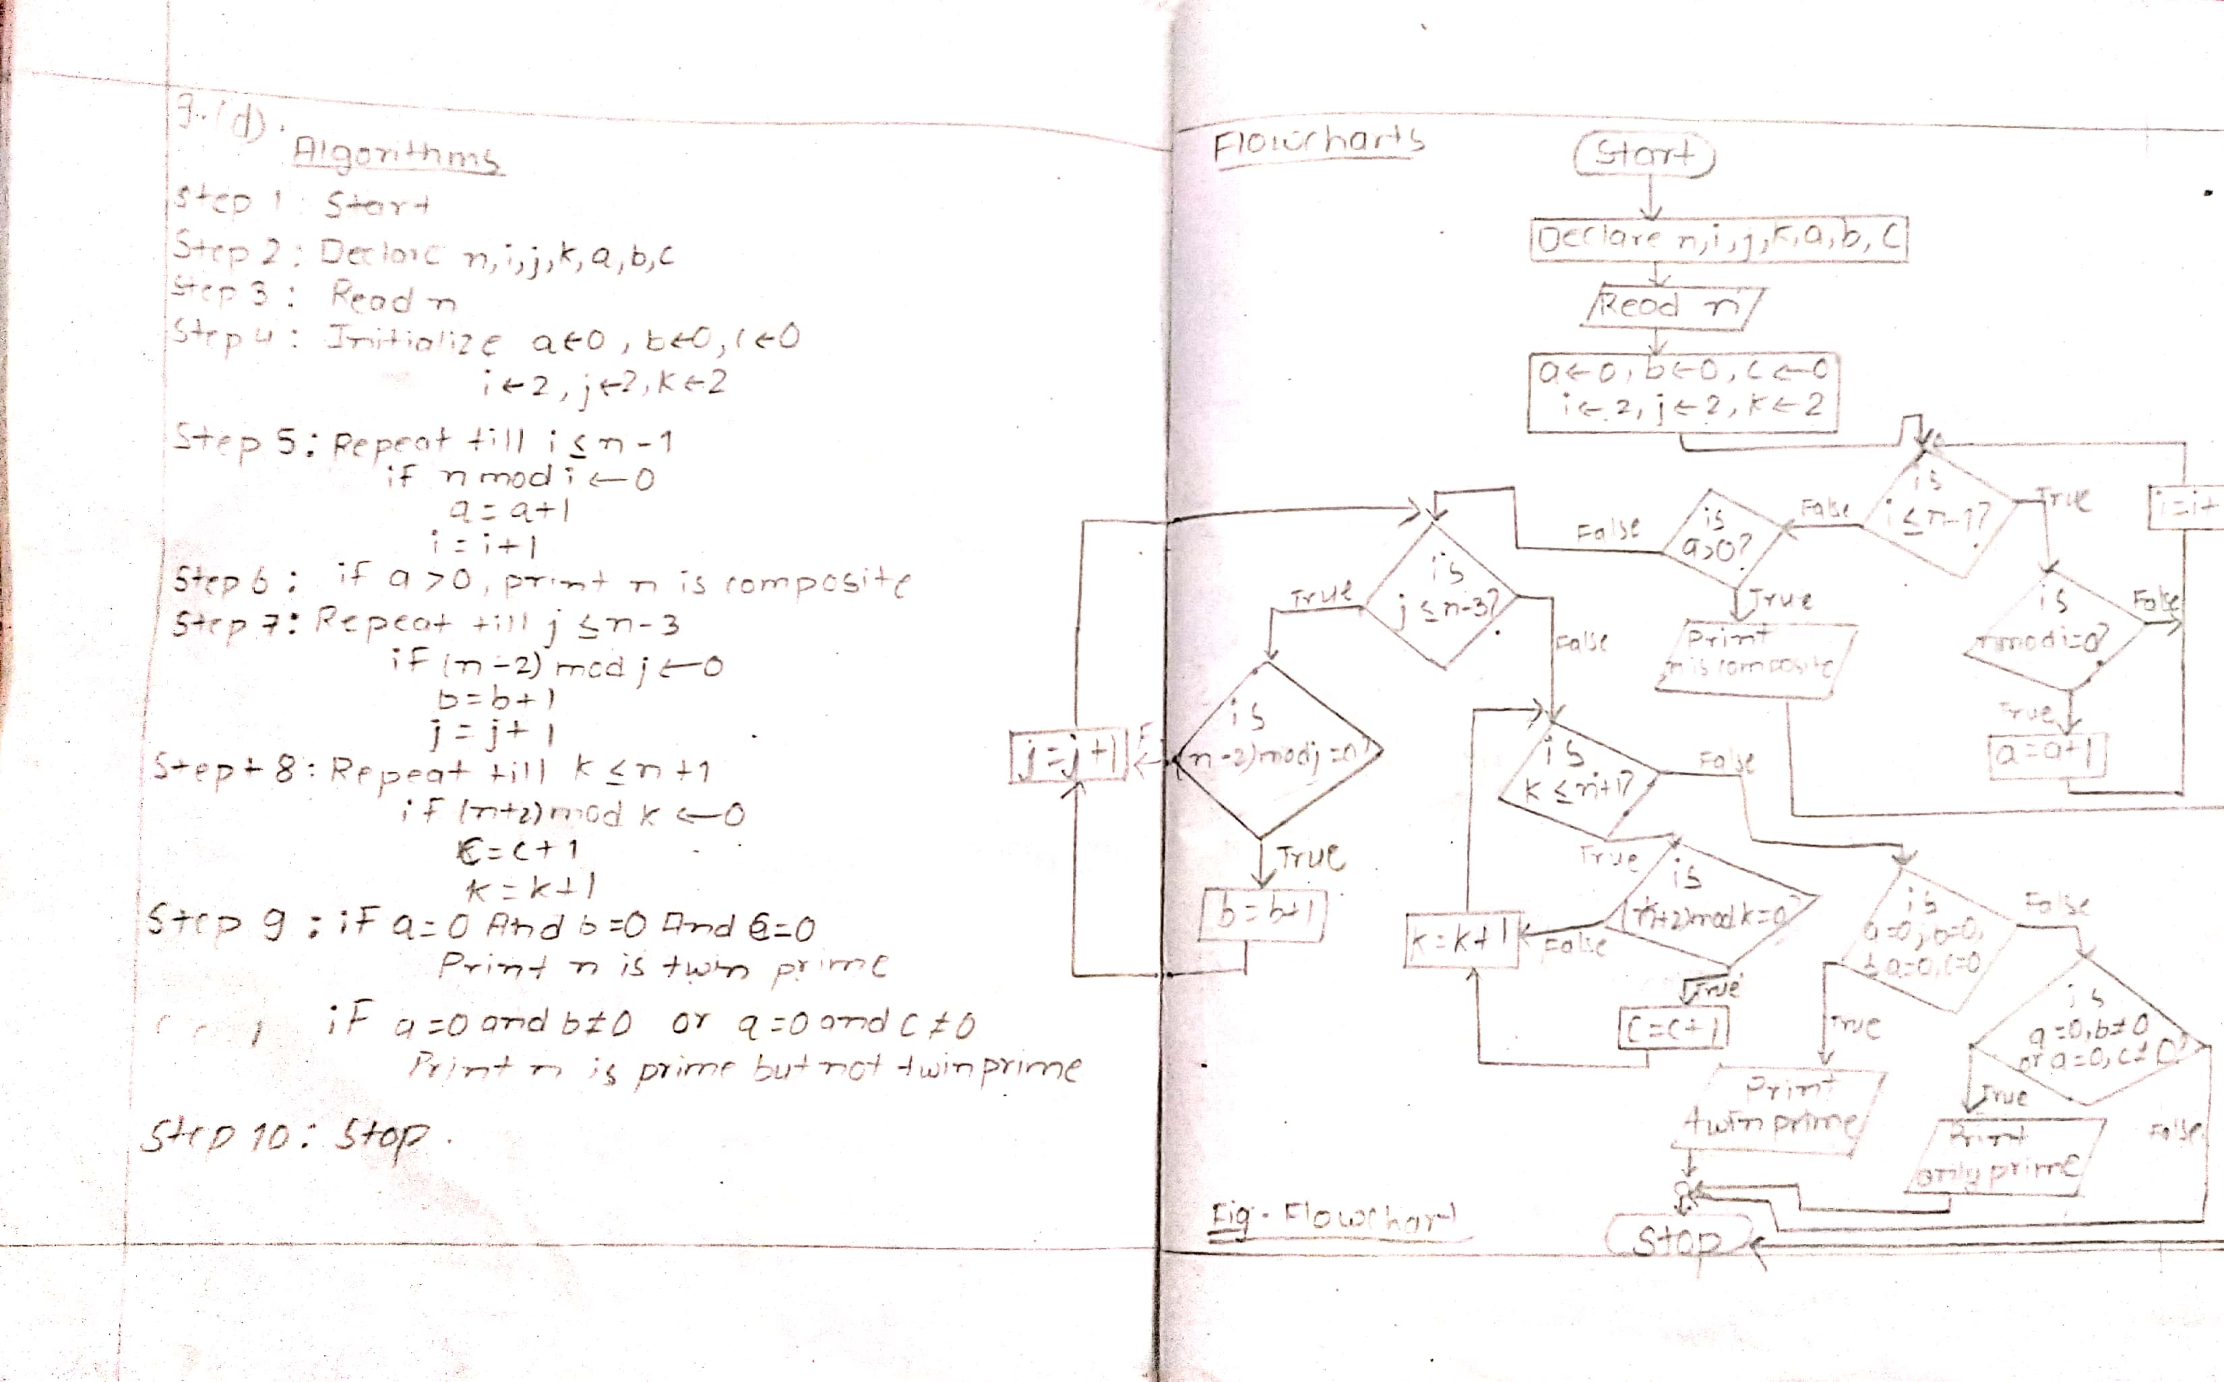

Source code:

*include<stdio.h>*

*#include<conio.h>*

*void main()*

*{*

*int n,i,j,k,a=0,b=0,c=0;*

*printf("Enter any number \n");*

*scanf("%d",&n);*

*for(i=2;i<=(n-1);i++)*

*{*

*if(n%i==0)*

*a=a+1;*

*}*

*if(a>0)*

*printf("%d is Composite number",n);*

*for(j=2;j<=(n-3);j++)*

*{*

*if((n-2)%j==0)*

*b=b+1;*

*}*

*for(k=2;k<=(n+1);k++)*

*{*

*if((n+2)%k==0)*

*c=c+1;*

*}*

*if(a==0&&b==0&&a==0&&c==0)*

*printf("%d is a twin prime number",n);*

*if(a==0&&b!=0||a==0&&c!=0)*

*printf("%d is prime but not twin prime",n);*

*getch();*

*}*

Output:

Enter any number

3

3 is a twin prime number

Enter any number

7

7 is prime but not twin prime

**Q.10 To read number and display its multiplication table upto 10.**

Algorithm and flowchart:

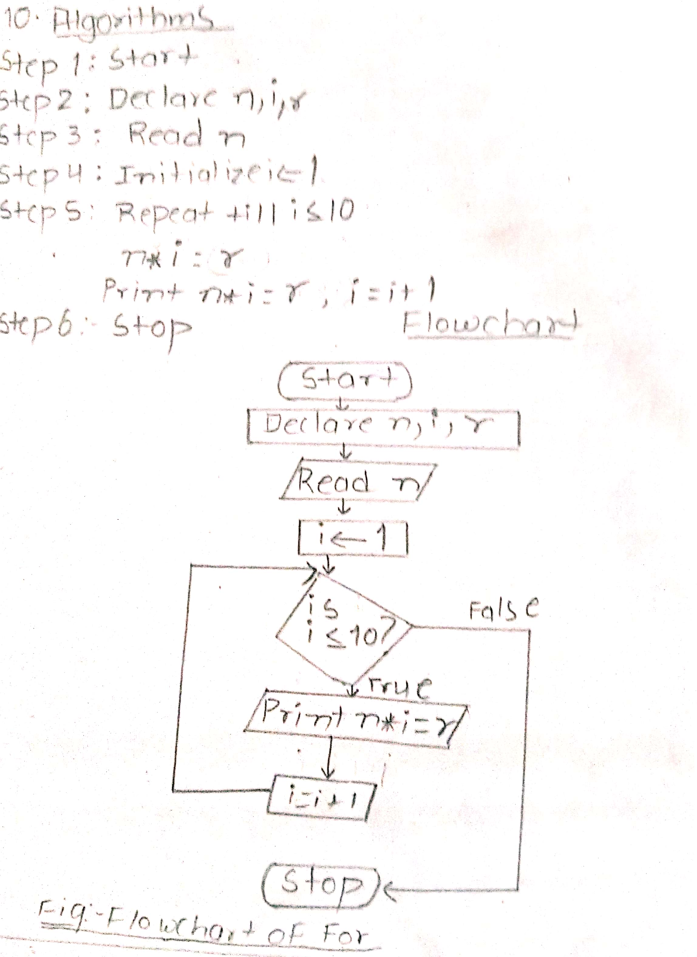

Source code:

*#include <stdio.h>*

*#include<conio.h>*

*int main()*

*{*

*int n,i;*

*printf("Enter a integer: ");*

*scanf("%d", &n);*

*for(i=1;i<=10;i++)*

*printf("%d * %d = %d\n",n,i,n*i);;*

*getch();*

*}*

Output:

Enter a integer: 7

7 * 1 = 7

7 * 2 = 14

7 * 3 = 21

7 * 4 = 28

7 * 5 = 35

7 * 6 = 42

7 * 7 = 49

7 * 8 = 56

7 * 9 = 63

7 * 10 = 70

**Analysis and discussion**

Therfore, in lab 5 we learned about looping/iteraton. We also learned to print about ASCII value and about reassigning of value of variable in program(Q.1). similarly, we practised various probem related to *while*, *do while* and *fo*r loop,break statement. Also, we learned to program about Fibonacci series(Q7), Armstrong number, palindrome and prime number(Q.9) along with multiplication table by using various types of looping structure in C language.

**Conclusion**

Hence, in a conclusion we came to know more about looping structure and its flowchart. We understood the use of break statement and the application of various types of loopes according to the need of the problem.

**Thank you**



**TRIBHUVAN UNIVERSITY**

**INSTITUTE OF ENGINEERING**

**PULCHWOK CAMPUS**

**Subject**: C-Programming

**Experiment Number**: 6

**Title**: Nested Looping

**Date**: 2077/03/ 18

**Submitted By:**   **Submitted To:**

Name: Subham Shrestha Department of Electronics and Computer Engineering

Program: Bachelor in Computer Engineering

Section: C/D Checked By:

Roll: 077BCT082

**Contents of report**

**1. Background information**

Nested loops in C

1. Nested while loop
2. Nested do-while loop
3. Nested for loop

**2. Code and output**

1. Alogrithm and flowchart
2. Source code
3. output

**3. Analysis and discussion**

**4. Conclusion**

**Background Information**

**Nested Loops in C**

 Nesting of loops is the feature in C that allows the looping of statements inside another loop. Any number of loops can be defined inside another loop, i.e., there is no restriction for defining any number of loops.

Syntax of Nested loop

*Outer loop*

*{*

*Inner loop*

*{*

*inner loop statements.*

*}*

*outer loop statements.*

*}*

**1.Nested while loop**

The nested while loop means any type of loop which is defined inside the 'while' loop.

*while(condition)*

*{*

*while(condition)*

*{*

*inner loop statements.*

*}*

*outer loop statements.*

*}*

**2.Nested do..while loop**

The nested do..while loop means any type of loop which is defined inside the 'do..while' loop.

*do*

*{*

*do*

*{*

*inner loop statements.*

*}while(condition);*

*outer loop statements.*

*}while(condition);*

**3.Nested for loop**

The nested for loop means any type of loop which is defined inside the 'for' loop.

*for (initialization; condition; update)*

*{*

*for(initialization; condition; update)*

*{*

*inner loop statements.*

*}*

*outer loop statements.*

*}*

**Code and output**

Compiler used: GDB compiler and debugger

**Q.1 To print a multiplication table of M x N.**

Flowchart

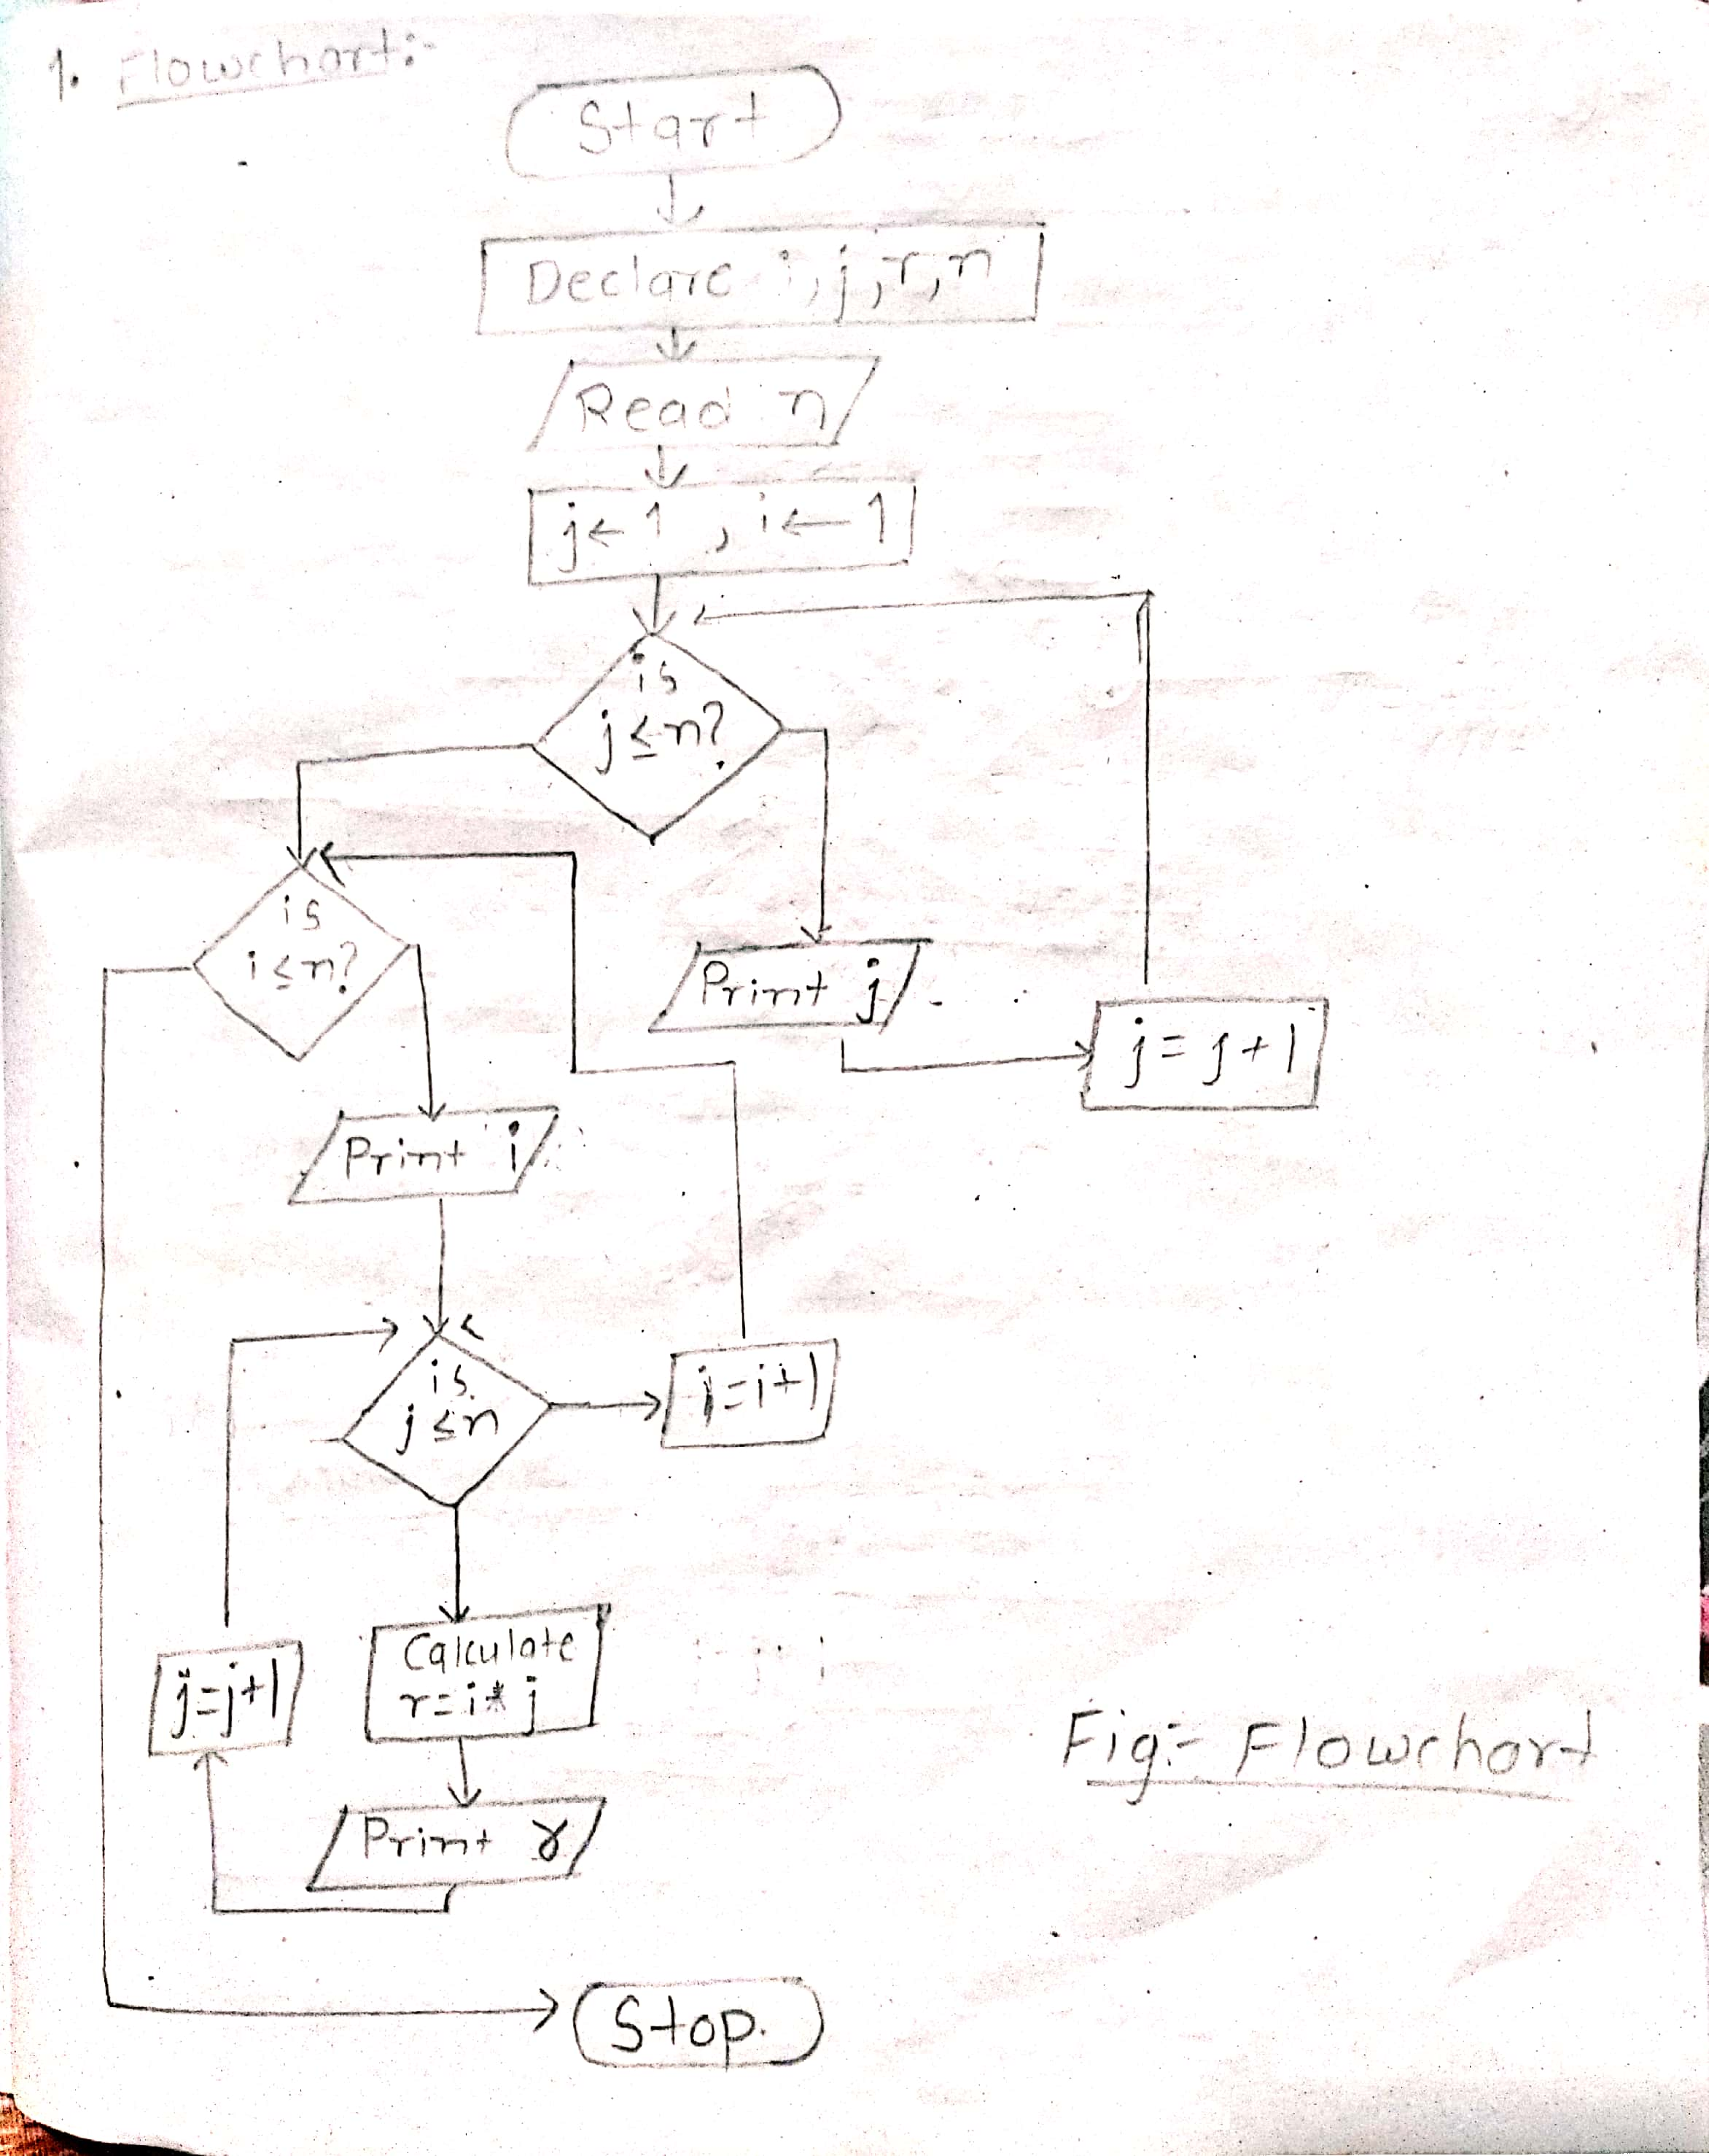

Source code:

*#include <stdio.h>*

*#include <conio.h>*

*void main()*

*{*

*int i, j, r, n;*

*printf("\nEnter Multiplication Table Size: ");*

*scanf("%d",&n);*

*printf("\n");*

*for (j = 1; j <= n; j++)*

*printf("%3dx", j);*

*for (i = 1; i <= n; i++)*

*{*

*printf("\n%2dx",i);*

*for (j = 1; j <= n; j++) {*

*r = i * j;*

*printf("%3d", r);*

*}*

*}*

*getch ();*

*}*

Output:

Enter Multiplication Table Size: 4

1x 2x 3x 4x

1x 1 2 3 4

2x 2 4 6 8

3x 3 6 9 12

4x 4 8 12 16

**Q.2 To print Chessboard pattern.**

Flowchart:

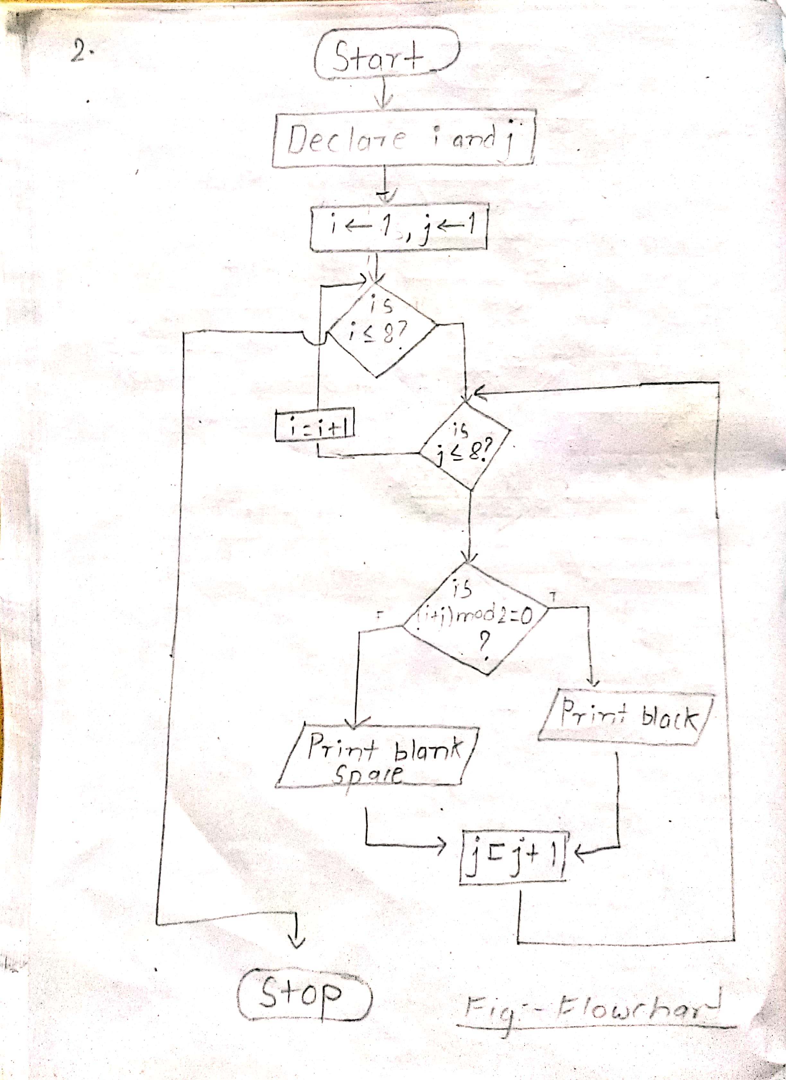

Source code:

*#include<stdio.h>*

*#include<conio.h>*

*void main()*

*{*

*int i,j;*

*for(i=1;i<=8;i++) {*

*for(j=1;j<=8;j++)*

*{*

*if((i+j)%2==0)*

*printf("\xdb");*

*else printf(" ");*

*}*

*printf("\n"); }*

*getch();*

*}*

Output:

� � � �

� � � �

� � � �

� � � �

� � � �

� � � �

� � � �

� � � �

**Q.3 To read two integer and display prime and palidrome number between them and also display the count.**

Flowchart:

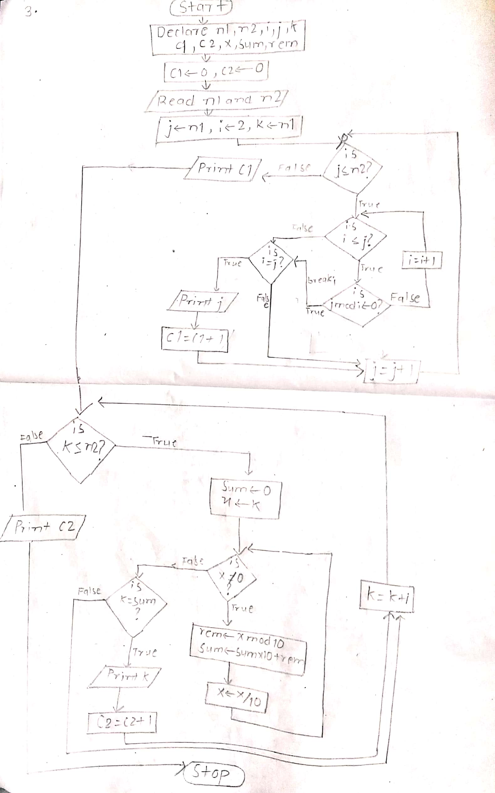

Source code:

*#include<stdio.h>*

*#include<conio.h>*

*void main()*

*{*

*int n1,n2,i,j,k,c1=0,c2=0,x,sum,rem;*

*printf("\n enter any two integer number ");*

*scanf("%d%d",&n1,&n2);*

*printf("the prime numbers between n1 and n2 are:\n");*

*for(j=n1;j<=n2;j++)*

*{*

*for(i=2;i<=j;i++)*

*{ if(j%i==0)*

*break;*

*}*

*if(i==j){*

*printf("%d\t",j);*

*c1++;}*

*}*

*printf("\n count of prime number is %d\n\n",c1);*

*printf("the palidrome numbers between n1 and n2 are:\n");*

*for(k=n1;k<=n2; k++)*

*{*

*sum=0;*

*x=k;*

*while(x!=0)*

*{*

*rem=x%10;*

*sum= sum*10+rem;*

*x=x/10;*

*}*

*if(k==sum)*

*{*

*printf("%d\t",k);*

*c2++;}*

*}*

*printf("\nthe count of palidrome number are %d",c2);*

*getch();*

*}*

Output:

enter any two integer number 100 200

the prime numbers between n1 and n2 are:

101 103 107 109 113 127 131 137 139 149 151 157 163 167 173 179 181 191 193 197 199

count of prime number is 21

the palidrome numbers between n1 and n2 are:

101 111 121 131 141 151 161 171 181 191

the count of palidrome number are 10

**Q.4 To find the sum of all positive number until the user enter 0.**

Flowchart:

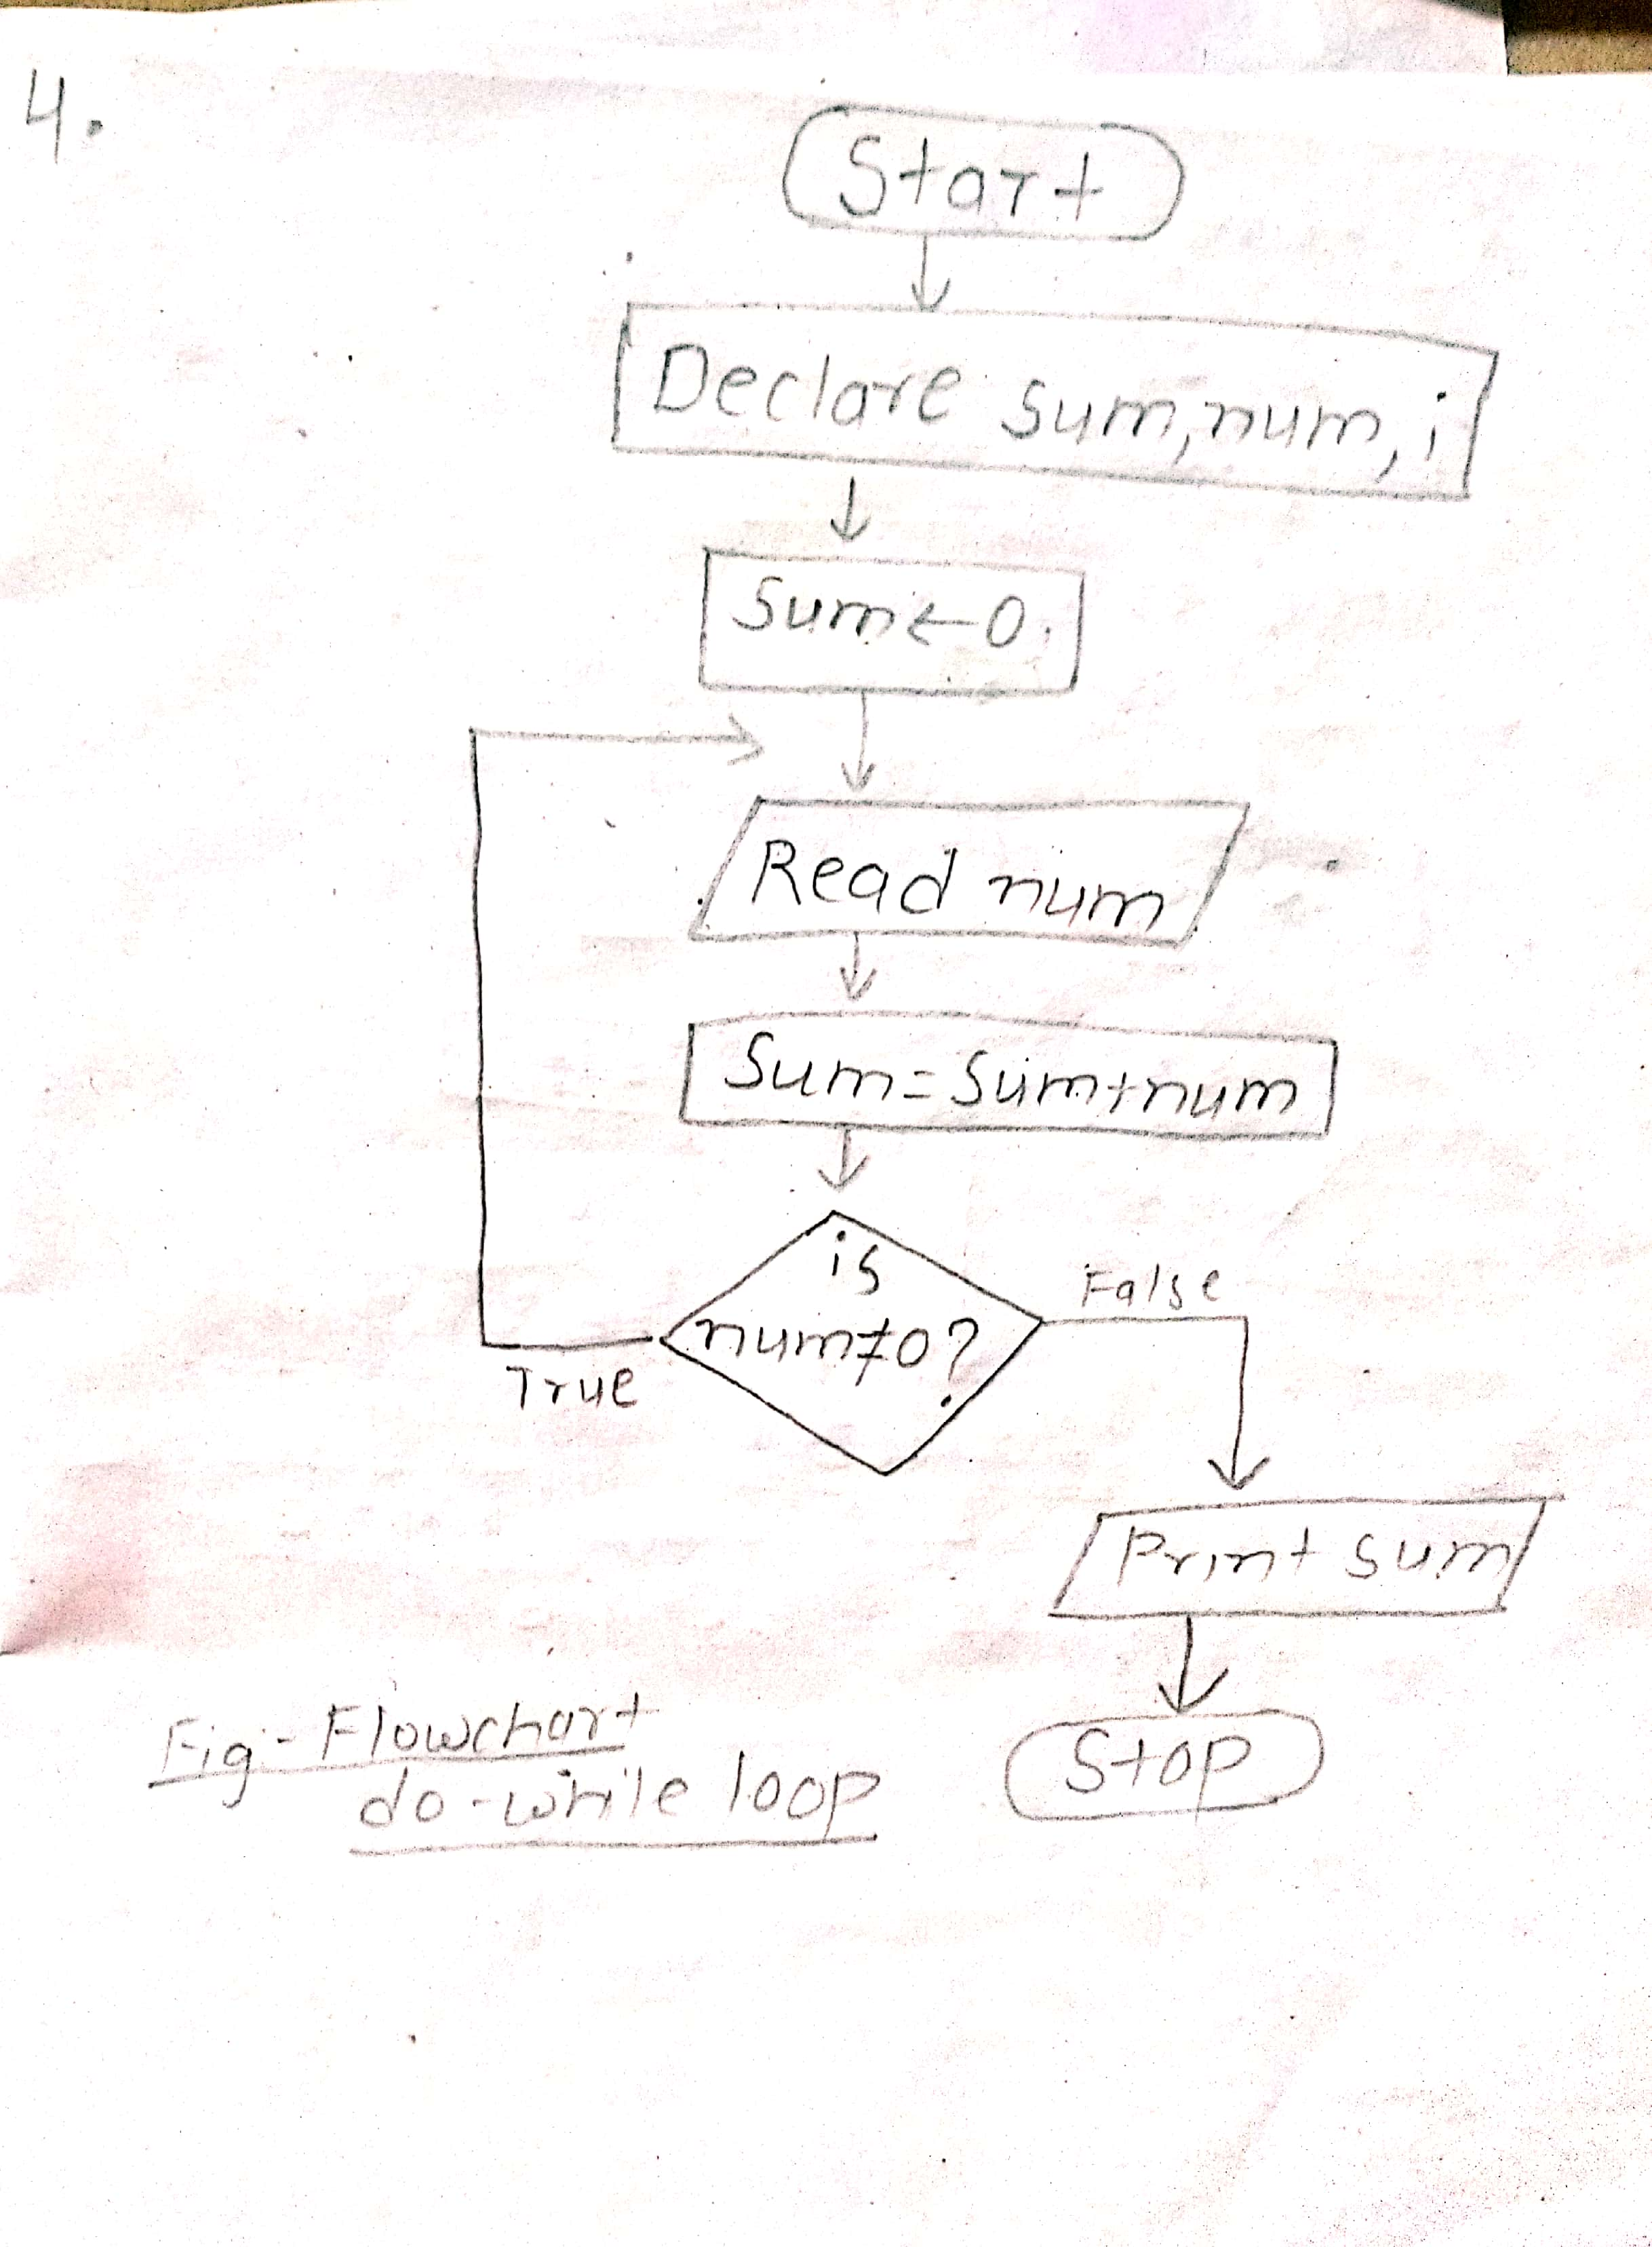

Source code:

*#include <stdio.h>*

*#include<conio.h>*

*void main()*

*{*

*unsigned int sum=0,num,i;*

*do {*

*printf("Insert the number ");*

*scanf("%u",&num);*

*sum+=num;*

*}while(num!=0);*

*printf("sum=%u",sum);*

*getch();*

*}*

Output:

Insert the number 3

Insert the number 57

Insert the number 8

Insert the number 85

Insert the number 0

sum=153

**Q.5. To display terms upto n terms.**

**a.**

Flowchart:

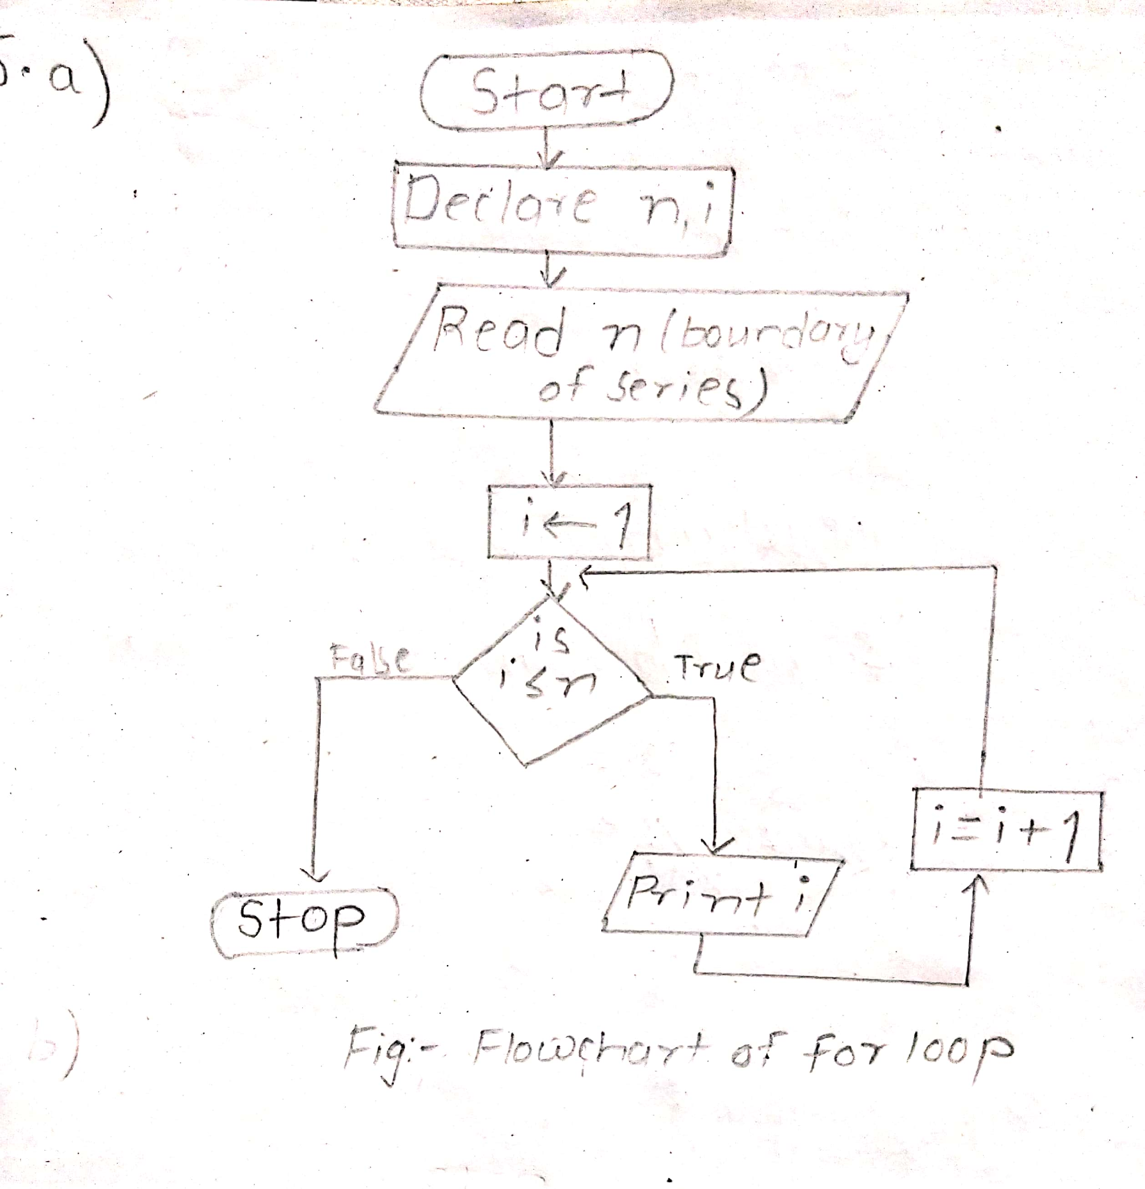

Source code:

*#include <stdio.h>*

*#include<conio.h>*

*void main()*

*{*

*int n,i;*

*printf("enter the boundary of series ");*

*scanf("%d",&n);*

*for(i=1;i<=n;i++)*

*printf("%d\t",i);*

*getch();*

*}*

Output:

enter the boundary of series 12

1 2 3 4 5 6 7 8 9 10 11 12

**b.** Flowchart:

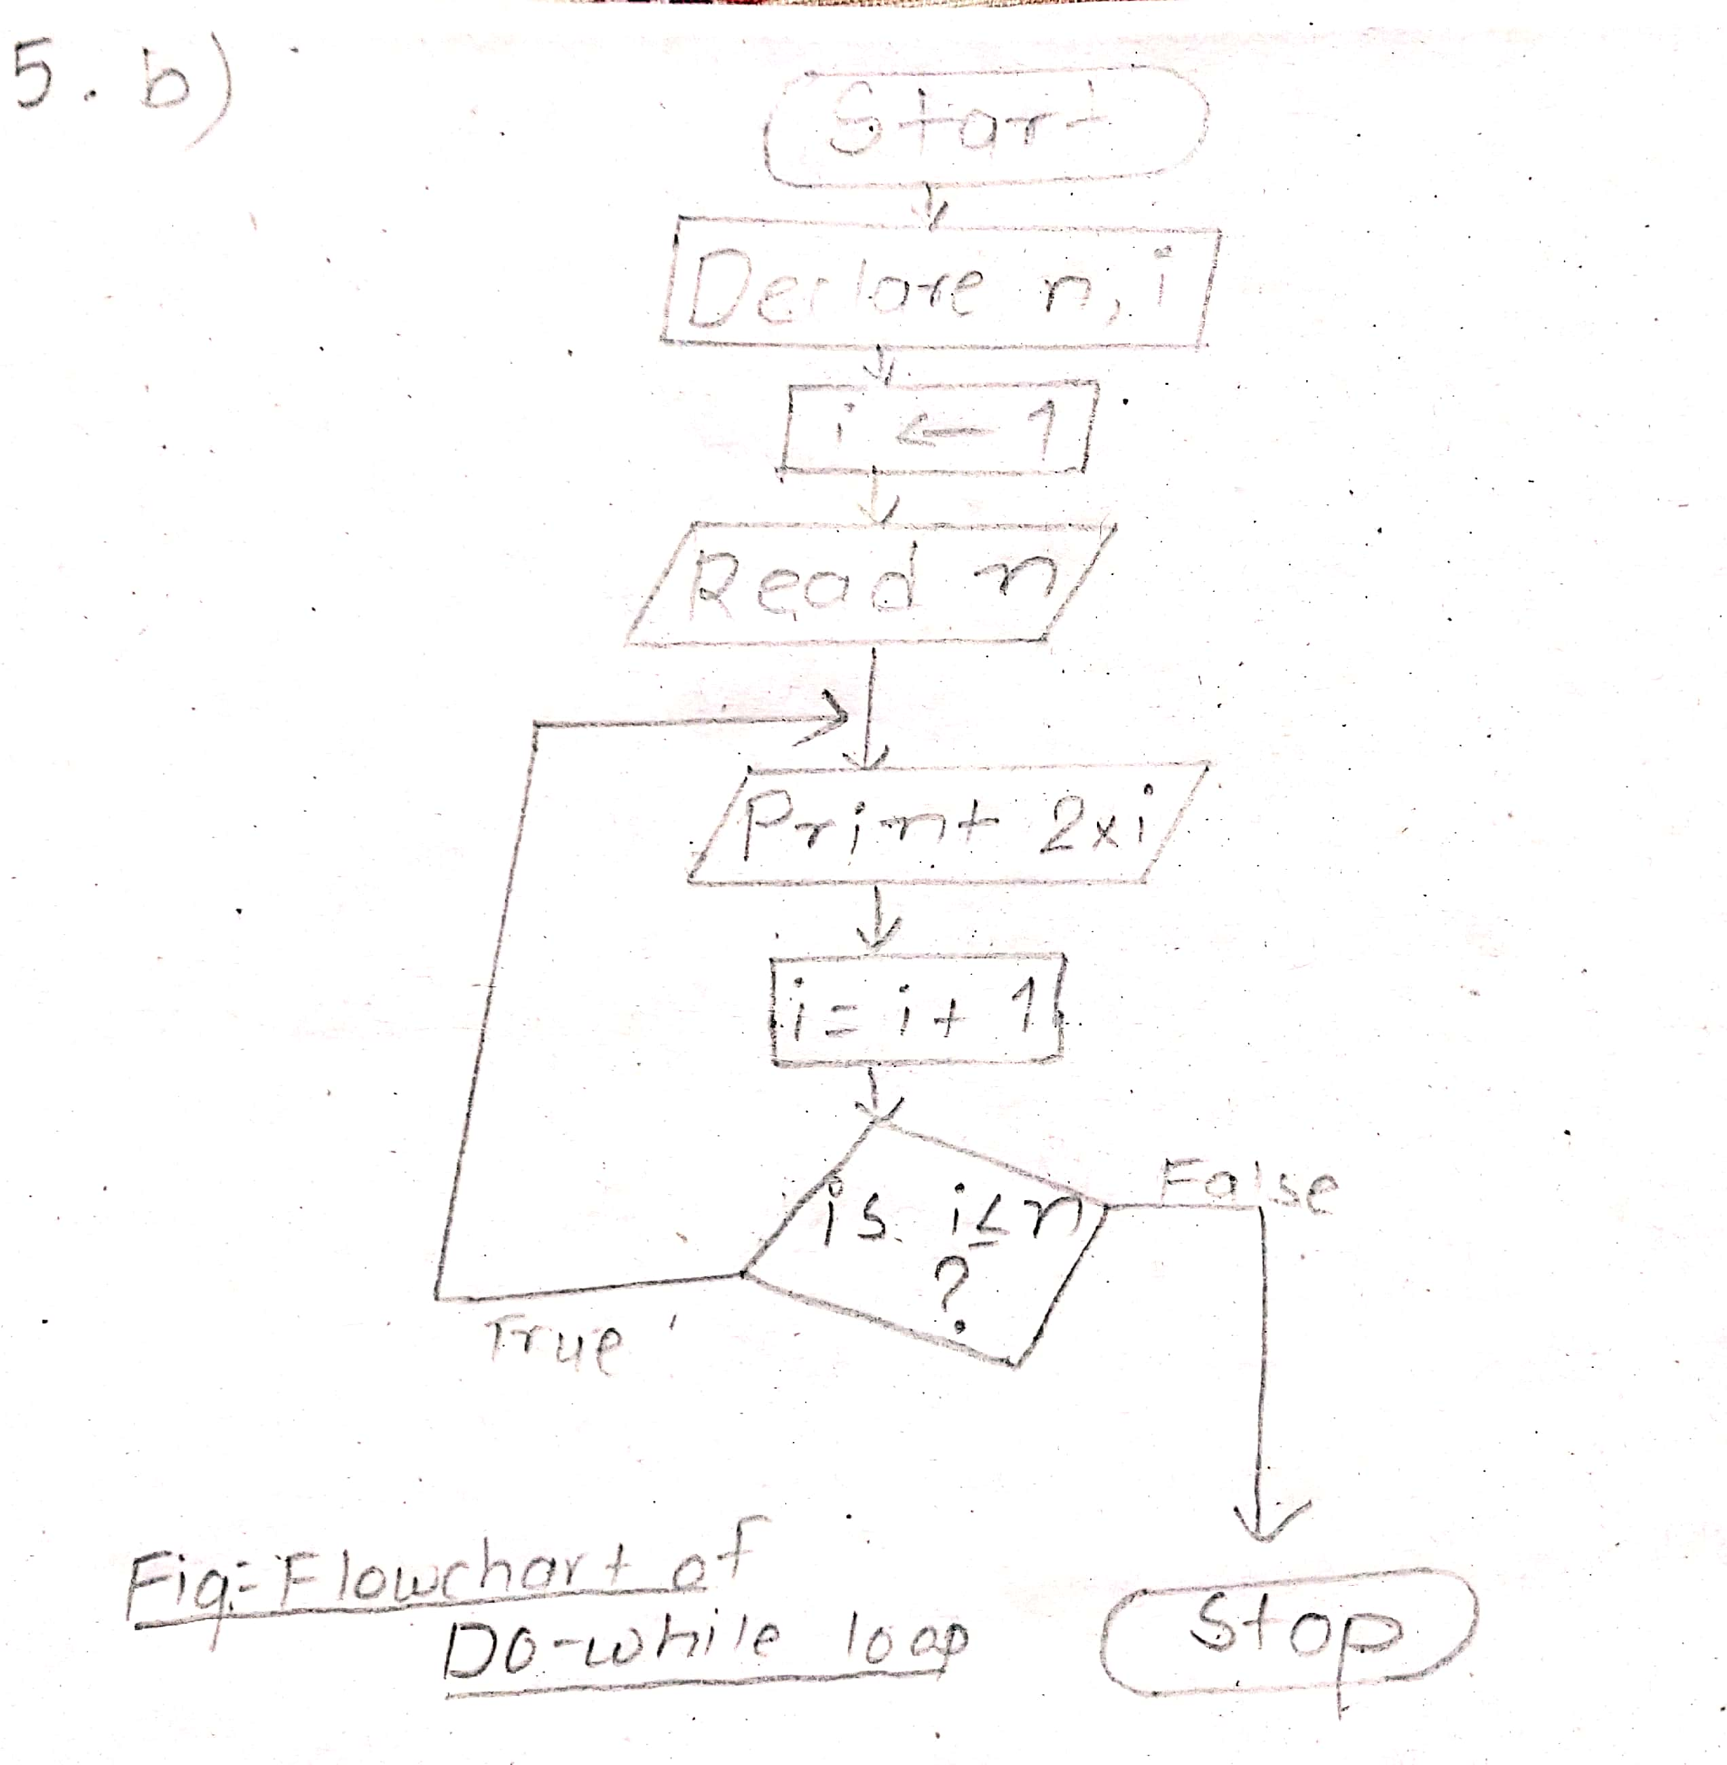

Source code:

*#include <stdio.h>*

*#include<conio.h>*

*void main()*

*{*

*int n,i=1;*

*printf("Insert boundary of series ");*

*scanf("%d",&n);*

*do{*

*printf("%d\t",(i*2));*

*i++;*

*}while(i<=n);*

*getch();*

*}*

Output:

Insert boundary of series 11

2 4 6 8 10 12 14 16 18 20 22 24

**c.**

Flowchart:

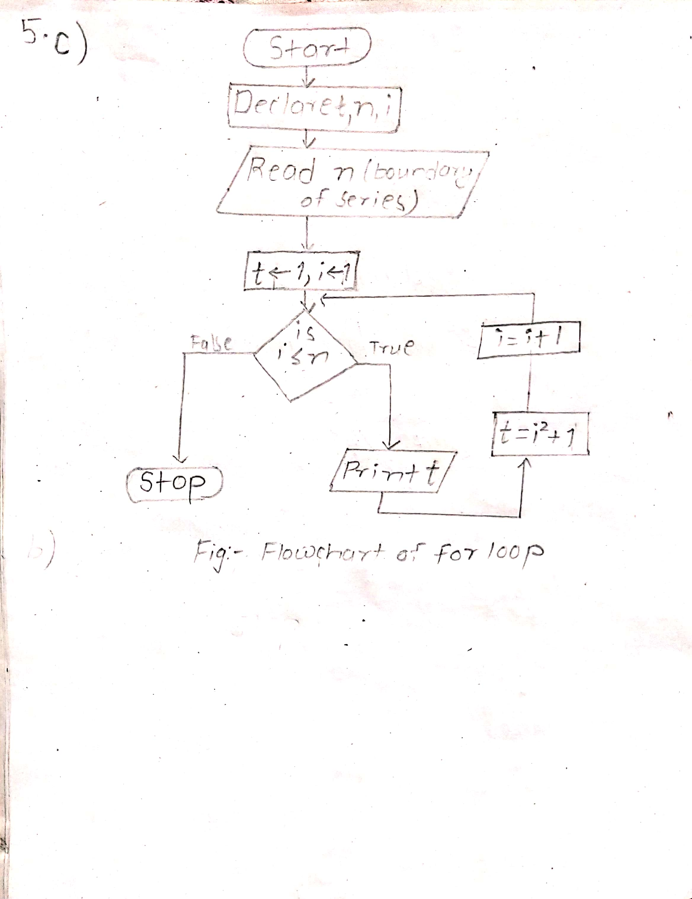

Source code:

*#include <stdio.h>*

*#include<conio.h>*

*void main()*

*{*

*int term=1,n,i;*

*printf("enter the boundary of series ");*

*scanf("%d",&n);*

*for(i=1;i<=n;i++)*

*{*

*printf("%d\t",term);*

*term=i*i+1;*

*}*

*getch();*

*}*

Output:

enter the boundary of series 8

1 2 5 10 17 26 37 50

**d.**

Flowchart: 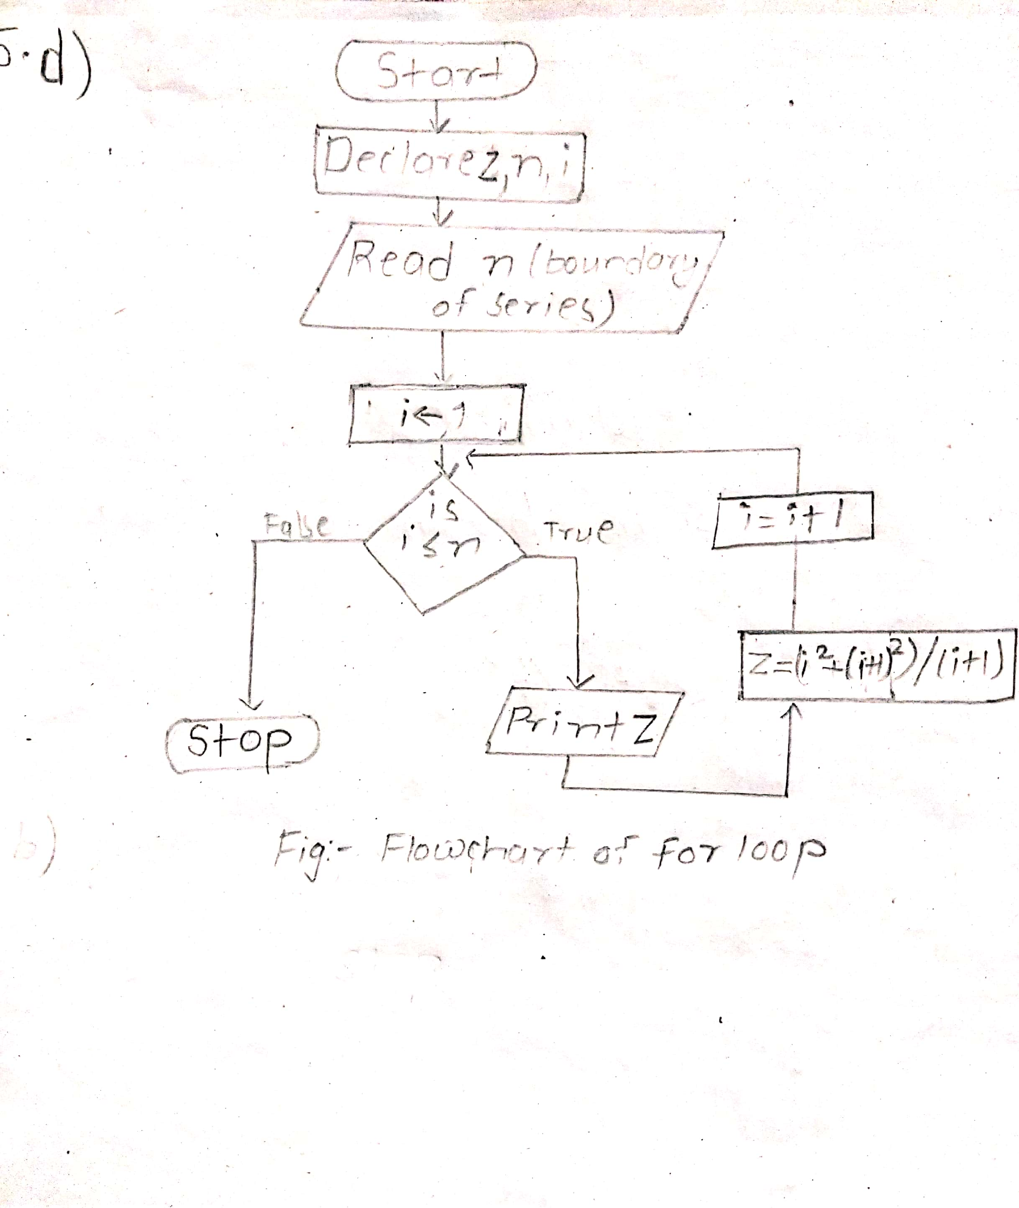

Source code:

*#include <stdio.h>*

*#include<conio.h>*

*#include<math.h>*

*void main()*

*{*

*float n,i,z;*

*printf("Insert boundary of series ");*

*scanf("%f",&n);*

*for(i=1;i<=n;i++)*

*{*

*z=((i*i)+pow((i+1),2))/(i+1);*

*printf("%.2f\t",z);*

*}*

*getch();*

*}*

Output:

Insert boundary of series 6

2.50 4.33 6.25 8.20 10.17 12.14

**e.**

Flowchart:

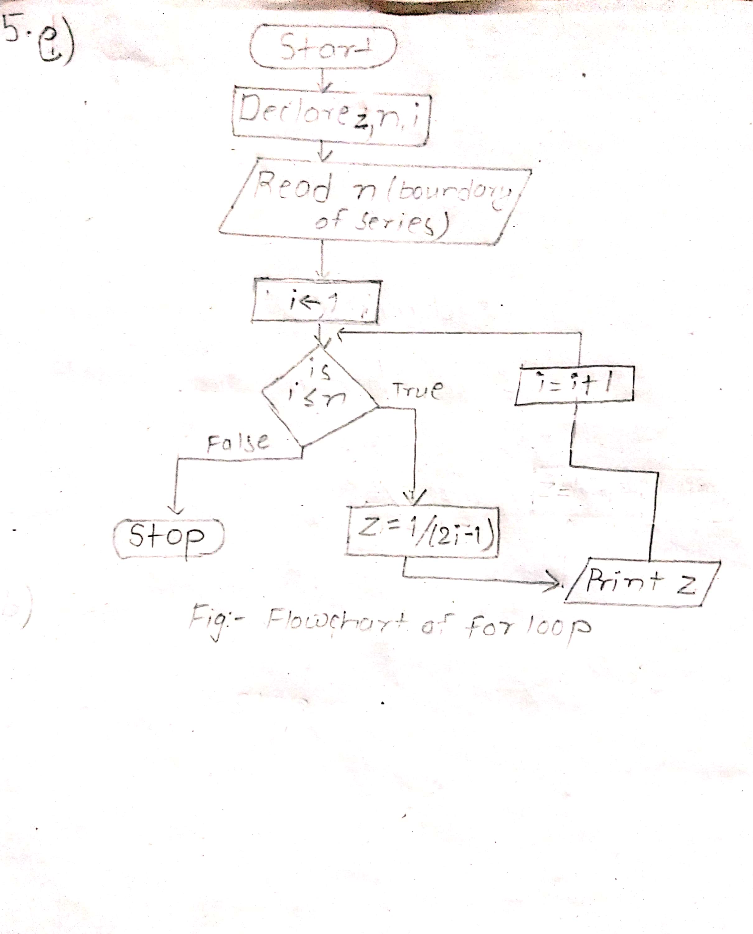

Source code:

*#include <stdio.h>*

*#include<conio.h>*

*void main()*

*{*

*float n,i,z;*

*printf("Insert boundary of series ");*

*scanf("%f",&n);*

*for(i=1;i<=n;i++)*

*{*

*z=1/(2*i-1);*

*printf("%.2f\t",z);*

*}*

*getch();*

*}*

Output:

Insert boundary of series 7

1.00 0.33 0.20 0.14 0.11 0.09 0.08

**Q.6.a To evaluate the series.**

Flowchart:

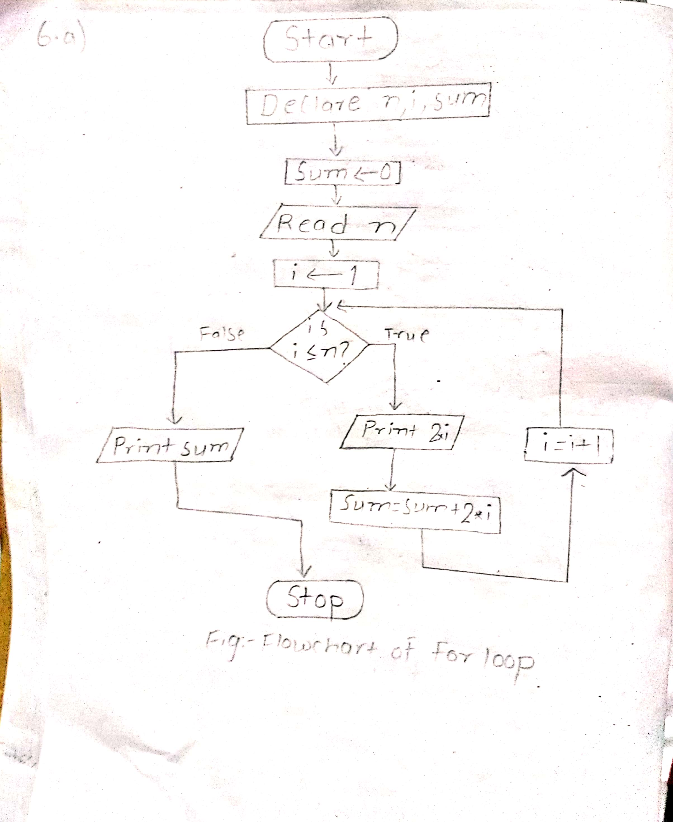

Source code:

*#include <stdio.h>*

*#include<conio.h>*

*void main()*

*{*

*int n,i,sum=0;*

*printf("Insert boundary of series ");*

*scanf("%d",&n);*

*for(i=1;i<=n;i++)*

*{*

*printf("%d\t",2*i);*

*sum=sum+2*i;*

*}*

*printf("\nthe sum is %d",sum);*

*getch();*

*}*

Output:

Insert boundary of series 5

2 4 6 8 10

the sum is 30

**Q.6.b**

Flowchart:

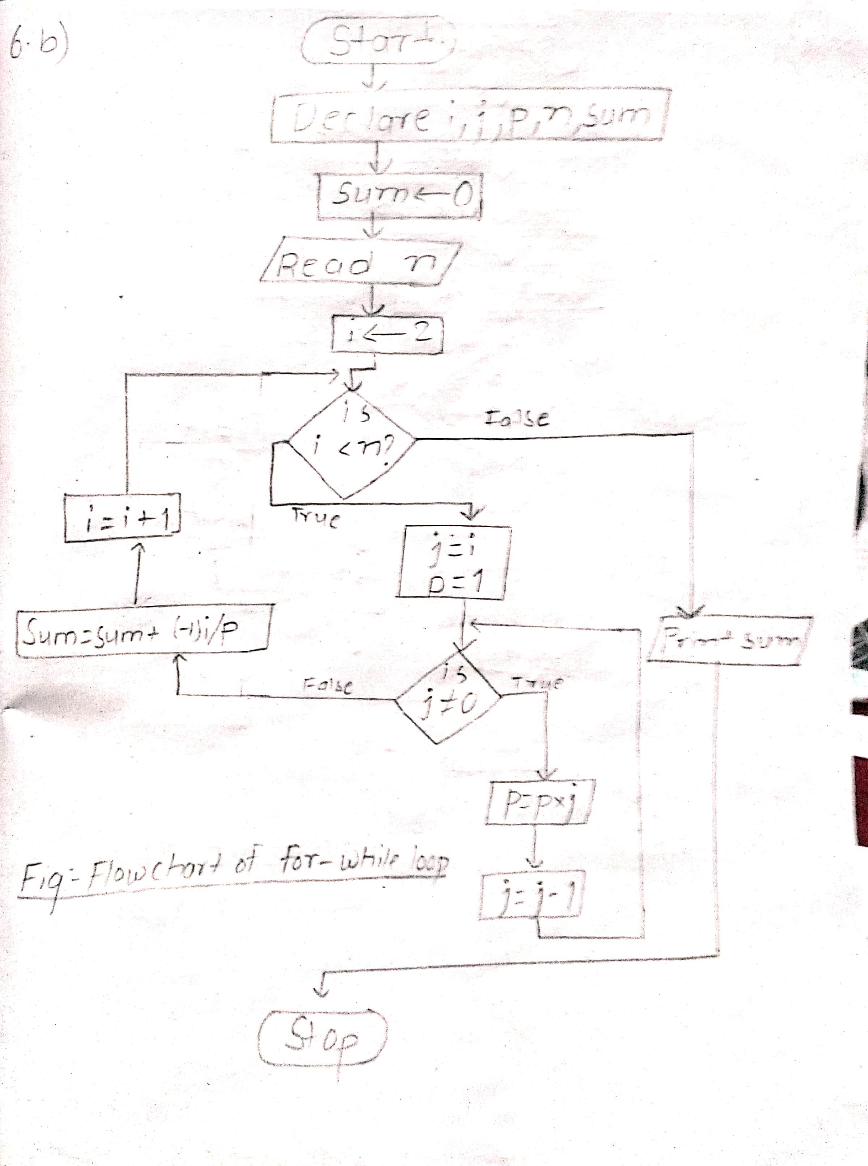

Source code:

*#include<stdio.h>*

*#include<conio.h>*

*#include<math.h>*

*void main()*

*{*

*int i,j,p,n;*

*float sum=0;*

*printf("enter the value of n ");*

*scanf("%d",&n);*

*printf("calculation of value of e^-1 upto n:\n");*

*for(i=2;i<n;i++)*

*{*

*j=i;*

*p=1;*

*while(j!=0)*

*{*

*p=p*j;*

*j--;*

*}*

*sum=sum+((pow(-1,i))/p);*

*}*

*printf("%f",sum);*

*getch();*

*}*

Output:

enter the value of n 29

calculation of value of e^-1 upto n:

0.367879

**Q.6.c**

Source code:

*#include <stdio.h>*

*#include <conio.h>*

*#include <math.h>*

*int main()*

*{*

*int n, sign = -1, i, j, den = 1;*

*float x, term, sum, num;*

*printf("Enter the number of terms: ");*

*scanf("%d", &n);*

*printf("\nEnter the value of x: ");*

*scanf("%f", &x);*

*for(i = 0; i<n; i++)*

*{*

*sign *= -1;*

*den = 1;*

*for(j = 1; j<=2*i; ++j)*

*den *= j;*

*num = pow(x, 2*i);*

*term = sign * num / den;*

*sum += term;*

*}*

*printf("The required sum is: %f", sum);*

*return 0;*

*}*

Output:

Enter the number of terms: 6

Enter the value of x: 3

The required sum is: -0.991049

**Q.7 To evaluate the series until term becomes less than 10^-6.**

Source code:

*#include <stdio.h>*

*#include <conio.h>*

*#include <math.h>*

*void main()*

*{*

*int i, j;*

*float x, term = 1, sum = 1;*

*double fact = 1;*

*printf("Enter the value of x: ");*

*scanf("%f", &x);*

*for(i = 1; term > 1e-6; ++i)*

*{*

*fact = 1;*

*for(j = 1; j<=i; ++j)*

*fact *= j;*

*term = pow(x, i)/fact;*

*sum += term;*

*}*

*printf("The sum until the limit is reached: %f", sum);*

*}*

Output:

Enter the value of x: 1

The sum until the limit is reached: 2.718282

**Q.8.a To print the given pattern.**

Flowchart:

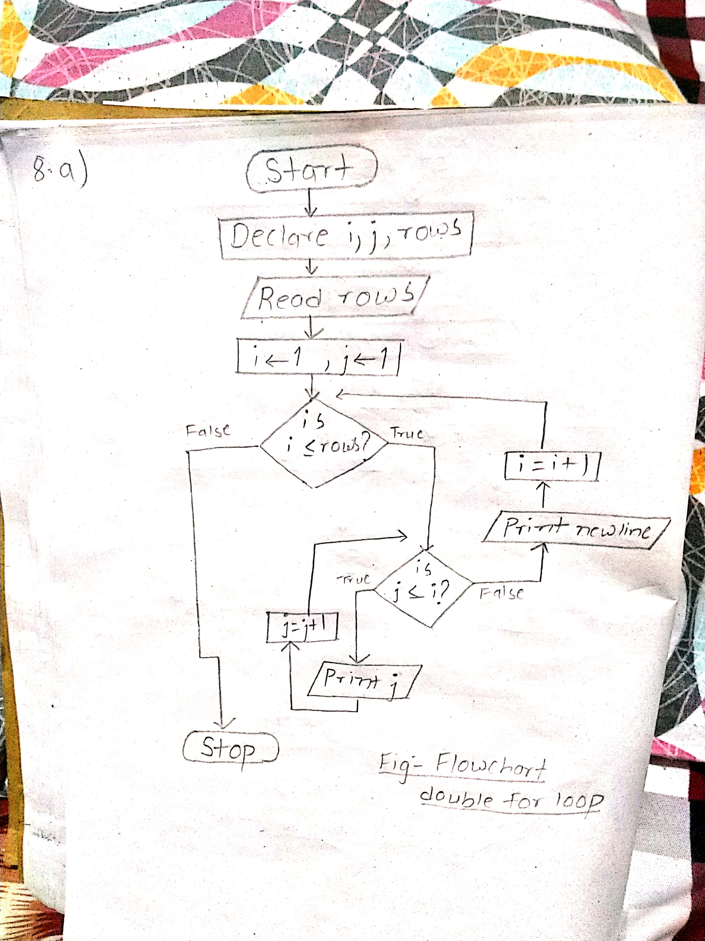

Source code:

*#include <stdio.h>*

*#include <conio.h>*

*void main() {*

*int i, j, rows;*

*printf("Enter the number of rows: ");*

*scanf("%d", &rows);*

*for (i = 1; i <= rows; ++i) {*

*for (j = 1; j <= i; ++j) {*

*printf("%d ", j);*

*}*

*printf("\n");*

*}*

*getch();*

*}*

Output:

Enter the number of rows: 5

1

1 2

1 2 3

1 2 3 4

1 2 3 4 5

**Q.8.b**

Flowchart:

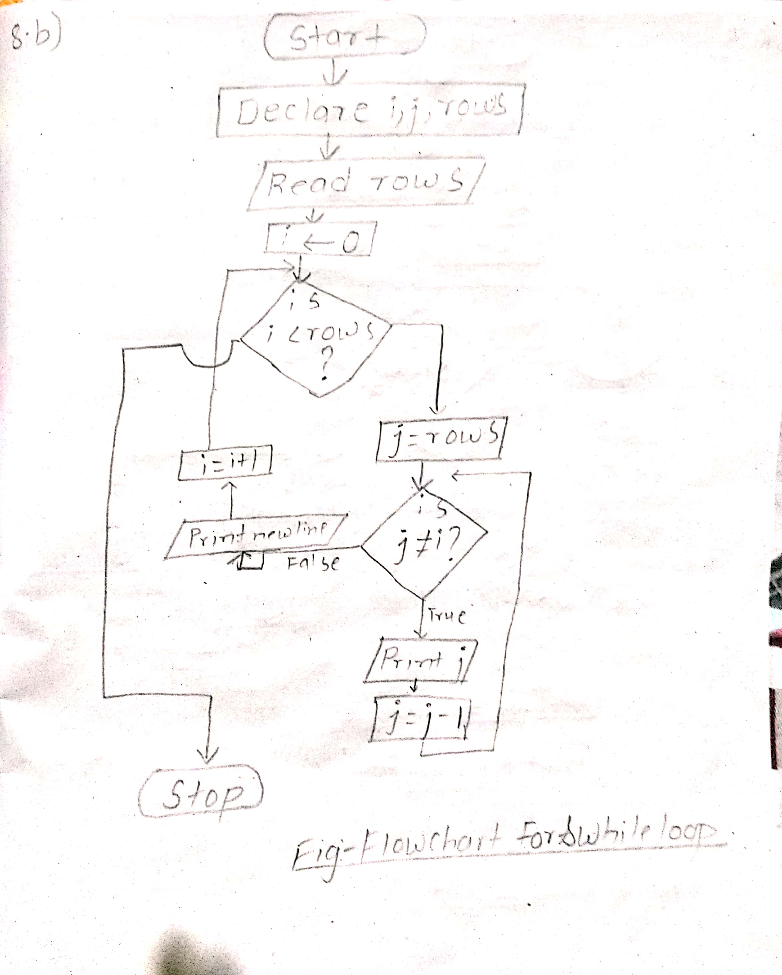

Source code:

*#include <stdio.h>*

*#include<conio.h>*

*void main()*

*{*

*int i,j,rows;*

*printf("enter the number of rows ");*

*scanf("%d",&rows);*

*for(i=0;i<rows;i++)*

*{ j=rows;*

*while(j!=i){*

*printf("%d",j);*

*j--;*

*}*

*printf("\n");*

*}*

*getch();*

*}*

Output:

enter the number of rows 5

54321

5432

543

54

5

**Q.8.c**

Source code:

*#include<stdio.h>*

*#include<conio.h>*

*void main()*

*{*

*char s[]="NEPAL";*

*int i,j;*

*for(i=0;s[j];i++)*

*{*

*for(j=0;j<=i;j++)*

*printf("%c",s[i]);*

*printf("\n");*

*}*

*getch();*

*}*

Output:

N

EE

PPP

AAAA

LLLLL

**Q.8.d**

Flowchart:

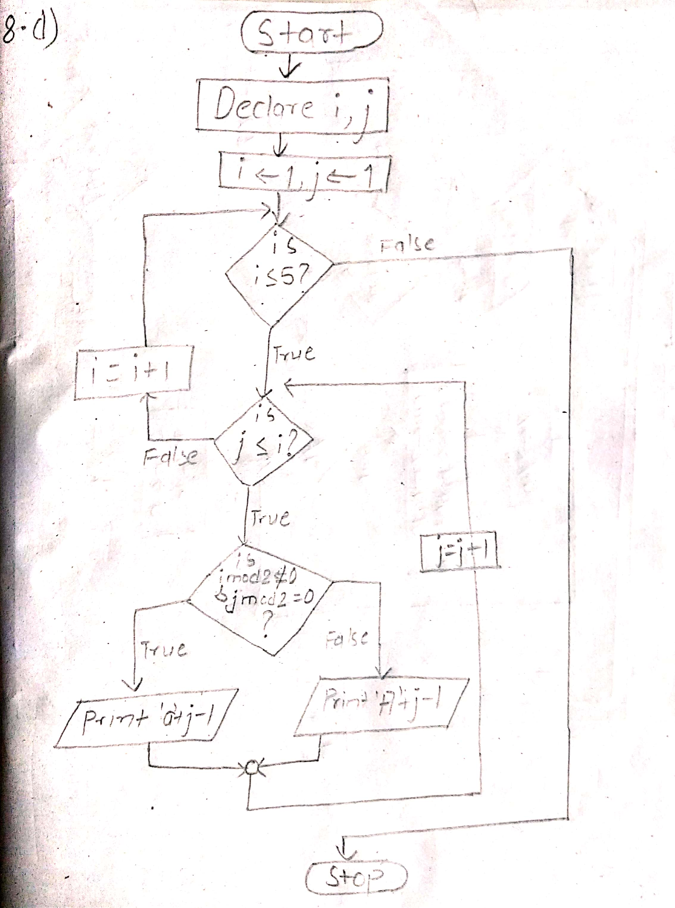

Source code:

*#include<stdio.h>*

*#include<conio.h>*

*int main()*

*{*

*int i, j;*

*for(i=1;i<=5;i++)*

*{*

*for(j=1;j<=i;j++)*

*{ if((i%2)!=0&&j%2==0)*

*printf("%3c",'a'+j-1);*

*else*

*printf("%3c",'A' + j-1);*

*}*

*printf("\n");*

*}*

*return 0;*

*}*

Output:

A

A B

A b C

A B C D

A b C d E

**Q.8.e**

Flowchart:

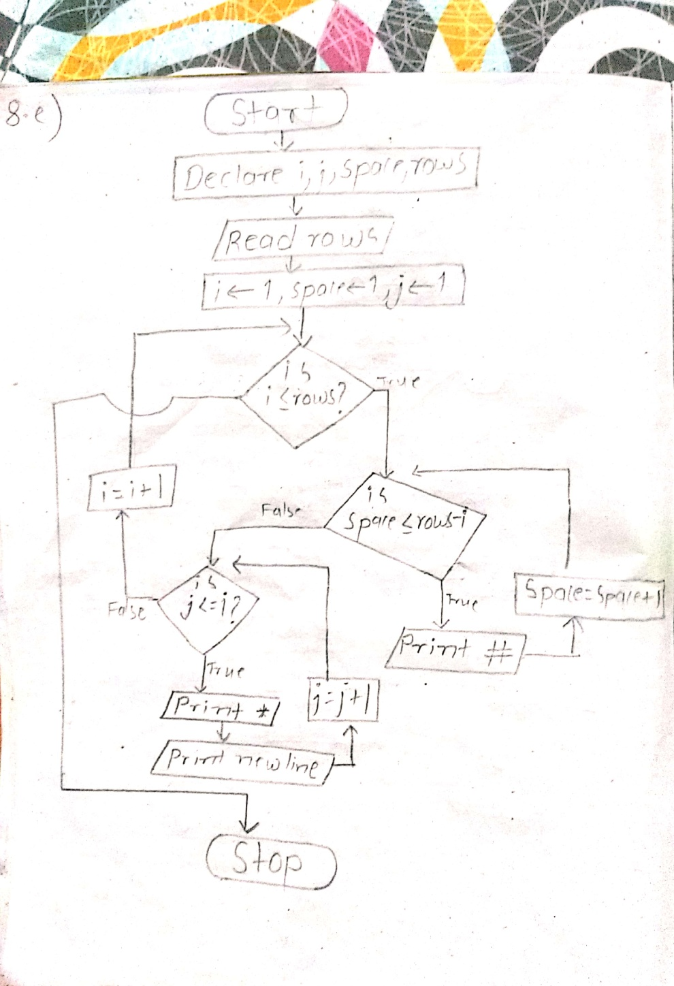

Source code:

*#include <stdio.h>*

*#include<conio.h>*

*void main()*

*{*

*int i,j,space,rows;*

*printf("enter the number of rows ");*

*scanf("%d",&rows);*

*for(i=1;i<=rows;i++)*

*{*

*for(space=1;space<=rows-i;space++)*

*{ printf("# ");*

*}*

*for(j=1;j<=i;j++)*

*printf("* ");*

*printf("\n");*

*}*

*getch();*

*}*

Output:

enter the number of rows 5

# # # # *

# # # * *

# # * * *

# * * * *

* * * * *

**Q.8.f**

Flowchart:

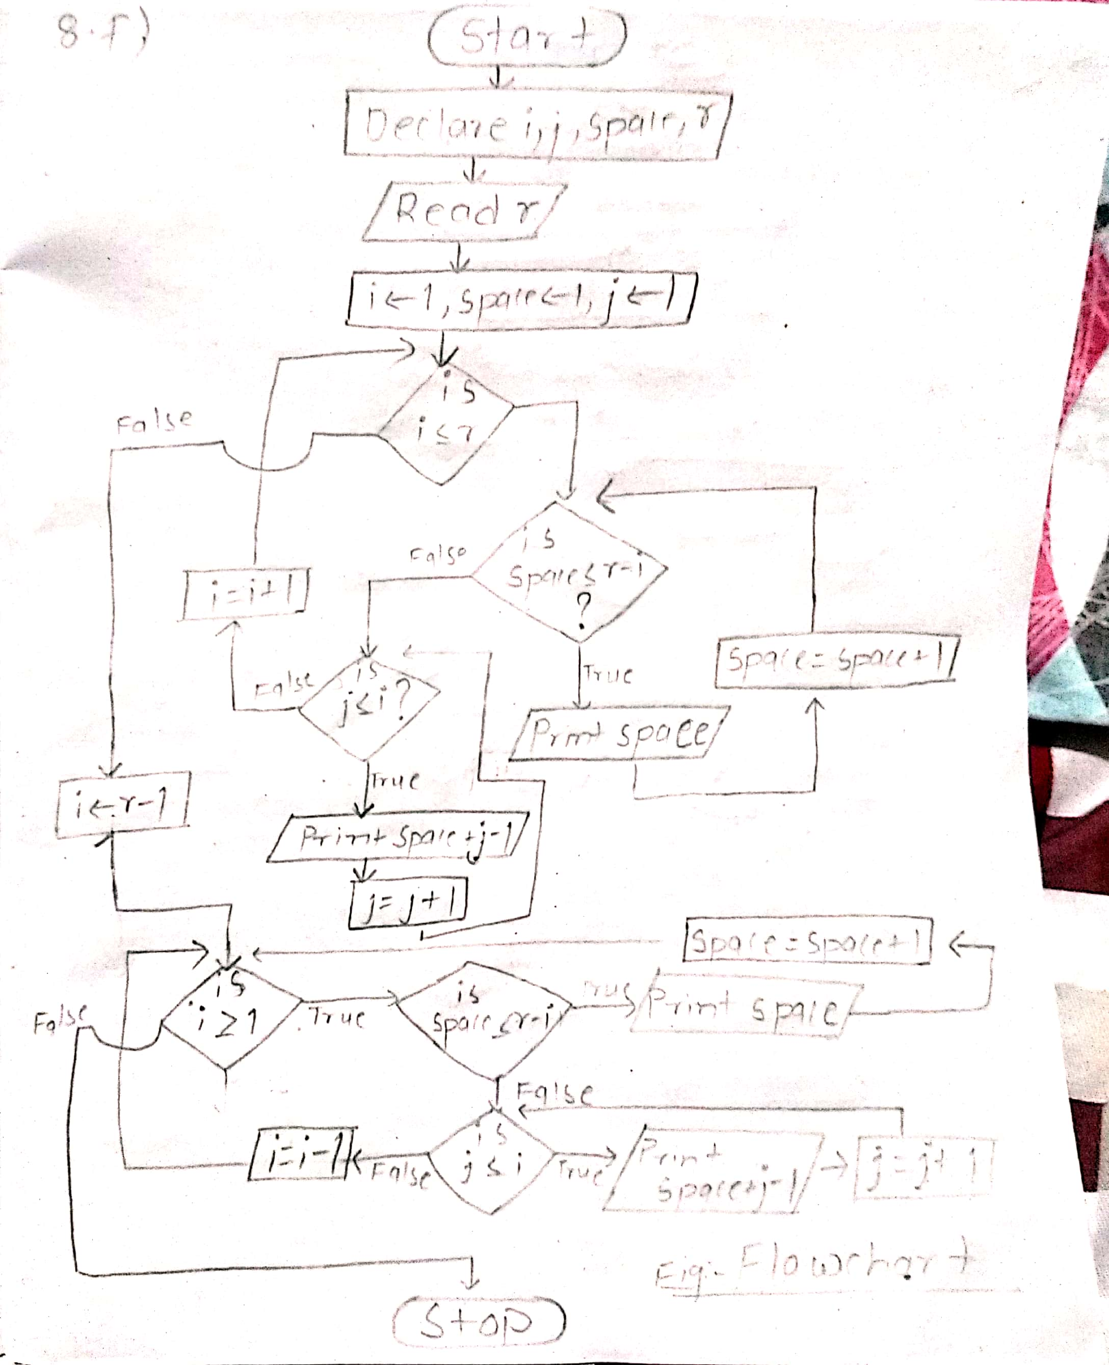

Source code:

*#include <stdio.h>*

*#include<conio.h>*

*void main()*

*{*

*int i,j,space,r;*

*printf("enter the base number ");*

*scanf("%d",&r);*

*for(i=1;i<=r;i++)*

*{*

*for(space=1;space<=r-i;space++)*

*{ printf(" ");*

*}*

*for(j=1;j<=i;j++)*

*printf("%d",space+j-1);*

*printf("\n");*

*}*

*for(i=r-1;i>=1;i--)*

*{ for(space=1;space<=r-i;space++)*

*{ printf(" ");*

*}*

*for(j=1;j<=i;j++)*

*printf("%d",space+j-1);*

*printf("\n");*

*}*

*getch();*

*}*

Output:

enter the base number 4

4

34

234

1234

234

34

4

**Q.8.g**

Flowchart:

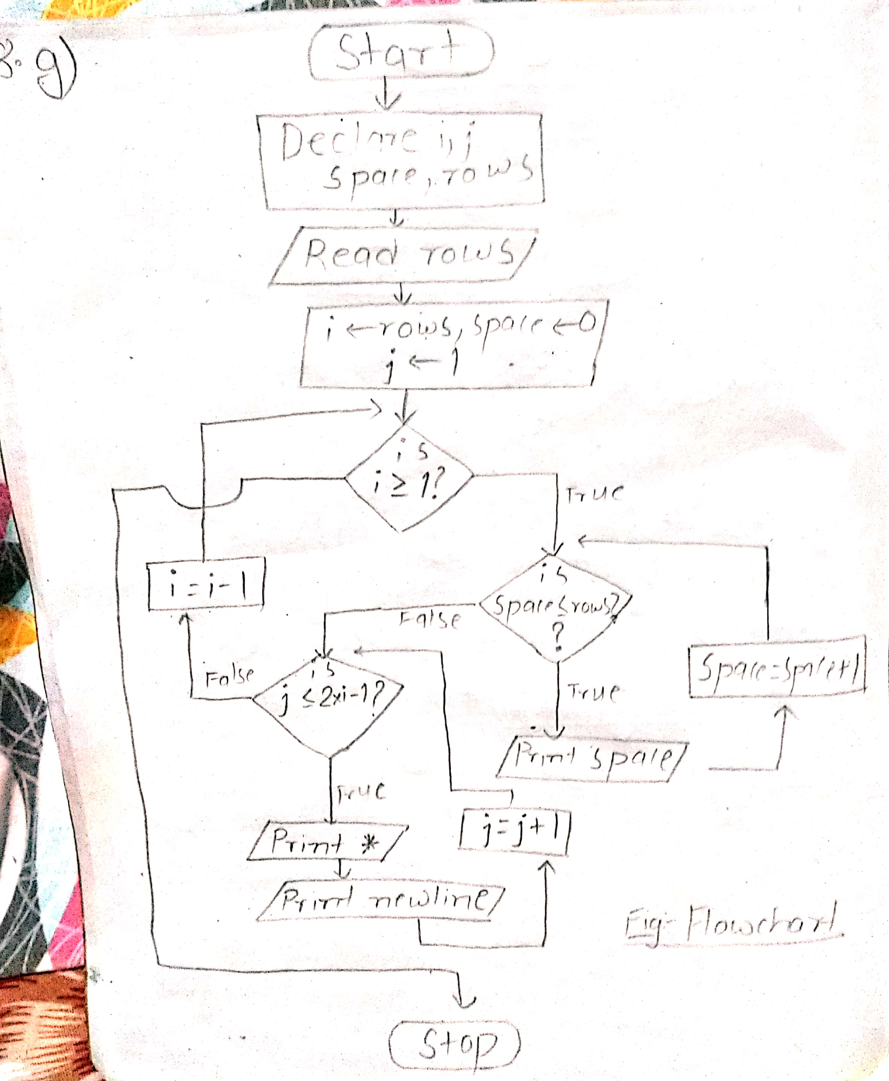

Source code:

*#include <stdio.h>*

*#include<conio.h>*

*void main()*

*{*

*int i,j,space,rows;*

*printf("enter the number of rows ");*

*scanf("%d",&rows);*

*for(i=rows;i>=1;i--)*

*{*

*for(space=0;space<=rows-i;space++)*

*{ printf(" ");*

*}*

*for(j=1;j<=2*i-1;j++)*

*printf("* ");*

*printf("\n");*

*}*

*getch();*

*}*

Output:

enter the number of rows 4

* * * * * * *

* * * * *

* * *

*

**Analysis and discussion**

In the course of lab , we learned about nesting of loops. Mainly there are 3 types of nested loop i.e nested for, nested while and nested do while. We practiced programs related to nested loop through practical method. We also used nested loops for the evaluation of various sort of series like taylor series of cosine, exponential , etc. similarly we also learned to print different pattern(Q.8) using nested loop in C.

**Conclusion**

Therefore, we came to know more about the application of nested loop in various problems according to the requirement. We learned about the evaluation and expansion of series and prinnting pattern in C language.

**Thank You**



**TRIBHUVAN UNIVERSITY**

**INSTITUTE OF ENGINEERING**

**PULCHWOK CAMPUS**

**Subject**: C-Programming

**Experiment Number**: 7

**Title**: Function

**Date**: 2077/03/28

**Submitted By:**   **Submitted To:**

Name: Subham Shrestha Department of Electronics and Computer Engineering

Program: Bachelor in Computer Engineering

Section: C/D Checked By:

Roll: 077BCT082

**Contents of report**

**1. Background information**

1. Function
2. Elements of function
3. Types of Function
4. Passing arguments to functions
5. Recursive function
6. Scope of variable
7. Storage classes

**2. Code and output**

1. Source code
2. output

**3. Analysis and discussion**

**4. Conclusion**

**Background Information**

**Function:**

A function is a named unit of a group of program statements. The unit can be called from other  part of the program. Advantage of function:

1. It facilitates top-down modular programming.

2. The length of source program can be reduced by using functions at appropriate places.

3. It is easy to locate and isolate a faulty function for further investigations.

4. A function may be used by many other program and is useful in a lengthy programs.

**Elements of function:**

1. Function definition

2. Function call

3. Function declaration or Function prototype.

**a.Function Prototype/ declaration:**

A function prototype is a declaration of the function that tells the program about the type of the  value returned by the function and the number and type of each argument. It consist of four parts.

Syntax:

*Function-type function-name (parameter list);*

Example:   *void sum(int a, int b);*

**b.Function Definition:**

A function must be defined before it is used anywhere in the program.

Syntax:

*Type function-name(parameter list)*

*{*

*Body of the function*

*}*

**c.Function call:**

A function can be called by simple using the function name followed by a list of actual  parameter (or arguments),if any, enclosed in parentheses.

Syntax:

*function-name(list of variable or value);*

When the compiler encounters the function call, the control is transferred to the function  definition. And it executes each line of code in function and returns the control to the main  program again.

**Types of Function:**

**1. Function with no arguments and no return values:**

When a function has no argument, it does not receive any data from the calling function.  Similarly, when it does not return value , the calling function does not receive any data  from the called function.

**2. Function with argument and no return type:**

In this approach, we could make the calling function to read data from the terminal and  pass it on the called function.

**3. Function with argument and return type:**

In this, the calling function sends the data to the function and the called function returns  the value to the calling function statement. It is a two-way data communication between  the calling and called function.

**4. Function with no argument and return type:**

In this function, the function does not take any input from the calling function but it  returns value to the calling function.

**Passing arguments to functions:**

1. Pass by value (call by value)
2. Pass by reference (call by pointer)

**a.Pass by value:** Values of actual parameters are copied to the variable in the parameter list  of the called function. The called function works on the copy and not on the original values  of the actual parameters. This ensures that the original data in the calling function cannot be  changed accidently.

**b.Pass by pointer:**In pass by pointers (also known as pass by address), the memory addresses of the variables  rather than the copies of value are sent to the called function. In this case, the called function  directly work on the data in the calling function and the changed value are available in the  calling function for its use.  Pass by pointers method is often used when manipulating arrays and strings.

**Recursive:**

A function is said to be recursive if a statement in the body of the function calls itself. It should always have a exit criteria otherwise it will go to infinity.

**Scope of variable:**

**a.Local variable:** these exist inside specific function that creates them. They are known to other function. They are recreated each time function is executed or called.

**b.Global variable:** They can be accessed by any function in program. They arenot recreated if function is recalled. It is declared outside function above main.

**Storage classes:**

**a.Automatic variable:**They are declared inside a functions in which they are to be utilized. They are  created when the function is called and destroyed automatically when the function is exited. Automatic variables are therefore private ( or local ) to the function in  which they are declared. We may also use the keyword auto to declare automatic variables  explicitly.

**b.External variables:**

Variables that are both *alive* and *active* throughout the entire program are known as external  variables. They are also known as *global variables*.

**c.Static variable:**

A variable can be declared static using the keyword static like  *static int a;*

Internal static variable are those which are declared inside a function. Therefore, internal  static variables are similar to auto variables, except that they remain in existence throughout the remainder of the program.

**d.Register variable:**

A register access is much  faster than a memory access, keeping the frequently accessed variables in the register will lead to  faster execution of program. Most compilers allow only int or char type variable to be placed in register. This is done as follows:

*register auto int a;*

**Code and output**

Compiler used: GDB compiler and debugger

**Q.1 Program to create a function float add(int,float);**

Source Code:

*#include<stdio.h>*

*#include<conio.h>*

*float add(int a, float b);*

*void main()*

*{*

*float x,y,r;*

*printf("enter any two number ");*

*scanf("%f%f",&x,&y);*

*r=add(x,y);*

*printf("the result is %.3f",r);*

*getch();*

*}*

*float add(int x, float y)*

*{ float sum;*

*sum=x+y;*

*return(sum);*

*}*

Output:

enter any two number 2

4.66

the result is 6.660

**Q.2 Program to create a function void sumofdigits(int);**

Source Code:

*#include<stdio.h>*

*#include<conio.h>*

*void sumofdigits(int x);*

*void main()*

*{*

*int x;*

*printf("enter the digit ");*

*scanf("%d",&x);*

*sumofdigits(x);*

*getch();*

*}*

*void sumofdigits(int x)*

*{*

*int sum=0,rem;*

*do{*

*rem=x%10;*

*sum=sum+rem;*

*x=x/10;*

*} while(x!=0);*

*printf("the sum of digits is %d",sum);*

*}*

Output:

enter the digit 2343

the sum of digits is 12

**Q.3 To calculate the factorial of given positive number.**

Source Code:

*#include<stdio.h>*

*#include<conio.h>*

*unsigned int fact(unsigned int a);*

*void main()*

*{*

*unsigned int x,r;*

*printf("enter positive number to find factorial ");*

*scanf("%u",&x);*

*r=fact(x);*

*printf("factorial of %u is %u",x,r);*

*getch();*

*}//without recursion//*

*unsigned int fact(unsigned int x)*

*{ unsigned int facto=1,i;*

*for(i=1;i<=x;i++)*

*{*

*facto=facto*i;*

*}*

*return(facto); }*

Output:

enter positive number to find factorial 5

factorial of 5 is 120

**Q.4 Program to create a function void_check prime(); and check the prime number.**

Source Code:

*#include <stdio.h>*

*#include <conio.h>*

*void check_prime(int a)*

*{ int i;*

*for (i=2;i<a;i++)*

*{*

*if (a%i==0)*

*{*

*printf("\nIt is compostite number");*

*break;*

*}*

*}*

*if(a==i)*

*printf("\nIt is prime number");*

*}*

*void main()*

*{*

*int num;*

*printf(" Insert Number: ");*

*scanf("%d", &num);*

*check_prime(num);*

*getch();*

*}*

Output:

InsertNumber: 17

It is prime number

Insert Number: 6

It is compostite number

**Q.5 To combine the Q.1, Q.2, Q.3 and Q.4 using switch statements.**

Source Code:

*#include <stdio.h>*

*#include <conio.h>*

*float add(int a, float b)*

*{*

*float sum;*

*return(sum=a+b);*

*}*

*int sumofdigits(int a)*

*{*

*int sum=0,rem;*

*do{*

*rem=a%10;*

*sum=sum+rem;*

*a=a/10;*

*} while(a!=0);*

*return(sum);*

*}*

*unsigned int fact(unsigned int a)*

*{ unsigned int facto=1,i;*

*for(i=1;i<=a;i++)*

*{*

*facto=facto*i;*

*}*

*return(facto);*

*}*

*void check_prime(int a)*

*{ int i;*

*for (i=2;i<a;i++)*

*{*

*if (a%i==0)*

*{*

*printf("\nIt is compostite number");*

*break;*

*}*

*}*

*if(a==i)*

*printf("\nIt is prime number");*

*}*

*void option()*

*{*

*printf("<**************option************>\n");*

*printf( "1.Sum of Numbers\n");*

*printf( "2.Sum of Digits\n");*

*printf( "3.Factorial\n");*

*printf( "4.Check Prime or Composite\n");*

*}*

*//main body//*

*int main()*

*{*

*int one_number_one;*

*float one_number_two, one_sum;*

*int two_number, two_sum;*

*unsigned three_number, three_factorial;*

*int four_number;*

*int choice;*

*option();*

*printf("Choice: ");*

*scanf("%d", &choice);*

*switch (choice)*

*{*

*case 1:*

*printf("Number one:");*

*scanf("%d", &one_number_one);*

*printf("Number two:");*

*scanf("%f", &one_number_two);*

*one_sum = add(one_number_one, one_number_two);*

*printf("\nAddition of %d and %.2f is %.2f", one_number_one, one_number_two, one_sum);*

*break;*

*case 2:*

*printf("Number: ");*

*scanf("%d", &two_number);*

*two_sum = sumofdigits(two_number);*

*printf("Sum of digits in %d is %d", two_number, two_sum);*

*break;*

*case 3:*

*printf("Number : ");*

*scanf("%u", &three_number);*

*three_factorial = fact(three_number);*

*printf("\nFactorial of %u is %u", three_number, three_factorial);*

*break;*

*case 4:*

*printf("Number: ");*

*scanf("%d", &four_number);*

*check_prime(four_number);*

*break;*

*default:*

*printf("Please choose proper option");*

*break;*

*}*

*return 0;*

*}*

Output:

<**************option************>

1.Sum of Numbers

2.Sum of Digits

3.Factorial

4.Check Prime or Composite

Choice: 1

Number one:2

Number two:3.44

Addition of 2 and 3.44 is 5.44

Choice: 2

Number: 4566

Sum of digits in 4566 is 21

Choice: 3

Number : 6

Factorial of 6 is 720

Choice: 4

Number: 5

It is prime number

**Q.6 To read integer and count the odd and even digits in it.**

Source Code:

*#include <stdio.h>*

*#include <conio.h>*

*void countsDigits(int *, int *);*

*void main()*

*{*

*int digits, evencount = 0, oddcount = 0;*

*printf(" Insert number: ");*

*scanf("%d",&digits);*

*evencount = digits;*

*countsDigits(&evencount, &oddcount);*

*printf("\nEven Digits: %d\n", evencount);*

*printf("Odd Digits: %d", oddcount);*

*getch();*

*}*

*void countsDigits(int *e, int *o)*

*{*

*int num = *e;*

*\*e = 0;*

*int even = 0, odd = 0;*

*while (num!=0)*

*{*

*if (num % 2 == 0)*

*{*

*even++;*

*}*

*else if (num%2!=0)*

*{*

*odd++;*

*}*

*num /= 10;*

*}*

*\*e = even;*

*\*o = odd;*

*}*

Output:

Insert number: 987

Even Digits: 1

Odd Digits: 2

**Q.7 To find lowest and highest number between three number also using conditional operator.**

Source Code:

*#include <stdio.h>*

*#include <conio.h>*

*int findLowest(int, int, int);*

*int findHighest(int, int, int);*

*void main()*

*{*

*int numone,numtwo,numthree;*

*printf("Number One: ");*

*scanf("%d",&numone);*

*printf("Number Two: ");*

*scanf("%d",&numtwo);*

*printf("Number Three: ");*

*scanf("%d",&numthree);*

*printf("\nLowest number is %d", findLowest(numone, numtwo, numthree));*

*printf("\nHighest number is %d", findHighest(numone, numtwo, numthree));*

*getch();*

*}*

*int findLowest(int a, int b, int c)*

*{*

*int low;*

*(a < b && a < c) ? ((low = a)) : ((b < c) ? ((low = b)) : ((low = c)));*

*return low;*

*}*

*int findHighest(int a, int b, int c)*

*{*

*int high;*

*(a > b && a > c) ? ((high = a)) : ((b > c) ? ((high = b)) : ((high = c)));*

*return high;*

*}*

Output:

Number One: 6

Number Two: 9

Number Three: 3

Lowest number is 3

Highest number is 9

**Q.8.a To calculate factorial using recursive function.**

Source Code:

*#include <stdio.h>*

*#include <conio.h>*

*int factorial(int n)*

*{*

*if (n == 0)*

*{*

*return 1;*

*}*

*else*

*{*

*return n * factorial(n - 1);*

*}*

*}*

*int main()*

*{*

*int num;*

*printf("Insert Number : ");*

*scanf("%d", &num);*

*(num<0) ? ((printf("Invalid number."))) : (printf("Factorial of number is %d", factorial(num)));*

*return 0;*

*}*

Output:

Insert Number : 7

Factorial of number is 5040

**Q.8.b To find power of integer.**

Source Code:

*#include <stdio.h>*

*#include<conio.h>*

*float power( float n, float m)*

*{ if(m==0)*

*return(1);*

*else*

*return(n*power(n,m-1));*

*}*

*void main()*

*{*

*float x,y,a;*

*printf("enter the value of x and y to solve x^y ");*

*scanf("%f%f",&x,&y);*

*a=power(x,y);*

*printf("the value = %f",a);*

*getch();*

*}*

Output:

enter the value of x and y to solve x^y 2

3

the value = 8.000000

**Q.8.c To find HCF of two number.**

Source Code:

*#include <stdio.h>*

*#include <conio.h>*

*int HCF(int a, int b)*

*{*

*if (b==0);*

*{*

*return a;*

*}*

*if (a< b)*

*{*

*b = a + b - (b = a);*

*}*

*int quotient,remainder;*

*quotient = a / b;*

*remainder = a - quotient * b;*

*HCF(b, remainder);*

*}*

*int main()*

*{*

*int a, b;*

*printf("Number One: ");*

*scanf("%d",&a);*

*printf("Number Two: ");*

*scanf("%d",&b);*

*printf("HCF of %d and %d is %d", a, b, HCF(a, b));*

*return 0;*

*}*

Output:

Number One: 2

Number Two: 8

HCF of 2 and 8 is 2

**Q.8.d To find sum upto n terms.**

Source Code:

*#include <stdio.h>*

*#include <conio.h>*

*int sum(int n)*

*{*

*if (n == 0)*

*{*

*return 0;*

*}*

*else*

*{*

*return n + sum(n - 1);*

*}*

*}*

*void main()*

*{*

*int n;*

*printf("Value of n: ");*

*scanf("%d", &n);*

*printf("\nSum from 1 to %d is %d", n, sum(n));*

*getch();*

*}*

Output:

Value of n: 45

Sum from 1 to 45 is 1035

**Q.9 To compute the series using recursive function: 1^2 -2^2 +3^2……**

Source Code:

*#include <stdio.h>*

*#include <conio.h>*

*float series(int n)*

*{*

*if (n==1)*

*{*

*return 1;*

*}*

*else*

*{*

*return (n%2!=0) ? (n * n + series(n - 1)) : (-1 * n * n + series(n - 1));*

*}*

*}*

*int main()*

*{*

*int n;*

*printf("Value of n: ");*

*scanf("%d", &n);*

*printf("\nValue of series is %.3f", series(n));*

*return 0;*

*}*

Output:

Value of n: 7

Value of series is 28.000

**Q.10 To compute the taylor series of sine function.**

Source Code:

*#include<stdio.h>*

*#include<conio.h>*

*long int fact(long int m)*

*{*

*if(m==0)*

*return 1 ;*

*else*

*return(m*fact(m-1));*

*}*

*float num(float x, int p)*

*{*

*if(p==0)*

*return 1 ;*

*else*

*return(x*num(x,p-1));*

*}*

*void main()*

*{*

*int n,i,sign=-1,power;*

*float t,sum=0,x,numt,deg;*

*long int den;*

*printf("enter the number of terms ");*

*scanf("%d",&n);*

*printf("enter the value of X in degree ");*

*scanf("%f",&deg);*

*x=deg;*

*x=x*3.14/180;*

*for(i=1;i<=n;i++)*

*{*

*sign*=-1;*

*power=2*i-1;*

*numt=num(x,power);*

*den=fact(power);*

*t=sign*numt/den;*

*sum=sum+t;*

*}*

*printf("sin(%.2f)=%.3f",deg,sum);*

*getch();*

Output:

enter the number of terms 10

enter the value of X in degree 45

sin(45.00)=0.707

**Analysis and discussion**

During lab practical 7, we learned about function,its structure,types,recursive and may more. We practised probem related funtion on various application. In q.1, q.2,q.3 and q.4 we have done problems related to the two types of funtion on basis of return. In q.5, we combined all the above precedent number using switch statement and function. In q.6, we have done program about passing of function by address/reference. In q.7, we used conditional operator in a function. In q.8 we used recursive function on different cases. In q.9 and q.10 we computed given series using function according to the need of the problems.

**Conclusion**

Thus, in lab 7 we came to know more about the use of function and its types on different cases according to the requirement. The main topics covered were basic function elements, types of funtin, recursice function and storage class of variable that made us more capable to understand the function used in C programming.

**Thank you**



**TRIBHUVAN UNIVERSITY**

**INSTITUTE OF ENGINEERING**

**PULCHWOK CAMPUS**

**Subject**: C-Programming

**Experiment Number**:

**Title**: Array

**Date**: 2077/04/25

**Submitted By:**   **Submitted To:**

Name: Subham Shrestha Department of Electronics and Computer Engineering

Program: Bachelor in Computer Engineering

Section: C/D Checked By:

Roll: 077BCT082

**Contents of report**

**1. Background information**

1. Array
2. Single dimensional Array
3. Two –Dimensional Array
4. Passing Array To Functions
5. Passing Two dimensional Array to the function

**2. Code and output**

1. Source code
2. output

**3. Analysis and discussion**

**4. Conclusion**

**Background Information**

**Array**

Array is a collection of variables of the same type that are referenced by a common base. It is also known as derived data type as it is derived from fundamental data type. The array is given a name and its elements are referred by their subscripts or indices. In C array’s index numbering starts with 0. Arrays are of different types:

(i) one-dimensional array comprised of finite homogeneous element.

(ii) multi-dimensional array comprised of elements, each of which is itself an array. A two dimensional array is the simplest of multidimensional arrays.

**Single dimensional Array:**

The simplest form of an array is a single dimensional array. An array definition specifies a variable type and a name along with one more feature size to specify how many data items the array will contain.

The general form of an array declaration is as shown: *type array-name[size];*

Where type declares the data type of the array, which is the type of each element in the array. The array-name specifies the name with which the array will be referenced and size defined how many elements the array will hold. The size must be integer value or integer constant without any sign.

**Two –Dimensional Array:**

A two-dimensional array is an array in which each element is itself an array. For instance, an array A [M][N] is a M by N table with M rows and N columns containing M X N element. The number of elements in a 2-D array can be determined by multiplying number of rows with number or columns

The general form of a two-dimensional array is:

*type array-name[row_size][column_size];*

**Passing Array To Functions:**

Three Rules to pass an array to a function

1. Function must be called by passing only the name of the array.

2. In the function definition, the formal parameter must be an array type, the size of  the array does not need to be specified.

3. The function prototype must show that the argument in a array.

When an entire array is passed as an argument , the contents of the array are not copied into the  formal parameter array. Instead, information about the addresses of array elements are passed on  to the function. Therefore any changes introduced to the array elements are truly reflected in the  original array in the calling function. However, this does not apply when an individual element is  passed on argument.

**Passing Two dimensional Array to the function:**

The rules are:

1. The function must be called by passing only the array name.

2. In the function definition, we must indicate that the array has two dimensions by  including two set of brackets.

3. The size of the second dimension must be specified.

4. The prototype declaration should be similar to the function header.

**Code and output**

Compiler used: GDB compiler and debugger

**One dimensional Array**

**Q.1 Run the given program and study the output.**

Source Code:

*#include<stdio.h>*

*#include<conio.h>*

*void main()*

*{*

*int i, num[6]={4,5,3,2,15};*

*for(i=0;i<6;i++)*

*printf("%d\t",num[i]);*

*getch();*

*}*

Output:

4 5 3 2 15 0

**Q.2 Run the given program and study the output.**

Source Code:

*#include<stdio.h>*

*#include<conio.h>*

*void main()*

*{*

*int i, num[6];*

*printf("Enter members of the array ");*

*for(i=0;i<6;i++)*

*scanf("%d",&num[i]);*

*for(i=0;i<6;i++)*

*printf("%d\t",num[i]);*

*getch();*

*}*

Output:

Enter members of the array 2 3 4 5 6 7 8 9

2 3 4 5 6 7

**Q.3 Find the sum of elements of an integer array of size 5 that are divisible by 10 but not by 15.**

Source Code:

*#include<stdio.h>*

*#include<conio.h>*

*void main()*

*{*

*int i,n,a[5],sum=0,count=0;*

*printf("enter the integer in array ");*

*for(i=0;i<5;i++)*

*scanf("%d",&a[i]);*

*for(i=0;i<5;i++)*

*{*

*if(a[i]%10==0 && a[i]%15!=0)*

*{sum+=a[i];*

*count++;}*

*}*

*printf("there are %d divisible by 10 but not 15\n",count);*

*printf("the sum of array is %d",sum );*

*getch();*

*}*

Output:

enter the integer in array 10 2 3 20 50

there are 3 divisible by 10 but not 15

the sum of array is 80

**Q.4 Add the elements at corresponding position of two arrays of size n.**

Source Code:

*#include<stdio.h>*

*#include<conio.h>*

*void main()*

*{*

*int i,j,k,n;*

*printf("enter the size of the arrays ");*

*scanf("%d",&n);*

*int a[n],b[n],s[n];*

*printf("enter the first array\n");*

*for(i=0;i<n;i++)*

*{scanf("%d",&a[i]);}*

*printf("enter the second array\n");*

*for(j=0;j<n;j++)*

*{scanf("%d",&b[j]);}*

*printf("sum of corresponding element is\n");*

*if(i=j){*

*for(k=0;k<n;k++)*

*{*

*printf("%d\t",s[k]=a[k]+b[k]);*

*}}*

*getch();*

*}*

Output:

enter the size of the arrays 4

enter the first array

1 2 6 3

enter the second array

4 9 78 6

sum of corresponding element is

5 11 84 9

**Q.5 Find highest and lowest elements of array of size 5.**

Source Code:

*#include<stdio.h>*

*#include<conio.h>*

*void main()*

*{*

*int i,elemt[5],largest,lowest;*

*for(i=0;i<5;i++)*

*{*

*printf("\n elemt[%d]=",i);*

*scanf("%d",&elemt[i]);*

*}*

*largest=elemt[0];*

*for(i=1;i<5;i++)*

*{*

*if(elemt[i]>largest)*

*largest=elemt[i];*

*}*

*lowest=elemt[0];*

*for(i=1;i<5;i++)*

*{*

*if(elemt[i]<lowest)*

*lowest=elemt[i];*

*}*

*printf("\n largest=%d",largest);*

*printf("\n lowest=%d",lowest);*

*getch();*

*}*

Output:

elemt[0]=2

elemt[1]=35

elemt[2]=68

elemt[3]=5

elemt[4]=33

largest=68

lowest=2

**Q.6 Read elements of array and pass it to function to sort it in ascending order.**

Source Code:

*#include<stdio.h>*

*#include<conio.h>*

*void ascen( int a[100], int n)*

*{*

*int i,j,temp;*

*for(i=0;i<n;i++)*

*{ for(j=i+1;j<n;j++)*

*{ if(a[j]<a[i])*

*{ temp=a[i];*

*a[i]=a[j];*

*a[j]=temp;*

*}}}}*

*void main()*

*{*

*int num[100],i,n,s;*

*printf(" Enter size of array\n");*

*scanf("%d",&n);*

*printf("enter the element of array\n");*

*for(i=0;i<n;i++)*

*{ printf("num[%d]= ",i);*

*scanf("%d",&num[i]);*

*}*

*ascen(num,n);*

*printf("sorted in ascending order\n");*

*for(i=0;i<n;i++)*

*printf(" %d\t",num[i]);*

*getch();*

*}*

Output:

Enter size of array

3

enter the element of array

num[0]= 4

num[1]= 68

num[2]= 7

sorted in ascending order

4 7 68

**Q.7 Program to raise power of each member of array by 3.**

Source Code:

*#include<stdio.h>*

*#include<conio.h>*

*void main()*

*{*

*int num[100],i,j,n,s;*

*printf(" Enter size of array\n");*

*scanf("%d",&n);*

*printf("enter the element of array\n");*

*for(i=0;i<n;i++)*

*{ printf("num[%d]= ",i);*

*scanf("%d",&num[i]);*

*}*

*printf("the element with power raised by 3\n");*

*for(i=0;i<n;i++)*

*{s=1;*

*for(j=1;j<=3;j++)*

*{ s=s*num[i];*

*}*

*printf("%d\t",s);*

*}*

*getch();*

*}*

Output:

Enter size of array

5

enter the element of array

num[0]= 3

num[1]= 6

num[2]= 4

num[3]= 3

num[4]= 7

the element with power raised by 3

27 216 64 27 343

**Q.8 Read unsigned integer array in main(), pass it tp function that counts Armstrong members and return count.**

Source Code:

*#include<stdio.h>*

*#include<conio.h>*

*int cta(int b[],unsigned int n)*

*{*

*unsigned int i, x,remainder, result,ct;*

*printf("the armstrong number are ");*

*for(i=0;i<n;i++)*

*{*

*x=b[i];*

*result = 0;*

*while (x != 0) {*

*remainder = x % 10;*

*result += remainder * remainder * remainder;*

*x/= 10;*

*}*

*if (result ==b[i])*

*{ printf("%u\t",b[i]);*

*ct++; }*

*}*

*return ct;*

*}*

*void main()*

*{*

*unsigned int a[100],i,c,n;*

*printf("Enter the size of array\n");*

*scanf("%d",&n);*

*printf("Enter the array with positive element\n");*

*for(i=0;i<n;i++)*

*{printf("a[%u]= ",i);*

*scanf("%u",&a[i]);}*

*c=cta(a,n);*

*printf("\nthe total number of armstsrong number is %u",c);*

*getch();*

*}*

Output:

Enter the size of array

5

Enter the array with positive element

a[0]= 123

a[1]= 45

a[2]= 153

a[3]= 371

a[4]= 857

the armstrong number are 153 371

the total number of armstsrong number is 2

**Q.9 Compute median, variance and standard deviation.**

Source Code:

*#include<stdio.h>*

*#include<conio.h>*

*#include<math.h>*

*int main()*

*{*

*int i,n,temp,a[100];*

*float std_dev,sum=0,sumsqr=0, median = 0,mid=0,value,variance=0.0,tot=0, mean=0;*

*printf("Enter value of n : ");*

*scanf("%d",&n);*

*printf("\nEnter numbers : ");*

*for(i=0; i<n; i++)*

*scanf("%d",&a[i]);*

*for(i=0; i<n; i++)//mean//*

*{*

*tot = tot+a[i];*

*}*

*mean = tot/n;*

*//median//*

*if(n%2 == 0)*

*{*

*temp=(n/2)-1;*

*for(int i=0;i<n;i++)*

*{*

*if(temp==i || (temp+1)==i)*

*{*

*mid=mid+a[i];*

*}*

*}*

*mid=mid/2;*

*printf("Median value is: %.1f",mid);*

*}*

*else*

*{ temp=(n/2);*

*for(i=0;i<n;i++)*

*{*

*if(temp==i)*

*{*

*int mid=a[i];*

*printf(" Median value: %d",mid);*

*}*

*}*

*}*

*//variance and Standard deviation//*

*for(i=0;i<n;i++)*

*{*

*value=a[i]-mean;*

*sumsqr=sumsqr+value*value;*

*}*

*variance=sumsqr/n;*

*std_dev=sqrt(variance);*

*printf("\nVariance of %d numbers = %.3f\n",n,variance);*

*printf("Standard deviation of %d numbers = %.3f\n",n,std_dev);*

*return 0;*

*}*

Output:

Enter numbers : 1 2 3 4 5

Median value: 3

Variance of 5 numbers = 2.000

Standard deviation of 5 numbers = 1.414

**Q.10 Read array in main() and pass it to function that finds highest and lowest member. Display sum of highest and lowest and difference from main () using pass by reference and thus display the result.**

Source Code:

*#include<stdio.h>*

*#include<conio.h>*

*void hl(int e[10],int *lar,int *low)*

*{*

*int i,la,lo,c,d;*

*la=e[0];*

*for(i=1;i<10;i++)*

*{*

*if(e[i]>la)*

*{la=e[i];*

*c=i+1;}*

*}*

*printf("\n largest=%d",la);*

*printf("\nthe position of largest is %d",c);*

*lo=e[0];*

*for(i=1;i<10;i++)*

*{*

*if(e[i]<lo)*

*{ lo=e[i];*

*d=i+1;}*

*}*

*printf("\n lowest=%d",lo);*

*printf("\nthe position of lowest is %d",d);*

*\*lar=la;*

*\*low=lo;*

*}*

*void main()*

*{*

*int i,elemt[10],largest,lowest;*

*for(i=0;i<10;i++)*

*{*

*printf("\n elemt[%d]=",i);*

*scanf("%d",&elemt[i]);*

*}*

*hl(elemt,&largest,&lowest);*

*printf("\ndifference of largest and lowest is %d",largest-lowest);*

*printf("\nsum of largest and lowest is %d",largest+lowest);*

*getch();*

*}*

Output:

elemt[0]=12

elemt[1]=45

elemt[2]=76

elemt[3]=2

elemt[4]=98

elemt[5]=35

elemt[6]=99

elemt[7]=56

elemt[8]=5

elemt[9]=8

largest=99

the position of largest is 7

lowest=2

the position of lowest is 4

difference of largest and lowest is 97

sum of largest and lowest is 101

**Multi dimensional Array**

**Q.1 Run the given program and study the output.**

Source Code:

*#include<stdio.h>*

*#include<conio.h>*

*void main()*

*{*

*int i,j,num[2][2]={{4,5},{6,7}};*

*for(i=0;i<2;i++){*

*printf("\n");*

*for(j=0;j<2;j++)*

*printf("%d\t",num[i][j]);*

*}*

*getch();*

*}*

Output:

4 5

6 7

**Q.2 Run the given program and study the output.**

Source Code:

*#include<stdio.h>*

*#include<conio.h>*

*void main()*

*{*

*int i,j,num[3][3];*

*printf("Enter memebers of array ");*

*for(i=0;i<3;i++)*

*{ printf("\n");*

*for(j=0;j<3;j++)*

*{ scanf("%d",&num[i][j]);*

*printf("\t");}*

*}*

*for(i=0;i<3;i++)*

*{printf("\n");*

*for(j=0;j<3;j++)*

*printf("%d\t",num[i][j]); }*

*getch();*

*}*

Output:

Enter memebers of array

2 3 4

5 6 7

5 6 9

2 3 4

5 6 7

5 6 9

**Q.3 Find sum of elements of integer array of size 3x3 that are divisible by 7 but not 5.**

Source Code:

*#include<stdio.h>*

*#include<conio.h>*

*void main()*

*{*

*int i,j,a[100][100],s=0;*

*printf("enter the array\n");*

*for(i=0;i<3;i++)*

*for(j=0;j<3;j++)*

*{ printf("a[%d][%d]= ",i,j);*

*scanf("%d",&a[i][j]);*

*printf("\n");*

*if(a[i][j]%7==0 && a[i][j]%5!=0)*

*s=s+a[i][j];*

*}*

*printf("divisble by only 7 and not by 5\n");*

*printf("the sum is %d",s);*

*getch();*

*}*

Output:

enter the array

a[0][0]= 12

a[0][1]= 34

a[0][2]= 56

a[1][0]= 7

a[1][1]= 28

a[1][2]= 24

a[2][0]= 21

a[2][1]= 87

a[2][2]= 92

divisble by only 7 and not by 5

the sum is 112

**Q.4 Add the elements at corresponding position of two arrays of size MxN.**

Source Code:

*#include <stdio.h>*

*#include<conio.h>*

*void main()*

*{*

*int r, c, a[100][100], b[100][100], sum[100][100], i, j;*

*printf("Enter the number of rows: ");*

*scanf("%d", &r);*

*printf("Enter the number of columns : ");*

*scanf("%d", &c);*

*printf("\nEnter elements of 1st matrix:\n");*

*for (i = 0; i < r;i++)*

*for (j = 0; j < c;j++) {*

*printf("Enter element a%d%d: ", i, j);*

*scanf("%d", &a[i][j]);*

*}*

*printf("Enter elements of 2nd matrix:\n");*

*for (i = 0; i < r;i++)*

*for (j = 0; j < c;j++) {*

*printf("Enter element b%d%d: ", i, j );*

*scanf("%d", &b[i][j]);*

*}*

*for (i = 0; i < r;i++)*

*for (j = 0; j < c;j++) {*

*sum[i][j] = a[i][j] + b[i][j];*

*}*

*printf("\nSum of two matrices: \n");*

*for (i = 0; i < r;i++)*

*{printf("\n");*

*for (j = 0; j < c; j++)*

*printf("%d ", sum[i][j]);*

*}*

*getch();*

*}*

Output:

Enter the number of rows: 3

Enter the number of columns : 2

Enter elements of 1st matrix:

Enter element a00: 2

Enter element a01: 7

Enter element a10: 6

Enter element a11: 45

Enter element a20: 6

Enter element a21: 8

Enter elements of 2nd matrix:

Enter element b00: 45

Enter element b01: 6

Enter element b10: 1

Enter element b11: 10

Enter element b20: 98

Enter element b21: 6

Sum of two matrices:

47 13

7 55

104 14

**Q.5 Find highest and lowest elements of array 3x3.**

Source Code:

*#include<stdio.h>*

*#include<conio.h>*

*void main()*

*{*

*int i,j,e[100][100],la,lo;*

*printf("enter the array\n ");*

*for(i=0;i<3;i++)*

*for(j=0;j<3;j++)*

*{ printf("e[%d][%d]=",i,j);*

*scanf("%d",&e[i][j]);*

*printf("\n");*

*}*

*la=e[0][0];*

*for(i=0;i<3;i++)*

*{for(j=0;j<3;j++)*

*if(e[i][j]>la)*

*la=e[i][j];*

*}*

*lo=e[0][0];*

*for(i=0;i<3;i++)*

*{for(j=0;j<3;j++){*

*if(e[i][j]<lo)*

*lo=e[i][j];}}*

*printf("highest number is %d",la);*

*printf("\nlowest number is %d",lo);*

*getch();*

*}*

Output:

enter the array

e[0][0]=9

e[0][1]=87

e[0][2]=1

e[1][0]=3

e[1][1]=5

e[1][2]=6

e[2][0]=38

e[2][1]=5

e[2][2]=67

highest number is 87

lowest number is 1

**Q.6 Read members of 3x3 array in main (), pass it to function that finds sum of diagonal elements and returns to main ().**

Source Code:

*#include<stdio.h>*

*#include<conio.h>*

*int diag(int a[][10])*

*{ int i,j,s=0;*

*for(i=0;i<3;i++)*

*{for(j=0;j<3;j++)*

*if(i==j)*

*s+=a[i][j];*

*} return s;*

*}*

*void main()*

*{*

*int i,j,e[10][10],sum;*

*printf("enter the array\n");*

*for(i=0;i<3;i++)*

*for(j=0;j<3;j++)*

*{ printf("e[%d][%d]=",i,j);*

*scanf("%d",&e[i][j]);*

*printf("\n");*

*}*

*sum=diag(e);*

*printf("the sum of diagonal elements is %d",sum);*

*getch();*

*}*

Output:

enter the array

e[0][0]=3

e[0][1]=8

e[0][2]=9

e[1][0]=36

e[1][1]=23

e[1][2]=6

e[2][0]=4

e[2][1]=23

e[2][2]=76

the sum of diagonal elements is 102

**Q.7 Programto raise the power of each member by 5.**

Source Code:

*#include<stdio.h>*

*#include<conio.h>*

*void main()*

*{*

*int a[10][10],i,j,n,m,s[10][10],k;*

*printf(" Enter rows of array ");*

*scanf("%d",&n);*

*printf(" Enter column of array ");*

*scanf("%d",&m);*

*printf("enter the element of array\n");*

*for(i=0;i<n;i++)*

*for(j=0;j<m;j++)*

*{*

*printf("num[%d][%d]= ",i,j);*

*scanf("%d",&a[i][j]);*

*}*

*printf("the element with power raised by 5\n");*

*for(i=0;i<n;i++)*

*{*

*printf("\n");*

*for(j=0;j<m;j++)*

*{s[i][j]=1;*

*for(k=1;k<=5;k++)*

*{ s[i][j]*=a[i][j];*

*}*

*printf("%d\t",s[i][j]);*

*}} getch();*

*}*

Output:

Enter rows of array 3

Enter column of array 2

enter the element of array

num[0][0]= 1

num[0][1]= 2

num[1][0]= 3

num[1][1]= 4

num[2][0]= 5

num[2][1]= 6

the element with power raised by 5

1 32

243 1024

3125 7776

**Q.8 Generate a matrix of size 4x4 whose elements are given by aij=3^-(i+j).**

Source Code:

*#include<stdio.h>*

*#include<conio.h>*

*#include<math.h>*

*void main()*

*{ int i,j;*

*float a[10][10];*

*for(i=0;i<4;i++)*

*{ printf("\n");*

*for(j=0;j<4;j++)*

*{ a[i][j]=pow(3,-(i+j));*

*printf(" %.4f ",a[i][j]);*

*}}*

*getch();*

*}*

Output:

1.0000 0.3333 0.1111 0.0370

0.3333 0.1111 0.0370 0.0123

0.1111 0.0370 0.0123 0.0041

0.0370 0.0123 0.0041 0.0014

**Q.9 Find sum of individual rows of two dimensional array and assign to one dimensional array and display it.**

Source Code:

*#include<stdio.h>*

*#include<conio.h>*

*void main()*

*{*

*int a[10][10],i,j,n,m,s[10],k;*

*printf(" Enter rows of array ");*

*scanf("%d",&n);*

*printf(" Enter column of array ");*

*scanf("%d",&m);*

*printf("enter the element of array\n");*

*for(i=0;i<n;i++)*

*for(j=0;j<m;j++)*

*{*

*printf("num[%d][%d]= ",i,j);*

*scanf("%d",&a[i][j]);*

*}*

*printf("one d array of sum of rows is\n");*

*for(i=0;i<n;i++)*

*{ s[i]=0;*

*printf("\n");*

*for(j=0;j<m;j++)*

*s[i]+=a[i][j];*

*printf("row[%d]+=%d\t",i,s[i]);*

*}*

*getch();*

*}*

Output:

Enter rows of array 3

Enter column of array 3

enter the element of array

num[0][0]= 12

num[0][1]= 64

num[0][2]= 7

num[1][0]= 3

num[1][1]= 5

num[1][2]= 3

num[2][0]= 6

num[2][1]= 43

num[2][2]= 55

one d array of sum of rows is

row[0]+=83

row[1]+=11

row[2]+=104

**Q.10 Read two matrices of order mxn and pxq using function readMatrix() and multiply them using processMatrix() and show result by using function showMatrix().**

Source Code:

*#include<stdio.h>*

*#include<conio.h>*

*void read(int a[10][10], int b[10][10])*

*{*

*int i,j,n,m,p,q;*

*printf(" Enter rows of array 1 ");*

*scanf("%d",&m);*

*printf(" Enter column of array 1 ");*

*scanf("%d",&n);*

*for(i=0;i<m;i++)*

*for(j=0;j<n;j++)*

*{ printf("a[%d][%d]=",i,j);*

*scanf("%d",&a[i][j]);*

*}*

*printf(" Enter rows of array 2 ");*

*scanf("%d",&p);*

*printf(" Enter column of array 2 ");*

*scanf("%d",&q);*

*for(i=0;i<p;i++)*

*for(j=0;j<q;j++)*

*{ printf("b[%d][%d]=",i,j);*

*scanf("%d",&b[i][j]);*

*}*

*process(a,b,m,n,p,q);*

*}*

*void process(int c[10][10],int d[10][10], int m,int n,int p,int q)*

*{ int i,j,result[10][10],k;*

*if(n!=p)*

*printf("\nmultiplication not possible\n");*

*else*

*{ for (i = 0; i < m;i++) {*

*for (j = 0; j < q;j++) {*

*result[i][j]=0;*

*for (k = 0; k < p;k++) {*

*result[i][j] += c[i][k] * d[k][j];*

*}*

*}*

*}show(result,m,q);*

*}*

*}*

*void show(int e[10][10],int m,int q)*

*{ int i,j;*

*printf("\nOutput Matrix:\n");*

*for ( i = 0; i < m;i++) {*

*printf("\n");*

*for ( j = 0; j < q;j++)*

*printf("%d ", e[i][j]);*

*}*

*}*

*void main()*

*{ int x[10][10], y[10][10];*

*read(x,y);*

*getch();*

*}*

Output:

Enter rows of array 1 2

Enter column of array 1 2

a[0][0]=1

a[0][1]=2

a[1][0]=3

a[1][1]=4

Enter rows of array 2 2

Enter column of array 2 2

b[0][0]=1

b[0][1]=2

b[1][0]=3

b[1][1]=4

Output Matrix:

7 10

15 22

**Analysis and Discussion**

During lab 8, we studied about array and its types. We practised program related to one dimensional array and two dimensional array. We learned about development of matrices using array. We included program related to addition, highest number , sorting of matrices elements(Q.6),multiplication of matrices and many more. We learned about the ways of passing an array using function (Q9,10) and also passing the array using pass by reference.

**Conclusion**

Thus, array is arrangement of same kind of elements. It has two types namely, one dimensional array and two dimensional array. In lab 8 , we learned more deeper about array,its types, array and function,etc that are used in Cprogramming language.

**Thank you**



**TRIBHUVAN UNIVERSITY**

**INSTITUTE OF ENGINEERING**

**PULCHWOK CAMPUS**

**Subject**: C-Programming

**Experiment Number**: 9

**Title**: Pointer

**Date**: 2077/04/22

**Submitted By:**   **Submitted To:**

Name: Subham Shrestha Department of Electronics and Computer Engineering

Program: Bachelor in Computer Engineering

Section: C/D Checked By:

Roll: 077BCT082

**Contents of report**

**1. Background information**

1. Pointers
2. Declaring a pointer
3. Usage of pointer
4. Advantage of pointer

**2. Code and output**

1. Source code
2. output

**3. Analysis and discussion**

**4. Conclusion**

**Background Information**

**Pointers**

The pointer in C language is a variable which stores the address of another variable. This variable can be of type int, char, array, function, or any other pointer. The size of the pointer depends on the architecture. However, in 32-bit computer the size of a pointer is 2 byte.

*int  n = 10;*

*int* p = &n;* // Variable p of type pointer is pointing to the address of the variable n of type integer.

**Declaring a pointer**

The pointer in c language can be declared using * (asterisk symbol). It is also known as indirection pointer used to dereference a pointer.

*int *i ;* //pointer to int

*char *c*; //pointer to char

**Advantage of pointer**

1) Pointer reduces the code and improves the performance, it is used to retrieving strings, trees, etc. and used with arrays, structures, and functions.

2) We can return multiple values from a function using the pointer.

3) It makes you able to access any memory location in the computer's memory.

**Usage of pointer**

There are many applications of pointers in c language.

1) Dynamic memory allocation

In c language, we can dynamically allocate memory using malloc() and calloc() functions where the pointer is used.

2) Arrays, Functions, and Structures

Pointers in c language are widely used in arrays, functions, and structures. It reduces the code and improves the performance.

**Code and output**

Compiler used: Online Gdb debugger and compiler

**Q.1 Run the program and observe output.**

Source Code:

*#include<stdio.h>*

*void main()*

*{*

*int *p,*q;*

*int a,b;*

*p=&a;*

*q=&b;*

*printf("Address of a=%u\n",&a);*

*printf("Address of b=%u\n",&b);*

*printf("value of p=%u\n",p);*

*printf("value of q=%u\n",q);*

*printf("enter value of a nd b: ");*

*scanf("%d%d",&a,&b);*

*printf("the value pointed by p is %d\n",*p);*

*printf("the value pointed by q is %d\n",*q);*

*printf("a+b+%d\n",a+b);*

*printf("*p+*q=%d",*p+*q);*

*}*

Output:

Address of a=2729513960

Address of b=2729513964

value of p=2729513960

value of q=2729513964

enter value of a nd b: 2 3

the value pointed by p is 2

the value pointed by q is 3

a+b+5

*p+*q=5

**Q.2 Run the program and observe output.**

Source Code:

*#include<stdio.h>*

*void flarge(int *p,int *q,int *pl)*

*{ if(*p>*q)*

*\*pl=*p;*

*else*

*\*pl=*q;*

*}*

*void main()*

*{ int a,b,large;*

*printf("enter two number = ");*

*scanf("%d%d",&a,&b);*

*flarge(&a,&b,&large);*

*printf("the largest is %d",large);*

*getch();*

*}*

Output:

enter two number = 5 9

the largest is 9

**Q.3 Run the program and observe output.**

Source Code:

*#include<stdio.h>*

*void main()*

*{*

*float marks[5];*

*int i;*

*printf("%f",marks);*

*printf("address of different array element\n ");*

*for(i=0;i<5;i++)*

*printf("address of element %d is %u\n",i,&marks[i]);*

*getch();*

*}*

Output:

0.000000address of different array element

address of element 0 is 292614288

address of element 1 is 292614292

address of element 2 is 292614296

address of element 3 is 292614300

address of element 4 is 292614304

**Q.4 Run the program and observe output.**

Source Code:

*#include<stdio.h>*

*#include<calloc.h>*

*void main()*

*{*

*int i,n;*

*float *address;*

*printf("enter number of elements ");*

*scanf("%d",&n);*

*address=(float*)calloc(n,sizeof(float));*

*if (address==NULL)*

*{*

*printf("memory can not allocated");*

*exit();*

*}*

*for(i=0;i<n;i++)*

*{*

*printf("\nAddress of %d bock %d",i,(address+i));*

*}*

*free(address);*

*}*

Output:

enter number of elements 4

Address of 0 bock 30011408

Address of 1 bock 30011412

Address of 2 bock 30011416

Address of 3 bock 30011420

**ONE D**

**Q.5 Read elements of array and pass it to function to sort it in ascending order.**

Source Code:

*#include<stdio.h>*

*#include<conio.h>*

*void ascen( int a[100], int n)*

*{*

*int i,j,temp;*

*for(i=0;i<n;i++)*

*{ for(j=i+1;j<n;j++)*

*{ if(*(a+j)<*(a+i))*

*{ temp=*(a+i);*

*\*(a+i)=*(a+j);*

*\*(a+j)=temp;*

*}}}*

*}*

*void main()*

*{*

*int num[100],i,n,s;*

*printf(" Enter size of array\n");*

*scanf("%d",&n);*

*printf("enter the element of array\n");*

*for(i=0;i<n;i++)*

*{ printf("num[%d]= ",i);*

*scanf("%d",(num+i));*

*}*

*ascen(num,n);*

*printf("sorted in ascending order\n");*

*for(i=0;i<n;i++)*

*printf(" %d\t",*(num+i));*

*getch();*

*}*

Output:

Enter size of array

4

enter the element of array

num[0]= 6

num[1]= 5

num[2]= 2

num[3]= 8

sorted in ascending order

2 5 6 8

**Q.6 Find highest and lowest elements of array of size 5.**

Source Code:

*#include<stdio.h>*

*#include<conio.h>*

*void main()*

*{*

*int i,elemt[5],largest,lowest;*

*for(i=0;i<5;i++)*

*{*

*printf("\n elemt[%d]=",i);*

*scanf("%d",elemt+i);*

*}*

*largest=elemt[0];*

*for(i=1;i<5;i++)*

*{*

*if(*(elemt+i)>largest)*

*largest=*(elemt+i);*

*}*

*lowest=elemt[0];*

*for(i=1;i<5;i++)*

*{*

*if(*(elemt+i)<lowest)*

*lowest=*(elemt+i);*

*}*

*printf("\n largest=%d",largest);*

*printf("\n lowest=%d",lowest);*

*getch();*

*}*

Output:

elemt[0]=2

elemt[1]=35

elemt[2]=68

elemt[3]=5

elemt[4]=33

largest=68

lowest=2

**Q.7 Program to raise power of each member of array by 3.**

Source Code:

*#include<stdio.h>*

*#include<conio.h>*

*void main()*

*{*

*int num[100],i,j,n,s;*

*printf(" Enter size of array\n");*

*scanf("%d",&n);*

*printf("enter the element of array\n");*

*for(i=0;i<n;i++)*

*{ printf("num[%d]= ",i);*

*scanf("%d",num+i);*

*}*

*printf("the element with power raised by 3\n");*

*for(i=0;i<n;i++)*

*{s=1;*

*for(j=1;j<=3;j++)*

*{ s=s* *(num+i);*

*}*

*printf("%d\t",s);*

*}*

*getch();*

*}*

Output:

Enter size of array

5

enter the element of array

num[0]= 3

num[1]= 6

num[2]= 4

num[3]= 3

num[4]= 7

the element with power raised by 3

27 216 64 27 343

**Q.8 Read unsigned integer array in main(), pass it tp function that counts Armstrong members and return count.**

Source Code:

*#include<stdio.h>*

*#include<conio.h>*

*int cta(int b[],unsigned int n)*

*{*

*unsigned int i, x,remainder, result,ct;*

*printf("the armstrong number are ");*

*for(i=0;i<n;i++)*

*{*

*x=*(b+i);*

*result = 0;*

*while (x != 0) {*

*remainder = x % 10;*

*result += remainder * remainder * remainder;*

*x/= 10;*

*}*

*if (result ==*(b+i))*

*{ printf("%u\t",*(b+i));*

*ct++; }*

*}*

*return ct;*

*}*

*void main()*

*{*

*unsigned int a[100],i,c,n;*

*printf("Enter the size of array\n");*

*scanf("%d",&n);*

*printf("Enter the array with positive element\n");*

*for(i=0;i<n;i++)*

*{printf("a[%u]= ",i);*

*scanf("%u",a+i);}*

*c=cta(a,n);*

*printf("\nthe total number of armstsrong number is %u",c);*

*getch();*

*}*

Output:

Enter the size of array

5

Enter the array with positive element

a[0]= 123

a[1]= 45

a[2]= 153

a[3]= 371

a[4]= 857

the armstrong number are 153 371

the total number of armstsrong number is 2

**Q.9 Compute median, variance and standard deviation.**

Source Code:

*#include<stdio.h>*

*#include<conio.h>*

*#include<math.h>*

*int main()*

*{*

*int i,n,temp,a[100];*

*float std_dev,sum=0,sumsqr=0, median = 0,mid=0,value,variance=0.0,tot=0, mean=0;*

*printf("Enter value of n : ");*

*scanf("%d",&n);*

*printf("\nEnter numbers : ");*

*for(i=0; i<n; i++)*

*scanf("%d",a+i);*

*for(i=0; i<n; i++)//mean//*

*{*

*tot = tot+ *(a+i);*

*}*

*mean = tot/n;*

*//median//*

*if(n%2 == 0)*

*{*

*temp=(n/2)-1;*

*for(int i=0;i<n;i++)*

*{*

*if(temp==i || (temp+1)==i)*

*{*

*mid=mid+ *(a+i);*

*}*

*}*

*mid=mid/2;*

*printf("Median value is: %.1f",mid);*

*}*

*else*

*{ temp=(n/2);*

*for(i=0;i<n;i++)*

*{*

*if(temp==i)*

*{*

*int mid=*(a+i);*

*printf(" Median value: %d",mid);*

*}*

*}*

*}*

*//variance and Standard deviation//*

*for(i=0;i<n;i++)*

*{*

*value=*(a+i)-mean;*

*sumsqr=sumsqr+value*value;*

*}*

*variance=sumsqr/n;*

*std_dev=sqrt(variance);*

*printf("\nVariance of %d numbers = %.3f\n",n,variance);*

*printf("Standard deviation of %d numbers = %.3f\n",n,std_dev);*

*return 0;*

*}*

Output:

Enter numbers : 1 2 3 4 5

Median value: 3

Variance of 5 numbers = 2.000

Standard deviation of 5 numbers = 1.414

**Q.10 Read array in main() and pass it to function that finds highest and lowest member. Display sum of highest and lowest and difference from main () using pass by reference and thus display the result.**

Source Code:

*#include<stdio.h>*

*#include<conio.h>*

*void hl(int e[10],int *lar,int *low)*

*{*

*int i,la,lo,c,d;*

*la=e[0];*

*for(i=1;i<10;i++)*

*{*

*if(*(e+i)>la)*

*{la=*(e+i);*

*c=i+1;}*

*}*

*printf("\n largest=%d",la);*

*printf("\nthe position of largest is %d",c);*

*lo=e[0];*

*for(i=1;i<10;i++)*

*{*

*if(*(e+i)<lo)*

*{ lo=*(e+i);*

*d=i+1;}*

*}*

*printf("\n lowest=%d",lo);*

*printf("\nthe position of lowest is %d",d);*

*\*lar=la;*

*\*low=lo;*

*}*

*void main()*

*{*

*int i,elemt[10],largest,lowest;*

*for(i=0;i<10;i++)*

*{*

*printf("\n elemt[%d]=",i);*

*scanf("%d",elemt+i);*

*}*

*hl(elemt,&largest,&lowest);*

*printf("\ndifference of largest and lowest is %d",largest-lowest);*

*printf("\nsum of largest and lowest is %d",largest+lowest);*

*getch();*

*}*

Output:

elemt[0]=12

elemt[1]=45

elemt[2]=76

elemt[3]=2

elemt[4]=98

elemt[5]=35

elemt[6]=99

elemt[7]=56

elemt[8]=5

elemt[9]=8

largest=99

the position of largest is 7

lowest=2

the position of lowest is 4

difference of largest and lowest is 97

sum of largest and lowest is 101

**Analysis and Discussion**

In lab 9, we studied about pointer. Pointer that are closely related to arrray. We practised similar question of array but by using concept of pointer and pointer notation. We also became more clear about pointer and passing of pointer along with its advantages.similarly, we learned the basic introduction about dynamic memory alllocation.

**Conclusion**

Thus, pointer is derived data type variable that stores the address of another variable. There is wide use of pointer not only in C language but in other programming language also. From the lab we came to understand more about pointer and its application and also the basic concept of dynamic memory allocation in C language.

**Thank you**



**TRIBHUVAN UNIVERSITY**

**INSTITUTE OF ENGINEERING**

**PULCHWOK CAMPUS**

**Subject**: C-Programming

**Experiment Number**: 10

**Title**: String

**Date**: 2077/04/22

**Submitted By:**   **Submitted To:**

Name: Subham Shrestha Department of Electronics and Computer Engineering

Program: Bachelor in Computer Engineering

Section: C/D Checked By:

Roll: 077BCT082

**Contents of report**

**1. Background information**

1. String
2. Reading line of text
3. String handling function
4. Array of string

**2. Code and output**

1. Source code
2. output

**3. Analysis and discussion**

**4. Conclusion**

**Background Information**

**String**

A string is defined as a character array that is terminated by null character **‘\0’**. For this  reason, the character arrays are declared one character longer than the largest string they can  hold. The general form of declaration of a string variable is:

*char string_name[size];*

**Reading line of text**

scanf with %s or %ws can read only string without whitespaces. That is, they cannot be used for  reading a text containing more than one word. However, C supports a format specification  known as the edit set conversion code %[. .] that can be used to read a line containing a variety  of characters, including whitespace or gets() can be used.

**String handling function**

1. strcpy(s1, s2) = Copies string s2 into string s1
2. strcat(s1, s2) = Concatenates string s2 onto the end of string s1.
3. strlen(s1) = Returns the length of string s1.
4. strcmp(s1, s2) = Returns 0 if s1 and s2 are the same; less than 0 if s1<s2; greater than 0 if s1>s2.

**Array of string:**

An array of string is a two-dimensional character array the size of first index (rows) determines  the number of strings and the size of second index (column) determines maximum length of each  string.

**Code and output**

Compiler used: Online GDB compiler and debugger

**Q.1 Run the program and observe output.**

Source Code:

*#include<stdio.h>*

*#include<conio.h>*

*#include<string.h>*

*void main()*

*{*

*int i;*

*char name1[]="pokhara city";*

*char name2[]={'k','A','t','h','m','n','d','u','\0'};*

*for(i=0;i<strlen(name1);i++)*

*printf("%c\n",name1[i]);*

*for(i=0;i<strlen(name2);i++)*

*printf("%c\n",name2[i]);*

*getch();*

*}*

Output:

p

o

k

h

a

r

a

c

i

t

y

k

A

t

h

m

n

d

u

**Q.2 Check whether a string given y user is Palidrome or not.**

Source Code:

*#include<stdio.h>*

*#include<conio.h>*

*#include <string.h>*

*int main()*

*{*

*char s[1000];*

*int i,n,c=0;*

*printf("Enter the string : ");*

*gets(s);*

*n=strlen(s);*

*for(i=0;i<n/2;i++)*

*{*

*if(s[i]==s[n-i-1])*

*c++;*

*}*

*if(c==i)*

*printf("string is palindrome");*

*else*

*printf("string is not palindrome");*

*return 0;*

*}*

Output:

Enter the string : ramcha nera

string is not palindrome

Enter the string : lool

string is palindrome

**Q.3 Read a string in main(), pass it to function that returns count of words to main().**

Source Code:

*#include<stdio.h>*

*#include<conio.h>*

*#include <string.h>*

*int count(char a[1000])*

*{*

*int i,c=0,l ;*

*l=strlen(a);*

*for(i=0;i<l;i++)*

*c++;*

*return c;*

*}*

*void main()*

*{*

*char s[1000];*

*int i,n;*

*printf("Enter the string : ");*

*gets(s);*

*n=count(s);*

*printf("THe count of words is %d",n);*

*getch();*

*}*

Output:

Enter the string : janakpur

THe count of words is 8

**Q.4 Read a string in main() using gets(). Pass it to function that finds longest word, counts number of vowels and consonants in word and display the count.**

Source Code:

#include <stdio.h>

#include <string.h>

#include <stdlib.h>

#include <ctype.h>

void counter(char *string, char *longest, int *vowels, int *consonants);

int main()

{

char string[50], longest[30];

int vowel = 0, consonants = 0;

printf("Enter a sentence\n");

gets(string);

counter(string, longest, &vowel, &consonants);

printf(" longest word is %s\n No of vowel are %d\n No. of consonants are %d\n ", longest, vowel, consonants);

return 0;

}

void counter(char *string, char longest[], int *vowels, int *consonants)

{

char *token[20];

int i = 0, flag = 0, j = 0, k = 0;

for (i = 0; i < 20; i++)

{

token[i] = malloc(50 * sizeof(char));

}

i = 0;

while (flag == 0)

{

token[i][j] = string[k];

if (string[k] == 'a' || string[k] == 'e' || string[k] == 'i' || string[k] == 'o' || string[k] == 'u' || string[k] == 'A' || string[k] == 'E' || string[k] == 'I' || string[k] == 'O' || string[k] == 'U')

(*vowels)++;

else if (isalnum(string[k]))

(*consonants)++;

if (string[k] == '\0')

flag = 1;

j++;

if (string[k] == ' ')

{

token[i][j - 1] = '\0';

i++;

j = 0;

}

k++;

}

strcpy(longest, token[0]);

for (int m = 0; m < i + 1; m++)

{

if (strlen(token[m]) > strlen(longest))

strcpy(longest, token[m]);

}

}

Output:

Enter a sentence

tokyo is the capital of japan

longest word is capital

No of vowel are 10

No. of consonants are 14

**Q.5 Program to reverse a word using recursive function.**

Source Code:

*#include <stdio.h>*

*#include <string.h>*

*void rev(char[],int);*

*void main()*

*{*

*char s[100];*

*printf("enter the string ");*

*gets(s);*

*rev(s,strlen(s));*

*}*

*void rev(char sr[], int l)*

*{*

*putchar(sr[l]);*

*if(l>=0)*

*rev(sr,l-1);*

*}*

Output:

enter the string myname

emanym

**Q.6.a strlen**

Source Code:

*#include<stdio.h>*

*#include<conio.h>*

*int mystrlen(char str[30]);*

*int main()*

*{*

*char str[30];*

*int i, len;*

*printf("Enter string:\n");*

*gets(str);*

*len = mystrlen(str);*

*printf("Length of given string is: %d", len);*

*return 0;*

*}*

*int mystrlen(char str[30])*

*{*

*int i, len=0;*

*for(i=0;str[i]!='\0';i++)*

*{*

*len++;*

*}*

*return(len);*

*}*

Output

Enter string:

twiconce

Length of given string is: 8

**Q.6.b strcat**

Source Code:

*#include<stdio.h>*

*void mystrcat(char str1[40], char str2[40]);*

*int main()*

*{*

*char str1[50], str2[50];*

*int i, len=0;*

*printf("Enter first string:\n");*

*gets(str1);*

*printf("Enter second string:\n");*

*gets(str2);*

*mystrcat(str1, str2);*

*printf("Concatenated string is: %s", str1);*

*return 0;*

*}*

*void mystrcat(char str1[40], char str2[40])*

*{*

*int i, len=0;*

*for(i=0;str1[i]!='\0';i++)*

*{*

*len++;*

*}*

*for(i=0;str2[i]!='\0';i++)*

*{*

*str1[len+i] = str2[i];*

*}*

*str1[len+i]='\0';*

*}*

Output:

Enter first string:

first

Enter second string:

second

Concatenated string is: firstsecond

**Q.6.c strcpy**

Source Code:

*#include<stdio.h>*

*void mystrcpy(char str1[], char str2[])*

*{ int i=0;*

*while(str2[i]!='\0')*

*{*

*str1[i] = str2[i];*

*i++;*

*}*

*str1[i] = '\0';*

*}*

*void main()*

*{*

*char str1[30], str2[30];*

*printf("Enter string1:\n");*

*gets(str1);*

*printf("Enter string2:\n");*

*gets(str2);*

*mystrcpy(str1,str2);*

*printf("Copied string is: %s", str1);*

*return 0;*

*}*

Output:

Enter string1:

ram

Enter string2:

krishna

Copied string is: krishna

**Q.6.d strcmp**

Source Code:

*#include<stdio.h>*

*int mystrcmp(char[],char[]);*

*int main()*

*{*

*char str1[40], str2[40];*

*int d;*

*printf("Enter first string:\n");*

*gets(str1);*

*printf("Enter second string:\n");*

*gets(str2);*

*d=mystrcmp(str1,str2);*

*if(d==0)*

*printf("strings are equal\n");*

*else*

*printf("strings are not equal and difference is %d",d);*

*return 0;*

*}*

*int mystrcmp( char str1[],char str2[])*

*{*

*int i=0,d;*

*do{*

*d=str1[i]-str2[i];*

*if(d!=0)*

*break;*

*}while(str1[i]!='\0'||str2[i]!='\0');*

*return d;*

*}*

Output:

Enter first string:

grand

Enter second string:

theft

strings are not equal and difference is -13

**Q.7 Read a string and rewrite it in alphabetical order.**

Source Code:

*#include <stdio.h>*

*#include <conio.h>*

*#include <ctype.h>*

*#include <string.h>*

*void main()*

*{*

*char x[50], temp ;*

*int i, j, n ;*

*printf("Enter a string: ") ;*

*gets(x) ;*

*n=strlen(x) ;*

*for(i=0 ; i<n-1 ; i++)*

*for(j=0 ; j<n-1-i ; j++)*

*if( tolower(x[j]) > tolower(x[j+1]) )*

*{*

*temp=x[j] ;*

*x[j]=x[j+1] ;*

*x[j+1]=temp ;*

*}*

*printf("Given string in alphabetical order is %s ", x) ;*

*getch();*

*}*

Output:

Enter a string: subham

Given string in alphabetical order is abhmsu

**Q.8 Program to find frequency of a character in the string.**

Source Code:

*#include<stdio.h>*

*#include<string.h>*

*void main()*

*{*

*char a[100],ch;*

*int i=0,count=0;*

*printf("%c",ch);*

*printf("enter string ");*

*gets(a);*

*printf("enter a character to check its frequency :");*

*ch=getchar();*

*do{*

*if(a[i]==ch)*

*count++;*

*i++;*

*}while(a[i]!='\0');*

*printf("\n the number of %c is %d",ch,count);*

*}*

Output:

enter string canonion mode

enter a character to check its frequency :o

the number of o is 3

**Q.9 Program to count the frequency of a character in the string.**

Source Code:

#include<stdio.h>

#include<string.h>

void main()

{

char a[100],ch;

int i=0,j,counts[256]={0};

printf("enter string ");

gets(a);

while(a[i]!='\0')

{ counts[a[i]]=counts[a[i]]+1;

i++;

}

for(j=0;j<256;j++)

printf("\t%c=%d",j,counts[j]);

}

Output:

enter string rrrrrr

=0 =0 =0 =0 =0 =0 =0 =0 =0 =0 =0 =0 =0 =0 0=0 =0 =0 =0 =0 !=0 "=0 #=0 $=0 %=0 &=0 '=0 (=0 )=0 *=0 +=0 ,=0 -=0 .=0 /=0 0=0 1=0 2=0 3=0 4=0 5=0 6=0 7=0 8=0 9=0 :=0 ;=0 <=0 ==0 >=0 ?=0 @=0 A=0 B=0 C=0 D=0 E=0 F=0 G=0 H=0 I=0 J=0 K=0 L=0 M=0 N=0 O=0 P=0 Q=0 R=0 S=0 T=0 U=0 V=0 W=0 X=0 Y=0 Z=0 [=0 \=0 ]=0 ^=0 _=0 `=0 a=0 b=0 c=0 d=0 e=0 f=0 g=0 h=0 i=0 j=0 k=0 l=0 m=0 n=0 o=0 p=0 q=0 **r=6** s=0 t=0 u=0 v=0 w=0 x=0 y=0 z=0 {=0 |=0 }=0 ~=0 =0 �=0 �=0 �=0 �=0 �=0 �=0 �=0 �=0 �=0 �=0

**Q.10 Program to convert upper case to lower case and vice versa using funtion.**

Source Code:

*#include<stdio.h>*

*#include<conio.h>*

*#include<ctype.h>*

*void main()*

*{*

*char name[100],ch;*

*int i=0,j;*

*printf("enter wrod having both both upper & lower cases ending with* \n");*

*do{*

*ch=getchar();*

*if(ch=='*')*

*name[i]='\0';*

*else*

*name[i]=ch;*

*i++;*

*}while(ch!='*');*

*for(j=0;j<i;j++)*

*{ if(islower(name[j]))*

*name[j]=toupper(name[j]);*

*else*

*name[j]=tolower(name[j]);}*

*for(j=0;j<i;j++)*

*printf(" %c",name[j]);*

*getch();*

*}*

Output:

enter wrod having both both upper & lower cases ending with*

KathaMnAdu is NeaR*

k A T H A m N a D U I S n E A r

**Q.11 Read name of 10 students in main(), pass name to function that sorts it in ascending order.**

Source Code:

*#include<stdio.h>*

*#include<conio.h>*

*#include<string.h>*

*void sorta(char list[10][100])*

*{ char temp[100];*

*int i,j;*

*for(i=0;i<10;i++)*

*{ for(j=0;j<9-i;j++)*

*{ if(strcmp(list[j],list[j+1])>0)*

*{ strcpy(temp,list[j]);*

*strcpy(list[j],list[j+1]);*

*strcpy(list[j+1],temp);*

*}*

*}*

*}*

*}*

*void main()*

*{*

*char a[10][100];*

*int i;*

*for(i=0;i<10;i++)*

*gets(a[i]);*

*sorta(a);*

*printf("Sorted string is \n");*

*for(i=0;i<10;i++)*

*puts(a[i]);*

*getch();*

*}*

Output:

ram

sita

indra

hari

krishna

radhe

madhu

suman

alexander

mornin

Sorted string is

alexander

hari

indra

krishna

madhu

mornin

radhe

ram

sita

suman

**Q.12 Program to print question, accept answer and display proper output.**

Source Code:

*#include<stdio.h>*

*#include<string.h>*

*void main()*

*{*

*char a[100]="sher bahadur deuba",ch[100];*

*int i;*

*printf("Who is the current PM of Nepal");*

*for(i=0;i<3;i++){*

*printf("\nanswer%d = ",i+1);*

*gets(ch);*

*if(strcmp(a,ch)==0)*

*{ printf("Good");*

*break;}*

*else*

*printf("Try again");*

*}*

*}*

Output:

Who is the current PM of Nepal

answer1= kp oli

Try again

answer2 = ram nath

Try again

answer3 = sher bahadur deuba

Good

**Analysis and Discussion**

During lab 10 , we were introduced to the string used in C language. We practiced different problem related to string. From Q.3 we applied the concept of function to solve problem of string. Similarly we learned about different string handling function like strlen,strcmp,strcpy in Q5. Further more in upcoming problem we solved we learned about different ways string arrangement like sorting of string in alphabetical order Q7 and Q11, conversion of lower case to upper and vice versa in string Q10. Finally in Q12 we practiced about mini quiz using string function.

**Conclusion**

Therfore, string is the array of character that are widely used in C language. Through lab we came to know more about string, string handling function and its application in different cases by solving various problem related to it.

**Thank you**



**TRIBHUVAN UNIVERSITY**

**INSTITUTE OF ENGINEERING**

**PULCHWOK CAMPUS**

**Subject**: C-Programming

**Experiment Number**: 11

**Title**: Structure

**Date**: 2077/04/22

**Submitted By:**   **Submitted To:**

Name: Subham Shrestha Department of Electronics and Computer Engineering

Program: Bachelor in Computer Engineering

Section: C/D Checked By:

Roll: 077BCT082

**Contents of report**

**1. Background information**

1. Structure
2. Array VS Structure
3. Structure and function
4. Nested Structure
5. Array of Structures
6. Pointer and Structure

**2. Code and output**

1. Source code
2. output

**3. Analysis and discussion**

**4. Conclusion**

**Background Information**

**Structure:**

A structure is a collection of variable (of different data types) referenced under one name,  providing of convenient means of keeping related information together. A structure definition  forms a template that may be used to create structure variable. The general format of a structure  definition is as follows:

*stuct tag_name*

*{*

*data_type member1;*

*data_type member2;*

*---------- ------*

*----------- -----*

*};*

**Array VS Structure:**

1. An array is a collection of related data element of same type. Structure can have elements  of different types.

2. An array is derived data type whereas a structure is programmer-defined one.

  3. Any array behaves like a built-in data type. All we have to do is to declare an array  variable and use it. But in the case of a structure, first we have to design and declare a  data structure before the variable of that type are declared and used.

**Structure and function**:

There are three methods by which the values of a structure can be transferred from one function  to another.

1. The first method is to pass each member of the structure as an actual argument of the  function call.

The general format of sending a copy of a structure to the called function as:

*function_name(structure_variable_name);*

The called function takes the following form:

*data_type function_name(Struct_type st_name)*

*{*

*---*

*---*

*---*

*return (expression);*

**}**

**Pointer and Structure:**

Pointer used with simple variable (like type int and char ) provides the ability  to do things in your program that are difficult or impossible any other way. The same is true of  pointers used with structures.

Defining pointer to Structure:

*Struct sturucture_name * pointer_variable;*

*Pointer_variable -> member_name=value;*

**Array of Structures:**

We use structure to describe the format of a number of related variables representing a structure variable. An array of structures is stored inside the memory in the same  way as a multi-dimensional array.

Defining an Array of structure:

*struct structure array_name[size];*

Accessing Members of Array of Structure:

*array_name[i].member_name;*

**Nested Structure:**

Structure within a structure means *nesting of structure*.

**Code and output**

Compiler used: GDB compiler and debugger

**Q.1 Program to create a structure having name,address, telephone and salary of an employee.**

Source Code:

*#include<stdio.h>*

*#include<conio.h>*

*void main()*

*{*

*struct employee*

*{ char name[50];*

*char address[50];*

*unsigned int telephone;*

*unsigned int salary;*

*};*

*struct employee e;*

*printf(" Enter the name of employee ");*

*scanf("%s",&e.name);*

*printf("\nEnter address of employee ");*

*scanf("%s",&e.address);*

*printf("\nEnter telephone number of employee ");*

*scanf("%u",&e.telephone);*

*printf("\nEnter salary of employee ");*

*scanf("%u",&e.salary);*

*printf(" Name : %s\n Address : %s\n Telephone : %u\n Salary : Rs.%u",e.name,e.address,e.telephone,e.salary);*

*getch();*

*}*

Output:

Enter the name of employee krishna

Enter address of employee kathmandu

Enter telephone number of employee 14353192

Enter salary of employee 500000

Name : krishna

Address : kathmandu

Telephone : 14353192

Salary : Rs.500000

**Q.2 Create a structure containing names, telephone and salary of 10 employees. After that, display info of employee with highest and lowest salary and also their average salary.**

Source Code:

*#include<stdio.h>*

*#include<conio.h>*

*struct employee*

*{ char ename[20];*

*int eno;*

*int salary;*

*}emp[10];*

*int main()*

*{*

*int i,high,n,low,avg,r=0;*

*printf(" How many employee infoyou want to accept\n");*

*printf("Enter Limit: ");*

*scanf("%d",&n);*

*printf("\n");*

*printf("Enter details for %d employees:",n);*

*printf("\n");*

*for(i=0;i<n;i++)*

*{ printf("Name : ");*

*scanf("%s",emp[i].ename);*

*printf("Employee Number: ");*

*scanf("%d",&emp[i].eno);*

*printf("Salary : ");*

*scanf("\n %d",&emp[i].salary);*

*printf("\n");*

*}*

*high=emp[0].salary;*

*for(i=0;i<n;i++)*

*{ r+=emp[i].salary;*

*if(emp[i].salary>high)*

*high=emp[i].salary;*

*}*

*printf("Highest salary employee details:");*

*printf("\n");*

*for(i=0;i<n;i++)*

*{*

*if(emp[i].salary==high)*

*printf("\n NAME %s\nEMPNO %d\nSALARY %d",emp[i].ename,emp[i].eno,emp[i].salary);*

*}*

*low=emp[0].salary;*

*for(i=0;i<n;i++)*

*{*

*if(emp[i].salary<low)*

*low=emp[i].salary;*

*}*

*printf("\nlowest salary employee details:\n");*

*for(i=0;i<n;i++)*

*{*

*if(emp[i].salary==low)*

*printf("\n NAME %s\nEMPNO %d\nSALARY %d",emp[i].ename,emp[i].eno,emp[i].salary);*

*}*

*avg=r/n;*

*printf("\nAverage salary is %d",avg);*

*return 0;*

*}*

Output:

How many employee infoyou want to accept

Enter Limit: 4

Enter details for 4 employees:

Name : A

Employee Number: 9800000

Salary : 45000

Name : B

Employee Number: 987000

Salary : 50000

Name : C

Employee Number: 983000

Salary : 90000

Name : D

Employee Number: 9821000

Salary : 10000

Highest salary employee details:

NAME C

EMPNO 983000

SALARY 90000

lowest salary employee details:

NAME D

EMPNO 9821000

SALARY 10000

Average salary is 48750

**Q.3 Create a structure Date and create another structure person containing name, address, telephone, and date of birth. For date of birth , create date inside person. Read inpput until user enters ‘n’.**

Source Code:

*#include <stdio.h>*

*#include<conio.h>*

*#include<string.h>*

*struct date{*

*int dd;*

*int mm;*

*int yy;*

*};*

*struct employee{*

*char name[50];*

*char address[50];*

*int phone;*

*struct date d;*

*};*

*void main()*

*{ char ch[10];*

*struct employee e;*

*do {*

*printf("\nEnter the name "); scanf("%s",e.name);*

*printf("\nAdress :");*

*scanf("%s",e.address);*

*printf("\nEnter the telephone:");*

*scanf("%d",&e.phone);*

*printf("\nEnter the birth date:");*

*scanf("%d%d%d",&e.d.dd,&e.d.mm,&e.d.yy);*

*printf("Name :%s\nAddress : %s\nTelephone :%d\n Date of birth :%d %d %d",e.name,e.address,e.phone,e.d.dd,e.d.mm,e.d.yy);*

*printf("\nenter n or N to contiue add record ");*

*scanf("%s",ch);*

*} while(strcmp("n",ch)==0);*

*getch();*

*}*

Output:

Enter the name ram

Adress :ktm

Enter the telephone:9843

Enter the birth date:2 5 2023

Name :ram

Address : ktm

Telephone :9843

Date of birth :2 5 2023

enter n or N to contiue add record n

Enter the name shyam

Adress :baglung

Enter the telephone:26363

Enter the birth date:23 5 2022

Name :shyam

Address : baglung

Telephone :26363

Date of birth :23 5 2022

enter n or N to contiue add record e

**Q.4 Create a structure TIME and use it to input start and stop time in main(). Pass structure to function that calculate sum and difference of start and stop time.**

Source Code:

*#include<stdio.h>*

*#include<conio.h>*

*struct TIME*

*{ int hour;*

*int minutes;*

*int seconds;*

*};*

*void display(struct TIME,struct TIME,struct TIME*,struct TIME*);*

*void main()*

*{*

*struct TIME start,stop,sum={0,0,0},diff={0,0,0};*

*printf("\nEnter hour,minutes and seconds of start time: ");*

*scanf("%d%d%d",&start.hour,&start.minutes,&start.seconds);*

*printf("\nEnter hour,minutes and seconds of stop time: ");*

*scanf("%d%d%d",&stop.hour,&stop.minutes,&stop.seconds);*

*display(start,stop,&sum,&diff);*

*printf("sum time is");*

*printf("\nHours: %d\nMinutes: %d\nSeconds: %d\n",sum.hour,sum.minutes,sum.seconds);*

*printf("difference time is ");*

*printf("\nHours: %d\nMinutes: %d\nSeconds: %d\n",diff.hour,diff.minutes,diff.seconds);*

*getch();*

*}*

*void display(struct TIME star,struct TIME sto,struct TIME*su,struct TIME*dif)*

*{*

*int n=0;*

*su->seconds=star.seconds+sto.seconds;*

*if(su->seconds>60)*

*{ n=su->seconds/60;*

*su->seconds=su->seconds%60;*

*su->minutes=su->minutes+n;*

*}*

*su->minutes=star.minutes+sto.minutes;*

*if(su->minutes>60)*

*{*

*su->minutes=su->minutes%60;*

*su->hour=su->hour+n;*

*}*

*su->hour=su->hour+star.hour+sto.hour;*

*dif->seconds=sto.seconds-star.seconds;*

*if(dif->seconds<0)*

*{*

*dif->seconds=dif->seconds+60;*

*dif->minutes=dif->minutes-1;*

*}*

*dif->minutes=sto.minutes-star.minutes;*

*if(dif->minutes<0)*

*{*

*dif->minutes=dif->minutes+60;*

*dif->hour=dif->hour-1;*

*}*

*dif->hour=dif->hour+sto.hour-star.hour;*

*}*

Output:

Enter hour,minutes and seconds of start time: 2 52 17

Enter hour,minutes and seconds of stop time: 4 9 55

sum time is

Hours: 7

Minutes: 1

Seconds: 12

difference time is

Hours: 1

Minutes: 17

Seconds: 38

**Q.5 Program to compute any two integer memory spaces in format (kb,b,bits) using structure. Build function to add and subtract given memory spaces and display the result.**

Source Code:

*#include<stdio.h>*

*#include<conio.h>*

*struct memory*

*{ int kilobytes;*

*int bytes;*

*int bits;*

*};*

*void display(struct memory,struct memory,struct memory*,struct memory*);*

*void main()*

*{*

*struct memory s1,s2,sum={0,0,0},diff={0,0,0};*

*printf("\nEnter kilobytes,bytes and bits of memory space 1: ");*

*scanf("%d%d%d",&s1.kilobytes,&s1.bytes,&s1.bits);*

*printf("\nEnter kilobytes,bytes and bits of memory space 2: ");*

*scanf("%d%d%d",&s2.kilobytes,&s2.bytes,&s2.bits);*

*display(s1,s2,&sum,&diff);*

*printf("sum memory is");*

*printf("\nkilobytes : %d\nbytes : %d\nbits: %d\n",sum.kilobytes,sum.bytes,sum.bits);*

*printf("difference memory is ");*

*printf("\nkilobytes : %d\nbytes : %d\nbits: %d\n",diff.kilobytes,diff.bytes,diff.bits);*

*getch();*

*}*

*void display(struct memory S1,struct memory S2,struct memory*su,struct memory*dif)*

*{*

*int n=0;*

*su->bits=S1.bits+S2.bits;*

*if(su->bits>8)*

*{ n=su->bits/8;*

*su->bits=su->bits%8;*

*su->bytes=su->bytes+n;*

*}*

*su->bytes=S1.bytes+S2.bytes;*

*if(su->bytes>1024)*

*{ n=0;*

*n=su->bytes/1024;*

*su->bytes=su->bytes%1024;*

*su->kilobytes=su->kilobytes+n;*

*}*

*su->kilobytes=su->kilobytes+S1.kilobytes+S2.kilobytes;*

*dif->bits=S2.bits-S1.bits;*

*if(dif->bits<0)*

*{*

*dif->bits=dif->bits+8;*

*dif->bytes=dif->bytes-1;*

*}*

*dif->bytes=S2.bytes-S1.bytes;*

*if(dif->bytes<0)*

*{*

*dif->bytes=dif->bytes+1024;*

*dif->kilobytes = dif->kilobytes-1;*

*}*

*dif->kilobytes=dif->kilobytes+S2.kilobytes-S1.kilobytes;*

*}*

Output:

Enter kilobytes,bytes and bits of memory space 1: 20 45667 32

Enter kilobytes,bytes and bits of memory space 2: 30 56332 876

sum memory is

kilobytes : 149

bytes : 623

bits: 4

difference memory is

kilobytes : 10

bytes : 10665

bits: 844

**Analysis and Discussion**

In lab 11, we studied about structure in C language. We learned about basic syntax of structure in programming.We practiced problem related to array and structure in Q2, nesting of structure in Q3, passing of structure using function in Q5 and Q6. Similarly we also learned about passing of structure using pointer variable.

**Conclusion**

Therfore, structure is collection of data of different types that have wide application in field of database management. We learned more about structure and its basic application in different problem in C programming language.

**Thank you**



**TRIBHUVAN UNIVERSITY**

**INSTITUTE OF ENGINEERING**

**PULCHWOK CAMPUS**

**Subject**: C-Programming

**Experiment Number**: 12

**Title**: File handling

**Date**: 2077/04/25

**Submitted By:**   **Submitted To:**

Name: Subham Shrestha Department of Electronics and Computer Engineering

Program: Bachelor in Computer Engineering

Section: C/D Checked By:

Roll: 077BCT082

**Contents of report**

**1. Background information**

1. File
2. Defining and opening a file:
3. Types of Files
4. Error handling during I/O operation:
5. File opening Modes

**2. Code and output**

1. Source code
2. output

**3. Analysis and discussion**

**4. Conclusion**

**Background Information**

**File**

A file is a place on the disk where a group of related data is.It is necessary to have more flexible approach where data can be stored on the disk and  read whenever necessary.

The basic file  operations performed are:

• Naming a file,

• Opening a file,

• Reading data from a file,

• Writing data from a file,

• Closing a file.

**Defining and opening a file:**

If we want to perform operation in a file in the secondary memory, we must specify certain  things about the file, to the operating system. They include:

1. Filename

2. Data structure

3. Purpose

Data structure of a file is defined as *FILE* in the library of standard I/O function definitions.  Therefore, all files should be declared as type FILE before they are used. *FILE*is a defined data  type.  Syntax:

*FILE *fp;*

*fp= fopen(“filename”,”mode”);*

the first statement declares the variable fp as a “pointer to the data type FILE”. The second  statement opens the file named filename and assigns an identifier to the FILE type pointer fp.  This pointer, which contains all the information about the file is subsequently used as a  communication link between the system and the program.

**Types of Files**

1. Text files : Text files are the normal .txt files that are easily create text files using any simple text editors such as Notepad. When we open those files, we see all the contents within the file as plain text. They take minimum effort to maintain, are easily readable, and provide the least security and takes bigger storage space.

2. Binary files : Binary files are mostly the .bin files in computer. Instead of storing data in plain text, they store it in the binary form (0's and 1's). They can hold a higher amount of data, are not readable easily, and provides better security than text files**.**

**File opening Modes**

The different types of file opening modes are:

**“r”:** This mode open file for reading only. While opening the file in this mode if file exists, then  the file is opened with the current content safe otherwise and error occurs i.e fopen()  returns NULL. In this mode, FILE pointer points to the starting of bite of file.

**“w”:** This mode open file for writing only. In this mode, a file with specified name is created if   the file does not exist. The contents are deleted, if the file already exists.

**“a”:** This mode open file for appending (or adding) data to it. When the file is opened in this  mode the file is opened with the current content safe. A file with the specified name is  created if the file does not exist. When the file is opened in this mode, FILE pointer points  to end of file.

**“r+”:** This mode opens the file for reading existing content, writing new contents and modifying   existing content of the file.

“**w+”** This mode opens the file for writing new content, reading them back and modifying the   existing content of the file.

**“a+”:** This mode opens the file for appending new content to the end of file, reading existing   content from the file, But cannot modify existing contents.

**Error handling during I/O operation:**

It is possible that an error may occur during I/O operations on a file. Typical error situation  include:

1. Trying to read beyond the end of-file mark.

2. Device Overflow.

3. Trying to use a file that has not been opened.

4. Trying to perform an operation on a file, when the file is opened for another type of  operation.

5. Opening a file with an invalid filename.

6. Attempting to write a write-protected file.

**Code and output**

Compiler used: Online GDB compiler and debugger

**Q.1 Program to read years from user and write it to file only if it is leap year.**

Source code:

*#include <stdio.h>*

*#include<conio.h>*

*int main()*

*{*

*FILE *fp;*

*fp=fopen("leap yaear","w");*

*if(fp==NULL)*

*printf("error file cant be opened");*

*unsigned int y;*

*printf("\nenter year :");*

*scanf("%u",&y);*

*if(y%4==0){*

*if(y%100!=0)*

*{ leap :fprintf(fp," %u\n",y);*

*printf("it is a leap year");*

*}*

*else*

*{ if(y%400==0)*

*{*

*goto leap;*

*}else*

*goto label;*

*}}*

*else*

*label:*

*printf("it is not a leap year");*

*fclose(fp);*

*return 0;*

*}*

Output:

enter year :2020

it is a leap year

enter year :1700

it is not a leap year

**Q.2 Program to read words from user until user enters ‘NO’ and write them to file if word is vowel free and display the content.**

Source code:

*#include<stdio.h>*

*#include<string.h>*

*void main()*

*{*

*FILE *fp;*

*fp=fopen("vowel.txt","w");*

*if(fp==NULL)*

*{printf("error");*

*}*

*char e,n[30],ch;*

*do{*

*printf("enter the word: ");*

*do{*

*e=getchar();*

*if(e!='a'&& e!='e' && e!='i'&& e!='o' && e!='u'&& e!='I' && e!='A'&&e!='E'&&e!='O'&&e!='U')*

*{*

*fprintf(fp,"%c",e);*

*}}while(e!='\n');*

*printf("enter NO to exit");*

*scanf("%s",n);*

*}while(strcmp(n,"NO")!=0);*

*fclose(fp);*

*fp=fopen("vowel.txt","r");*

*if(fp==NULL)*

*{printf("error");*

*}*

*while(1){*

*ch=fgetc(fp);*

*if(ch==EOF)*

*break;*

*printf("%c",ch);*

*} fclose(fp);*

*}*

Output:

enter the word: ram

enter NO to exitNO

rm

**Q.3 Program to open a file, read roll number, name , address and phone of students until user says “no” after reading data write it to file then display content.**

*Source* code:

*#include<stdio.h>*

*#include<conio.h>*

*#include<string.h>*

*void main()*

*{*

*struct student*

*{*

*char name[80];*

*char address[100];*

*char phoneno[25];*

*int roll;*

*}s;*

*int i;*

*char next[10];*

*FILE *fp;*

*fp=fopen("students.dat","wb");*

*do{*

*fflush(stdin);*

*printf("\nEnter name :");*

*gets(s.name);*

*fflush(stdin);*

*printf("\nEnter address :");*

*gets(s.address);*

*fflush(stdin);*

*printf("\nenter phone number ;");*

*gets(s.phoneno);*

*printf("\nEnter roll :");*

*scanf("%d",&s.roll);*

*fwrite(&s,sizeof(s),1,fp);*

*printf("Enter no to exit ");*

*scanf("%s",next);*

*}while(strcmp("no",next));*

*fclose(fp);*

*fp=fopen("students.dat","rb");*

*while(fread(&s,sizeof(s),1,fp)==1)*

*{*

*printf("Name : %s\nAddress : %s\n Phone :%s\nRoll : %d\n",s.name,s.address,s.phoneno,s.roll);*

*}*

*fclose(fp);*

*}*

Output:

Enter name :ram

Enter address :ktm

enter phone number ;435344

Enter roll :23

Enter no to exit no

Name : ram

Address : ktm

Phone :435344

Roll : 23

**Q.4 Program to input name, roll, address, telephone and score of student. Store the content in first.txt after that copy content to second.txt and display content of second.txt.**

Source code:

*#include<stdio.h>*

*void main()*

*{*

*struct student*

*{*

*char name[200];*

*char address[200];*

*int phoneno;*

*int roll;*

*int score;*

*}s;*

*int i;*

*FILE *sfp, *dfp;*

*sfp=fopen("first.txt","w");*

*printf("\nEnter name :");*

*scanf("%s",s.name);*

*printf("\nEnter address :");*

*scanf("%s",s.address);*

*printf("\nenter phone number ;");*

*scanf("%d",&s.phoneno);*

*printf("\nEnter roll :");*

*scanf("%d",&s.roll);*

*printf("\nEnter score :");*

*scanf("%d",&s.score);*

*fprintf( sfp,"%s\n %s\n %d\n%d\n%d",s.name,s.address,s.phoneno,s.roll,s.score);*

*fclose(sfp);*

*sfp=fopen("first.txt","r+");*

*dfp=fopen("second.txt","w");*

*while( fscanf(sfp,"%s%s%d%d%d",s.name,s.address,&s.phoneno,&s.roll,&s.score)!=EOF)*

*{*

*fprintf(dfp,"%s\n%s\n%d\n%d\n%d",s.name,s.address,s.phoneno,s.roll,s.score);*

*}*

*fclose(sfp);*

*fclose(dfp);*

*dfp=fopen("second.txt","r");*

*while(fscanf(dfp,"%s%s%d%d%d",s.name,s.address,&s.phoneno,&s.roll,&s.score)!=EOF)*

*{*

*printf("Name :%s\nAddress :%s\n Phone :%d\nRoll :%d\n score :%d",s.name,s.address,s.phoneno,s.roll,s.score);*

*}*

*fclose(dfp);*

*}*

Output:

Enter name :ram

Enter address :jhapa

enter phone number ;984343

Enter roll :3

Enter score :99

Name :ram

Address :jhapa

Phone :984343

Roll :3

score :99

**Q.5 Modify question 4 using binary file.**

Source code:

*#include<stdio.h>*

*#include<string.h>*

*struct student*

*{*

*char name[80];*

*char address[100];*

*int phoneno;*

*int roll;*

*int score;*

*}s;*

*void main()*

*{*

*int i;*

*char next[10];*

*FILE *sfp, *dfp;*

*sfp=fopen("first.txt","wb");*

*printf("\nEnter name :");*

*gets(s.name);*

*printf("\nEnter address :");*

*gets(s.address);*

*printf("\nenter phone number ;");*

*scanf("%d",&s.phoneno);*

*printf("\nEnter roll :");*

*scanf("%d",&s.roll);*

*printf("\nEnter score :");*

*scanf("%d",&s.score);*

*fwrite(&s,sizeof(s),1,sfp);*

*fclose(sfp);*

*sfp=fopen("first.txt","rb");*

*dfp=fopen("second.txt","wb");*

*while(fread(&s,sizeof( s),1,sfp)==1)*

*{fwrite(&s,sizeof( s),1,dfp);*

*}*

*fclose(sfp);*

*fclose(dfp);*

*dfp=fopen("second.txt","rb");*

*while(fread(&s,sizeof( s),1,dfp)==1)*

*{*

*printf("Name : %s\nAddress : %s\n Phone :%d\nRoll : %d\nscore :%d\n",s.name,s.address,s.phoneno,s.roll,s.score);*

*}*

*fclose(dfp);*

*}*

Output:

Enter name :subh

Enter address :ktm

enter phone number ;98056

Enter roll :4

Enter score :99

Name : subh

Address : ktm

Phone :98056

Roll : 4

score :99

**Analysis and discussion**

During lab 12, we learned about file input and output in C language. We practiced problem set relating file. In Q1 and Q2 we solved basic problem of file hanling. In Q3 and Q4 we practiced about use of structure in file and copying cotent from one file to another. Similarly in Q5 we learned about binary file and its use.

**Conclusion**

Therefore, for permanent storage of data ,file I/O is used in C language. Here we became more familiar about the syntax, modes and use of file handling function in C.Also we learned about text file and encrpted binary file.

**Thank you**

**………………...…..........The end…………………….….**